LEUKEMIC INFILTRATION OF THE GALLBLADDER MANIFESTING AS CHOLECYSTITIS: A CASE REPORT

ABSTRACT
Acute Myeloid Leukemia is a hematologic malignancy that results from the clonal expansion of myeloid blasts in the peripheral blood, bone marrow, or other tissues. It is the most common form of leukemia in adults and may also be present in the form of extra-medullary disease. However, published cases of leukemic infiltration of the gallbladder is quite rare.
We present a rare case of leukemic infiltration of the gallbladder in a 60 year old, male, who presented with cholecystitis. The patient was just diagnosed with Acute Myeloid Leukemia and had chemotherapy when a few days after discharge, he noted abdominal pain. Ultrasound findings showed gallbladder with pericholecystic fluid, slight wall thickening, multiple polyps and cholesterolosis. Open cholecystectomy was performed and the gallbladder was submitted for evaluation.
Histologic examination of the gallbladder showed sheets of atypical mononuclear cells infiltrating the lamina propria and muscle layer. A review of the bone marrow flow cytometry study gated on the blast gate population showed a moderately bright CD45 expression, with low side scatter expression. The analyzed population showed dim expression of the stem cell marker CD34, with moderately bright HLA-DR expression; myeloid markers showed bright expression for CD13 and CD33, and moderately bright expression for CD117; myelomonocytic marker CD11c showed moderately bright expression; and cytoplasmic myeloid marker MPO showed bright expression. A panel of immunohistochemistry studies were tailored based on the history, morphology and bone marrow flow cytometry profile done previously. Immunohistochemistry studies on the gallbladder specimen showed positive expression for CD45, CD34 and MPO, proving the nature of these myeloid blasts. These findings are also in concordance with the bone marrow flow cytometry profile.
This case shows that Acute Myeloid Leukemia can present with extramedullary manifestations. It can also present as a rare case of leukemic infiltration of the gallbladder and present as cholecystitis. Thus, a high index of suspicion should be given in any patient who has a history of leukemia despite the rarity of these manifestations. This case also highlights the importance of different diagnostic modalities in giving a timely and accurate diagnosis.

LESTER FLOYD D. ZAMORA, M.D.
Pathology Resident
Department of Pathology and Laboratory Medicine
National Kidney and Transplant Institute
East Avenue, Diliman, Quezon City, 1100, Philippines
lesterfloydzamora@gmail.com
+63 981-0300 local 1065
TITLE:
LEUKEMIC INFILTRATION OF THE GALLBLADDER MANIFESTING AS CHOLECYSTITIS: A CASE REPORT

OBJECTIVES:
- To present a rare case of leukemic infiltration of the gallbladder in a patient newly diagnosed with Acute Myeloid Leukemia.
- To discuss the importance of flow cytometry and immunohistochemistry studies in the diagnosis of Hematolymphoid Neoplasms such as Acute Myeloid Leukemia.

CASE SUMMARY:

HISTORY
This is a case of a 60 year old, male, diagnosed case of Acute Myeloid Leukemia status post chemotherapy who was admitted for abdominal pain, hematochezia and constipation. Ultrasound findings revealed a gallbladder with pericholecystic fluid and slight wall thickening, multiple polyps and cholesterolosis. Other findings include hepatomegaly and nephromegaly. The patient was then scheduled for cholecystectomy.
CASE PRESENTATION
The specimen is received in formalin labeled as “gallbladder” which measures 6.5 cm in length, 4 cm in diameter and 0.4 cm in wall thickness. The serosa is tan-gray and dull. Cut sections show a dark-green and velvety mucosa. Several tan-yellow, friable stones were present. No masses are seen.
Histologic examination of the gallbladder revealed gallbladder tissues lined by simple columnar epithelium with sheets of neoplastic cells infiltrating the lamina propria and muscularis layer. These neoplastic cells have large, ovoid to mildly pleomorphic nuclei with prominent nucleoli and occasional multiple nucleoli, fine to lacy chromatin pattern and scant to ample cytoplasm. Several mitotic figures are seen.
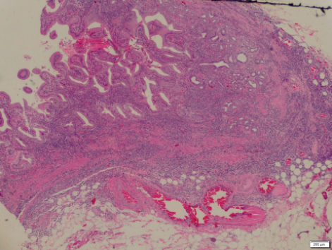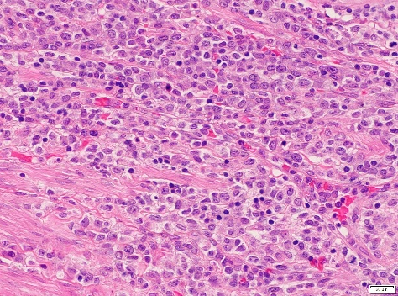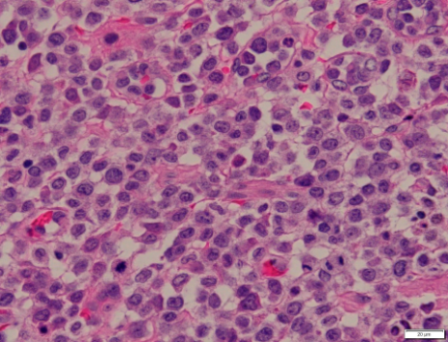

Review of the bone marrow aspirate smears showed several medium to large sized blasts having ovoid to irregular nuclei, fine to slightly coarse chromatin pattern, few conspicuous nucleoli, and scant to moderately abundant cytoplasm. The bone marrow core biopsy is moderately hypercellular for age, showing 90% to 95% cellularity. There are sheets and interstitial infiltrates of mononuclear cells compatible with blasts involving 20% to 25% of the marrow space.

(PICTURES OF PREVIOUS BONE MARROW ASPIRATE AND CORE BIOPSY, FLOW CYTOMETRY AND IHC CAN BE EMAILED IF REQUESTED FOR THIS ABSTRACT)

Bone marrow flow cytometry study (previous flow cytometry study)
CD34 – DIM
HLA-DR – BRIGHT
CD13, CD33 – BRIGHT
MPO – BRIGHT
CD117 – MODERATELY BRIGHT
CD11C – MODERATELY BRIGHT

Based on the morphology and previous flow cytometry study, immunohistochemistry studies with CD34, MPO and LCA were done.

CD45 – POSITIVE, diffuse and strong cytoplasmic membrane expression in neoplastic cells.
MPO – POSITIVE, diffuse and strong cytoplasmic expression in neoplastic cells.
CD34 – POSITIVE, patchy, weak to moderately strong cytoplasmic expression in neoplastic cells.
Pancytokeratin – Negative expression.

DISCUSSION
Acute Myeloid Leukemia is the most common form of Acute Leukemia during the first few months of life, but during childhood and adolescence it accounts for approximately one third of Acute Leukemias. It is a clonal neoplastic proliferation of hematopoietic precursor cells causing excessive myeloblasts and other immature myeloid cells. These malignant cells replace bone marrow, may infiltrate the spleen, liver and lymph nodes and circulate in the bloodstream but rarely in soft tissues.
Although there are reported cases of leukemic infiltration of the gastrointestinal tract, it is exceptionally rare to have leukemic infiltration of the gallbladder by myeloblasts.

REFERENCES
- Azin, A., Racz, J. M., Carolina Jimenez, M., Sunil, S., Porwit, A., Jackson, T., Okrainec, A., Quereshy, F. (2014). Relapse of acute myeloid leukemia manifested by cholecystitis: A case report and review of the literature. International journal of surgery case reports, 5(6), 302-5.
- Dabbs, D (2014). Diagnostic Immunohistochemistry: Theranostic and Genomic Applications. Philadelphia: Saunders Elsevier.
- Goldblum, J., Lamps, L., McKenney, J., Myers, J. (2018). Rosai and Ackerman’s Surgical Pathology, Eleventh Edition. Elsevier Inc.
- McPherson, Richard A. (2017) Henry’s clinical diagnosis and management by laboratory methods. Elsevier.
- Bloom, S., Coad, J., Greeno, E., Ashrani, A., Hammerschmidt, D. (2002). Cholecystitis as the Presenting Manifestation of Acute Myeloid Leukemia: Report of a Case. American Journal of Hematology 70:254-256.
- Swerdlow S, Campo E, Harris N, Jaffe E, Pileri SA, Stein H, Thiele J (Eds): WHO Classfication of Tumours of Haematopoietic and Lymphoid Tissues, 4th ed. IARC: Lyon (2017).

