

Title: The date palm inflorescence rot fungus Mauginiella scaettae can infect the model plant Arabidopsis thaliana.

Bensaci M.B.¹, Rahmania F.²
- Ouargla Normal Higher School, Department of Natural Sciences, laboratory of Ecosystems protection and preservation in arid and semi arid areas, Ouargla 30 000, Algeria.
- Faculty of Biological Sciences. Laboratory of Researches on the Arid Zones. BP. 32. El - Alia, University Haouari Boumeriene, Bab-Ezzouar. Algiers. Algeria.
Abstract
Mauginiella scaettae is a fungal pathogen causing inflorescence rot date palm: one of the most divesting diseases in date palm growing regions worldwide. This disease was first reported by Cavara (1925) in Libya but the infection mechanisms remain obscure. To characterise the infection mechanism it was attempted to develop the model plant Arabidopsis thaliana as an alternative host for strains of Mauginiella scaettae were isolated from different oases of East-south of Algeria: Ouargla1 (OU1) ,Ouargla2 (OU2), Ouargla3 (OU3), Hadjira (Ha),Touggour1(T1), Touggourt2 (T2), Oued1 (OE1), Oued2 (OE2), Ghardaïa (G) and Biskra (Bis). Sequencing the internal spacer (ITS) regions of indicated the phylogenetic position of M. scaettae. Upon drop-inoculation with conidia of M. scaettae, Arabidopsis exhibited white necrotic lesions with marginal yellowing appeared on leaves at 6 days post inoculation and subsequently expanded throughout the entire leaves. It was noted that strain G was the most and T2 is the least virulent. Microscopic investigations demonstrated that a preference for fungal penetration via stomata, accompanied by hyphal tip swelling which may represent a primitive haustorium. Both of these features were also observed on M. scaettae infected date palm spathes. On Arabidopsis initial biotrophic growth was followed by a necrotrophic lifestyle, similar to what happens on date palms. To investigate how host resistance mechanisms could modify the interaction were examined M. scaettae interactions with Arabidopsis mutants cpr1 and sid2 respectively increased and compromised in biotrophic resistance mechanisms, and eto2 which displays elevated resistance against necrotrophic pathogens. Interactions with eto2 appeared to be particularly affected, suggesting that anti-necrotrophic mechanisms - here linked to ethylene - could be effective in conferring resistance to M. scaettae. This study demonstrated the value of using model species in providing novel insights into previously cryptic interactions.
Key words: Date palm, Algeria, inflorescence rot, Mauginiella scaettae, Arabidopsis thaliana. Infection, interaction.

Figures if any (BW/Color):

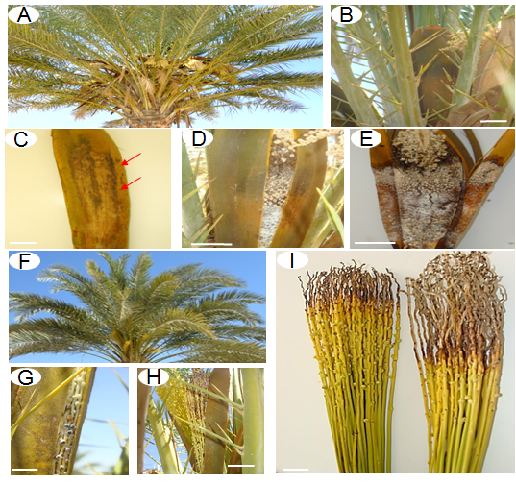
Fig. 1. Symptoms of date palm inflorescence rot caused by Mauginiella scaettae. (A) Male date palm with (B) male inflorescences with the spathe cover (bar=5 cm). (C) Necrotic symptoms symptomatic of inflorescence rot (arrowed), as seen on the outside of the male spathe (bar=5 cm) with (D) white mycelial development within the male spathe (bar=2 cm). (E) white mycelial development and necrosis is eventually observed both within and outside the infected male spathe (bar=5 cm). (F) healthy female date palm exhibiting the emergence of female flowers. (G) white mycelial development within inflorescence rot exhibiting female spathe (bar=5 cm) which (H) is associated with necrotic symptoms as the flowers emerge (bar=5 cm) and (I) kills the flowers at the tips (bar=5 cm).
Table 1. Ten sites in South-East of Algeria origin of the inflorescence rot in date palm. 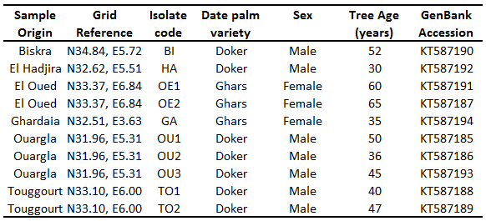

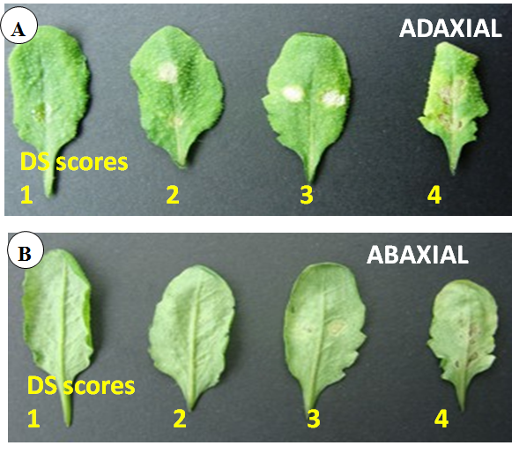
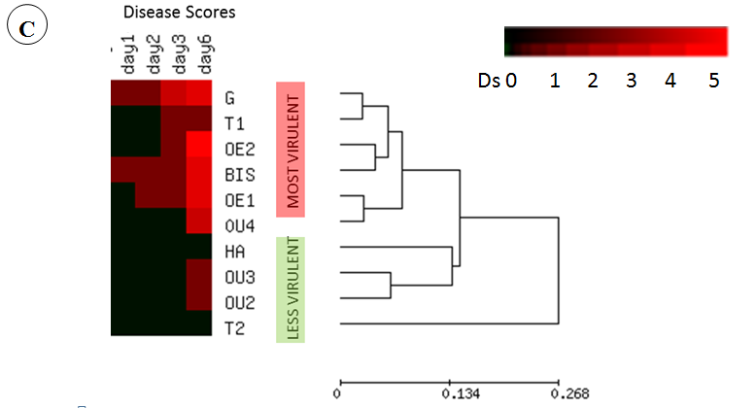
Fig. 2. (A, B) Diseases severity (DS) in Col-0 (see table 2). (C) Variation in disease severity on Col-0 following infection with the 10 M. scaettae strains. Mean DS scores at different days following infection are depicted by a heat map and grouped via hierarchical cluster analysis. The most and least virulent strains are indicated. No significant correlation between genetic variation (Fig. 4) and DS was observed

Table.2: Disease Severity on Arabidopsis scoring
Diseases severity score
0 | 1 | 2 | 3 | 4 | 5
Same as H₂O controls | Flecking (spots) | Adaxial Necrosis | Adaxial/ Abaxial Necrosis | Necrosis + Chlorosis | Whole leaf death

Fig. 3. (A, B) Diseases severity (DS) in Col-0 (see table 2). (C) Variation in disease severity on Col-0 following infection with the 10 M. scaettae strains. Mean DS scores at different days following infection are depicted by a heat map and grouped via hierarchical cluster analysis. The most and least virulent strains are indicated. No significant correlation between genetic variation (Fig. 4) and DS was observed
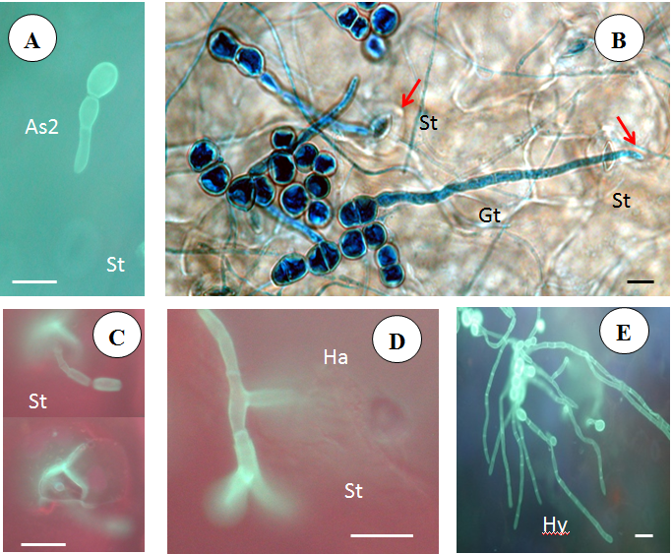

Fig. 4. Cytological analysis of Mauginiella scaettae growing invasively in Arabidopsis thaliana leaves via the stomata
A - Germination of M. scaettae arthroconidia at the leaf surface of Arabidopsis thaliana. B, C M. scaettae hyphae penetrating the leaf surface of Arabidopsis thaliana through stomata D- Micrograph with the haustorium in a sub-stomatal cavity. E- Extensive Intercellular invasion of the Arabidopsis thaliana leaf by M. scaettae. Bar = 20 um
Hyphae (Hy), Haustoria (Ha) , Stomata (St) , Germ tube (Gt), arthroconidia one cell (As1) and arthroconidia two cells (As2) are indicated.
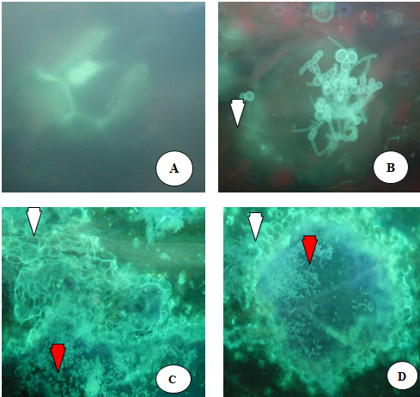
Fig. 5. Accumulation of callose compounds on Arabidopsis thaliana Col-0, leaves infected with
the Mauginiella scaettae strains,
- The white arrow shows the accumulation of fluorescent phenolic compounds
around the cells at the penetration site revealed by aniline blue staining after 6 dpi
- The red arrow shows the spores and mycelium
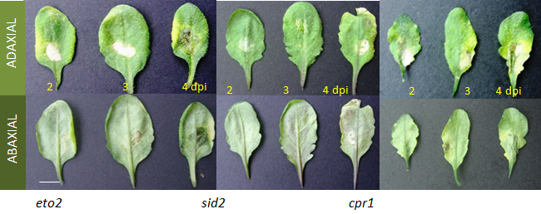
Fig. 6 .Diseases severity in eto-2, sid2 and cpi1 (Bar = 1 cm)
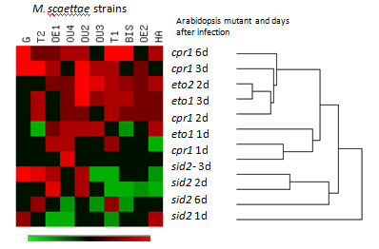
Fig.7. Heatmap showing the differential in Arabidopsis thaliana ecotypes plants inoculated with Mauginiella scaettae strains
Variation in disease severity on Col-0, eto2, sid2 and cpr1 are expressed and following infection with 10 M. scaettae strains. Mean DS scores at different days following infection are expressed relative to the mean values obtained for Col-0 (ie. less virulent or more virulent). These mean differences depicted by a heat map and grouped via hierarchical cluster analysis. The data suggest that eto2 and cpr1 display increased susceptible to the 10 M. scaettae strains and sid2 more resistance.

Biography
- Abdullah S. K; Asensio L.; Monfort E.; Gomez-Vidal S.; Palma-Guerrero J.; Salinas J.;Lopez-
Llorca L.V.; Jansson H.B.; Guarro J. (2005). Occurrence in
Elx, SE Spain of inflorescence rot disease of date palms caused by Mauginiella scaettae J.
Phytopathol.153:417-422
2- AL-Ani, H. Y.; EL-Behadli, A.; Majeed, H. A. and Majeed, M..(1971a). Reaction of date
palm cultivars to inflorescence rot and persistency and spreading of the diseases .
Phytopath.Medit. 10: 57-62
3 - Bowling S.A.; Guo A.; Cao H.; Gordon A. S. ; Klessig D.F. and X. Dong X. (1994). A
mutation in Arabidopsis that leads to constitutive expression of systemic acquired
resistance, The Plant Cell. 6: 1845- 1857.
- Cavara F. (1925b). Mauginiella scaettae Cav. nuovo ifomicete parassita della palma da datteri
in Cirenacia. Bol OrtoBot Napoli 08: 207–211.
- Carpenter J.B and Elmer H.S. 1978 . Pest and diseases of the date palm. In : Agriculture Handbook. Californie : U.S. date and citrus station, 42 p.
- Chae H. S.; Faure F. and Kieber J. J. (2003).The eto1, eto2, and eto3 Mutations and Cytokinin Treatment Increase Ethylene Biosynthesis in
Arabidopsis by increasing the Stability of ACS Protein ThePlant Cell. 15: 545–559.
- Djerbi M. (1983). Diseases of date palm Phoenix dactylifera. Near East and Africa, FAO
regional project for palm dates research centre 106pp
- Données climatiques de la région d’Ouargla (2001-2010), (O.N.M., 2010)
- Hood M. E. and Shew H. D. (1996). Applications of KOH-Aniline Blue Fluorescence in the Study of Plant-Fungal Interactions. Phytopathology. 86:704-708.
- Ploetz R.C. 2003. Disease of date ( Chapter 9 in Diseases of tropical fruits crops). CAB
publishing, British library, London, UK Library of Congress, Washington, DC, USA. PP: 235- 236.
11 - Nawrath C. and Jean-Pierre Métraux J.-P. (1999).Salicylic Acid Induction–Deficient Mutants
of Arabidopsis Express PR-2 and PR-5 and Accumulate High Levels of Camalexin after
Pathogen Inoculation The Plant Cell. 11:1393-1404.
12- Zolan ME, Pukkila PJ. (1986) Inheritance of DNA methylation in Coprinus cinereus. Mol Cell
Biol 6:195- 200.

