 Pathology week 2019

19 th Edition on WORLD PATHOLOGY WEEK

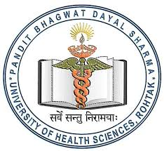

TITLE: Primordial odontogenic tumor- an untold story

- Nomenclature and classification of Odontogenic tumors have evolved tremendously since the first odontogenic tumor was described in over 200 years. Odontogenic tumors comprise of heterogenous group of lesions ranging from hamartomas or non neoplastic growths to benign and malignant neoplasm. Primordial odontogenic tumor (POT) is a new entry to the spectrum. It is a rare lesion in the jaw which has been included as a new entity of benign mixed epithelial and mesenchymal odontogenic tumour in the latest World Health Organization (WHO) classification (2017). Only seven cases have been reported till date. We report an additional case of POT in the maxilla of an 11-year-old boy presenting with an asymptomatic labial enlargement. A well-defined, unilocular, radiolucent lesion was observed. Histologically, the tumor was mostly composed of loose fibrous connective tissue resembling dental papilla and a single layer of columnar epithelium covering the periphery of the tumor. To rule out this tumor from hyperplastic follicular sac, odontogenic fibroma and chondromyxoid fibroma was a diagnostic challenge.

Author: Dr Anjali Narwal, Dr Susmita Saxena, Dr Mala Kamboj, Dr Anju Devi
Dept of Oral Pathology, Post Graduate Institute of Dental Sciences
Pt. B. D. Sharma University of Health Sciences, Rohtak, Haryana, India

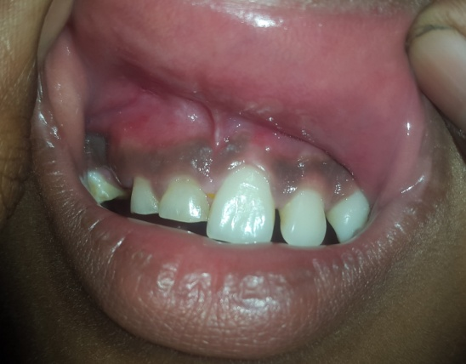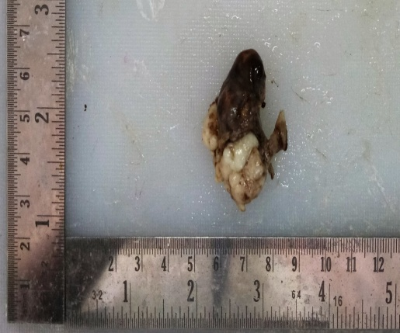

Biography
Dr Anjali Narwal has been working as Oral Pathologist for past 10 years. She is Professor in the Dept of Oral Pathology, Post Graduate Institute of Dental Sciences,Pt. B. D. Sharma University of Health Sciences, Rohtak, Haryana, India. It is a government run premiere Institue catering dental and oral health needs. Has published more than 30 research papers in reputed journals and also has been reviewer for many journals from time to time. Has keen interest in Oral oncology and has been awarded various awards for scientific presntations.

Presenting author details:
Dr Anjali Narwal
91-9896405060
anjalinarwal@yahoo.com
Oral/ Poster presentation
Session name: ORAL 19, JUNE
Research interest: Oral Pathology

