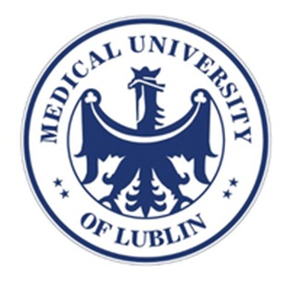

Evaluation of the pharmacological interaction between cambinol and cisplatin in breast cancer cells.
Anna Wawruszak¹, Marta Halasa¹, Marek Cybulski¹, Andrzej Stepulak¹

¹Medical University of Lublin, Poland, Europe

Sirtiun inhibitors (i.a. cambinol) are promising anticancer agents, which inhibit proliferation of a wide variety of cancer cells including breast carcinoma. In the present study, we investigated the influence of cambinol alone or in combination with cisplatin on proliferation, induction of apoptosis and cell cycle progression in MCF7, T47D, MDA-MB-231 and MDA-MB-468 human breast cancer cell lines. The type of interaction between cambinol and cisplatin was determined by an isobolographic analysis. The isobolographic analysis is a very precise and rigorous pharmacodynamic method, to determine the presence of synergism, addition or antagonism between different drugs with using variety of fixed dose ratios. Our experiments show that the combinations of cisplatin with cambinol at a fixed-ratio of 1:1 exerted antagonistic interaction in all analyzed cancer cell lines. Moreover, a better therapeutic effect was obtained when these compounds were administered separately than in combination. Cambinol used in monotherapy inhibited the proliferation of cancer cells, induced apoptosis and inhibition of the cell cycle in all types of breast cancer cell lines.

Anna Wawruszak has completed her double Master’s degree in Biotechnology and Chemistry of Bioactive Substances and Cosmetics from Maria Curie-Sklodowska University in Lublin, Poland. She was a fellow in Sacler School of Medicine at Tel Aviv University, Maimonides Biomedical Research Institute of Cordoba (IMIBIC), University of Cordoba and Jagiellonian University in Cracow. She is laureate of numerous awards and grants (i.a. Scholarship of Polish Ministry of Science and Higher Education, Israeli Government Scholarship of the Ministry of Foreign Affairs, Scholarship of National Agency for Academic Exchange). Her research interests focus on the epigenetic regulation of gene expression, histone acetylation and deacetylation, histone deacetylase inhibitors (HDIs), pharmacokinetic drug-drug interactions (isobolography method), epithelial-mesenchymal transition (EMT) and Notch signaling mainly in breast cancer.
Full name: Anna Wawruszak
Contact number: +48 513 962 680
Email id: anna.wawruszak@umlub.pl
Category: Oral presentation
Session name: Breast Pathology
Research interest: Breast cancer, epigenetic modification of histones, histone deacetylase inhibitors, epithelial-mesenchymal transition, Notch signalling

