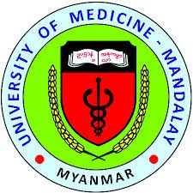

Title: ANDROGEN RECEPTOR, Ki-67 AND HISTOLOGIC GRADES IN TRIPLE-NEGATIVE BREAST CANCER
Authors: Phyu Phyu Htut, Saw Nu Nu Hlaing, San San Hlaing
University of Medicine, Mandalay, Myanmar
Triple-negative breast cancer (TNBC) is characterized by lack of expression of estrogen receptor, progesterone receptor and epidermal growth factor receptor-2. TNBC is an aggressive tumor associated with poor prognosis and high risk of early recurrence. Androgen receptor is currently one of the most studied biomarkers in TNBC, playing a role in the genesis and development of breast cancer and it has been suggested as a potential therapeutic target. High expression of Ki-67, a proliferative marker, has been associated with a worse prognosis in TNBC. The purposes of the study are to determine the histologic grades, the immunoexpression of androgen receptor and Ki-67 and to find out the association between androgen receptor, Ki-67 immunoexpression and histologic grades in TNBC. A hospital-based cross-sectional analytical study was carried out on 57 cases of TNBC at the Mandalay General Hospital during February 2017 to January 2018. Using immunohistochemistry, the formalin-fixed, paraffin-embedded blocks of TNBC cases were analyzed by monoclonal antibodies to androgen receptor and Ki-67 at the Common Research Laboratory, University of Medicine, Mandalay. The clinicopathological data were obtained from the histopathological reports. The mean age was 50.7 years and the age range was from 23 to 74 years. The majority of cases were invasive ductal carcinoma, 53 cases (93 percent) and remaining cases were 2 cases of invasive lobular carcinoma (3 percent), a case of metaplastic carcinoma (2 percent) and a case of secretory carcinoma (2 percent). Most of the cases were histologic grade III, 38 cases (66.7 percent), followed by grade II, 19 cases (33.3 percent). Positive androgen receptor immunoexpression was found in 12 cases (21.1 percent) and high Ki-67 immunoexpression was seen in 43 (75.4 percent). Negative androgen receptor immunoexpression was associated with high histologic grade (p = 0.005) and high Ki-67 immunoexpression was associated with high histologic grade (p = 0.004). This study may point out the combination of androgen receptor and Ki-67 immunoexpression might be useful prognostic markers in TNBC in order to sub classify the risk of these patients, prognostic stratification, provide useful data for further researches and targeted therapies for androgen receptor positive cases.

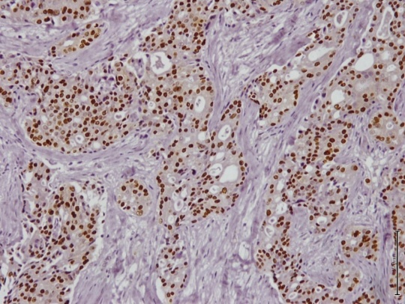
Figure 1. Invasive ductal carcinoma (NST) Histologic grade II, positive androgen receptor
Immunoexpression x200 (Case no-41)

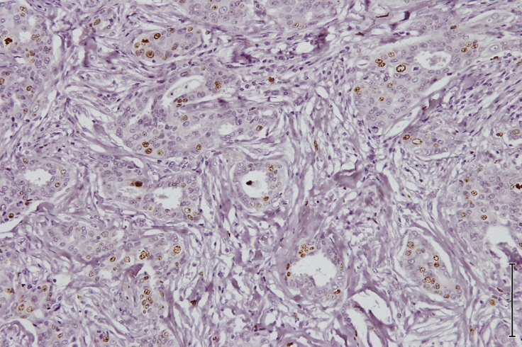
Figure 2. Invasive ductal carcinoma (NST) Histologic grade II, low Ki-67 immunoexpression x200 (Case no-41)

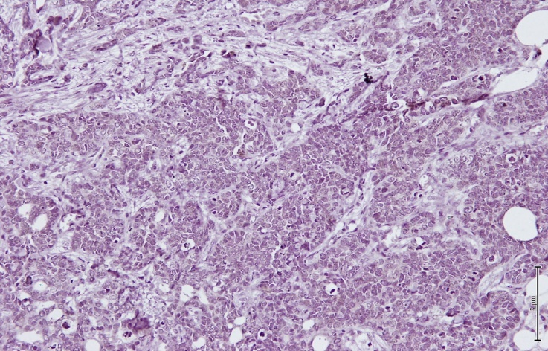
Figure 3. Invasive ductal carcinoma (NST) Histologic grade III, negative androgen receptor immunoexpression (x 200) (Case no-49)

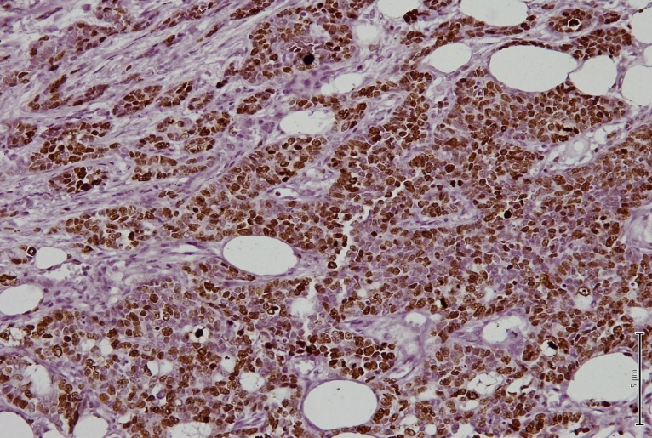
Figure 4. Invasive ductal carcinoma (NST) Histologic grade III, high Ki-67 immunoexpression (x 200) (Case no-49)

Biography
Phyu Phyu Htut has completed her PhD from University of Medicine, Mandalay, Myanmar (2018). She is the Consultant Pathologist of the Department of Pathology, Mandalay General Hospital, Myanmar. She has done local presentation (1) An autopsy study of neonatal death (M.Med.Sc Thesis) at Myanmar Medical Association Conference, Mandalay (2006) (2) Renal transplant pathology at Pathology CME (2016)

Presenting author details
Phyu Phyu Htut
959798599332
phyuphyuhtut2013@gmail.com
Poster presentation
Breast Pathology Section
Research interest in Breast Pathology and Renal Pathology

