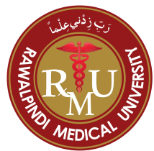

Title: Spectrum of bone marrow changes in patients of advanced chronic kidney disease

Author (s)Name: Dr. Rabbia Khalid Latif, MBBS, M.Phil,
Rawalpindi Medical University, Rawalpindi, Pakistan

INTRODUCTION: Chronic kidney disease (CKD) is a health problem present worldwide¹. CKD is a collective term covering a number of primary disease processes resulting in structural or functional kidney abnormalities, or both, persisting for at least 3 months². It is related with premature mortality and decreased quality of life. Untreated cases can end up in end stage renal disease (ESRD) finally necessitating dialysis. In Pakistan more than 21 million people are affected by this disease³. Almost every patient of advanced CKD suffers from some degree of hematological abnormalities. AIMS: The purpose of this study is to analyze various hematological manifestations of advanced stage CKD in peripheral blood & bone marrow (BM) of the patients, referred to us from the nephrology unit of our tertiary care medical set up. OBJECTIVE: To see the various hematological changes in the bone marrow of patients with chronic kidney disease (CKD) stage III, IV and V. MATERIALS & METHODS: Study was conducted in the department of hematology (Pathology), Army Medical College, Rawalpindi and duration was one year, from Mar 2015 to Feb 2016. Patients of both genders & all age groups with CKD stage III, IV & V were included in this study. Patient’s histories were recorded. Complete blood counts, bone marrow aspiration & trephine biopsies were done and evaluated microscopically. Mean blood counts of the patients in three groups of CKD were compared. Frequencies of various bone marrow findings in CKD patients were calculated. RESULTS: Out of 57 patients, 41 (71.9%) were males while 16 (28%) were females. Mean age was 60 years. There was no statistically significant difference between the mean hemoglobin, mean white cell count & mean platelet count of the patients in three groups of CKD. Reactive changes due to underlying CKD and inflammation were the most frequent finding in the BM of the patients. CONCLUSION & RECOMMENDATIONS: Anaemia of mild to moderate severity and reactive changes in the BM are the most frequent hematological findings encountered in patients suffering from advanced stage CKD. Since CKD is predominantly a disease of the elderly so it is not rare to find the co-morbidities including plasmacytosis, malignancies & their effects on the BM in the patients of CKD. Recommendations: We should focus our attention on primary prevention of anaemia by strictly adhering to the treatment guidelines, adapting healthy life styles & dietary modifications as early recognition can slow the progression of the disease to ESRD. Public awareness is very essential to halt the advancement of disease.

Figures if any (BW/Color):

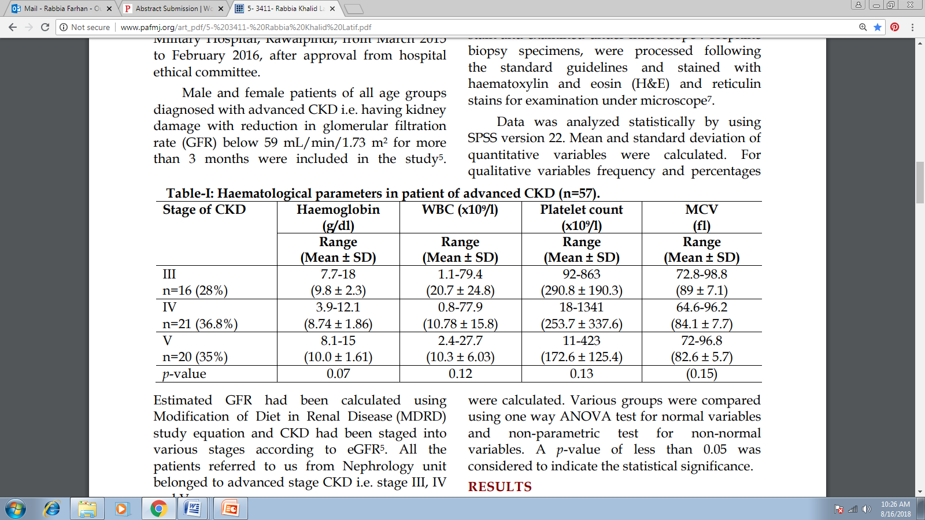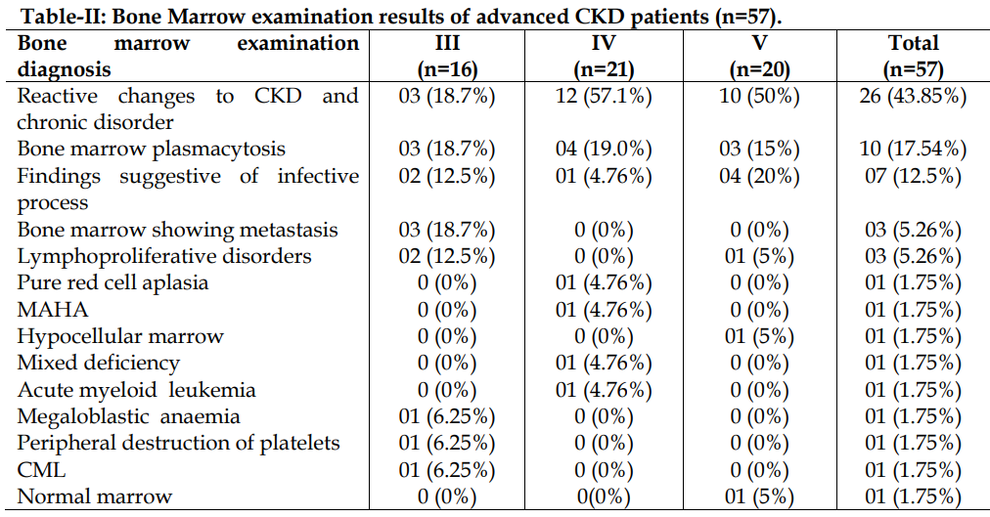

Biography

Dr. Rabbia has her expertise in evaluation and passion in improving the health and wellbeing. She completed her M.Phil in Hematology from Army Medical College, Rawalpindi in 2016 and currently working as lecturer at Rawalpindi Medical University, Rawalpindi. Her open and contextual evaluation model based on responsive constructivists creates new pathways for improving health care. She has built this model after years of experience in research, evaluation, teaching and administration both in hospital and education institutions. She is capable of accepting responsibility towards patient’s health and well-being and has thorough knowledge of medical laws and ethical standards of medical care.

Presenting author details
Full name: Dr. Rabbia Khalid Latif
Contact number: +923335608074
Email id: brittle_star44@hotmail.com
Category: Poster presentation
Session name: Hematopathology
Research interest: Hematology

