
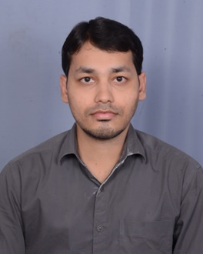

Title : Primary Giant cell tumour of soft tissue, a rare diagnosis on cytology with histopathological confirmation.
Authors name : Dr Akhtar Mohammad ; Dr Rajyalakshmi ; Dr Vijay Bhaskar.
Rangaraya medical college, Kakinada, India.
Primary giant cell tumor of soft tissue is an extremely rare entity and is considered as a counterpart of osseous giant cell tumor because of their similar morphology and immunohistochemial features. Cytological diagnosis of this entity with histopathological confirmation is rarely reported. Here we report a case of primary giant cell tumor of soft tissue in a 65year old male patient, presented with swelling on the right forearm with a duration of 6 months. The swelling is superficial in location and of size 3x3 cm. Clinical diagnosis of epidermoid cyst was made. X-ray of the right forearm is suggestive of soft tissue mesenchymal lesion possibly malignant because of irregular margins. There was no bone involvement. FNAC was done and possibility of a Giant cell tumour of soft tissue was considered with clinical and radiological correlation and advised excision for further evaluation which was confirmed histopathologically. The patient developed local recurrence of the tumour after 4 months of excision. No metastasis was observed during follow up period.
Figures a and b :
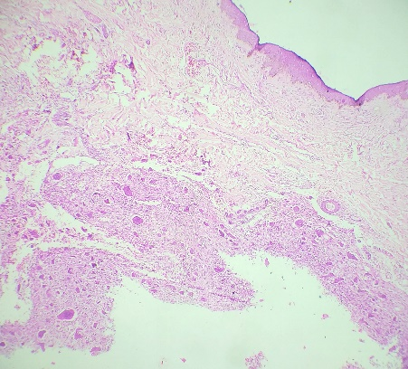
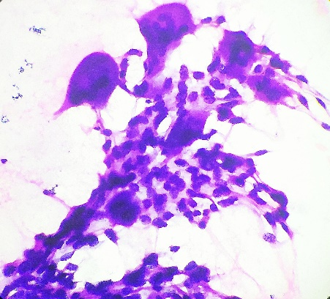

Figure a and b : Representing areas of Cytology and Histology of soft tissue giant cell tumor.
Biography :
Dr Akhtar Mohammad has pursued MD pathology post graduate degree from Osmania medical college in May,2017 and Diplomat of national board degree in Pathology in March 2018. Currently he is the senior resident in the department of pathology, Rangaraya medical college, Kakinada. He has published two original articals in reputed journals. He is very passionate about the subject and had a credit of many prizes in state wide quiz competitions .

Presenting author details :
Full name: AKHTAR MOHAMMAD
Contact number: +91 9177522658
Email id: drfahimakhtar@gmail.com
Category: E - Poster presentation
Session name:
Research interest: Soft tissue pathology, Hematopathology

