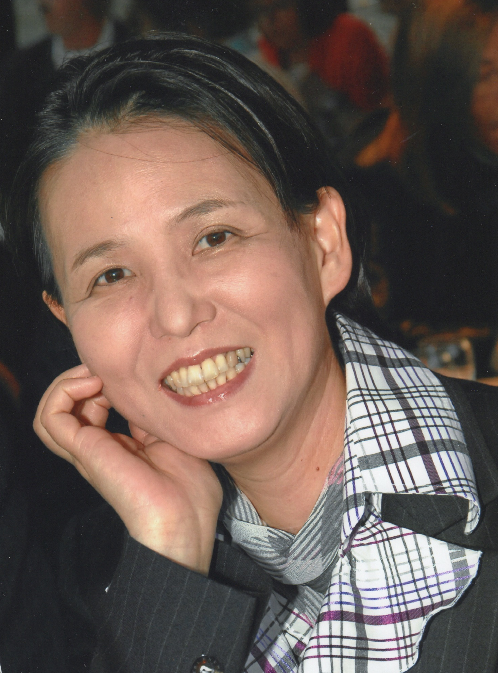
Photograph Logo of Institute
Japanese foundation for cancer research(JFCR)
http://www.jfcr.or.jp/english/index.html

Title: Directly sampled endometrial cytology for screening of endometrial cancers.
Author (s) Name:
Yuko Sugiyama (MD, FIAC) ^{1), 2)}, Katsuhiko Hasumi (MD) ^{1), 2)}.
¹⁾ Departments of Cytology, Cancer institute hospital, Tokyo, Japan
²⁾ Departments of Gynecology, Cancer institute hospital, Tokyo, Japan

Objective:
Currently, directly sampled endometrial cytology is the most common method of screening for endometrial cancer in Japan. The purpose of this study are as follows: comparison of the detection rate between endometrial cytology and biopsy for diagnosis of endometrial cancers, and comparison of the diagnostic value of conventional and liquid-based preparation for endometrial cytology.
Materials and Methods:
From 2000 to 2016, a total number of 2,326 patients with endometrial cancer underwent surgery at Cancer Institute Hospital, Tokyo Japan. Among them, we reviewed preoperative cytology and biopsy specimens of 1860 cases. The direct endometrial sampling method was applied for endometrial cytology.
Results:
1. The detection rate of endometrial cancers between cytology and biopsy in all stages was 83.9% and 95.7% respectively, and in early stage was 79.4% and 90.0% respectively. There were significant differences between them.
2. Comparison of the two preparation methods (conventional and liquid-based preparation). Even though there were some differences between conventional and lquid-based preparatio, our results indicated that both methods are useful for detecting endometrial cancers.
Conclusions: Although, there were significant differences between cytology and biopsy in the detection rates of endometrial cancers, compared to the endometrial biopsy, endometrial cytology is easier to insert into the uterine cavity and is less painful. Therefore endometrial cytology has been used as a screening for endometrial cancer in Japan. Even though there were some differences between conventional and liquid-based cytology, our results indicated that both methods are useful for detecting endometrial cancers.

Figures:
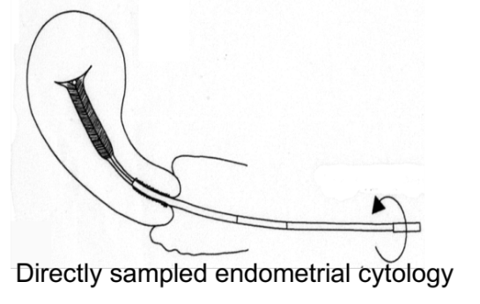

Biography
Yuko Sugiyama. M.D., Ph.D., FIAC , is a director of department of cytology, school of cytotechnologist and vice director of department of gynecology at the Cancer Institute Hospital (Tokyo, Japan) which was established in 1934 and the oldest and most prestigious cancer treating hospital in Japan. She holds dual specializations in cytopathology and gynecologic oncology, and places great importance on gynecologic cancer patient by providing both diagnostic and treatment services. Her academic area of interest is early detection of endometrial cancers through cytology. She invented the new devices for directly sampled endometrial cytology.

Presenting author details
Yuko Sugiyama. M.D., Ph.D.FIAC
Department of Cytopathology and Gynecology
Cancer Institute Hospital
Japanese foundation for cancer research (JFCR)
3-8-31 Ariake, Koto-ku,
Postal Code: 135-8550
Tokyo, Japan
Phone: +81-3-3520-0111
Fax: +81-3-3570-0343
E-mail: yuko.sugiyama@jfcr.or.jp

Category: (Oral presentation)
Research interest: Endometrial cancer, Endometrial cytology, Early detection

