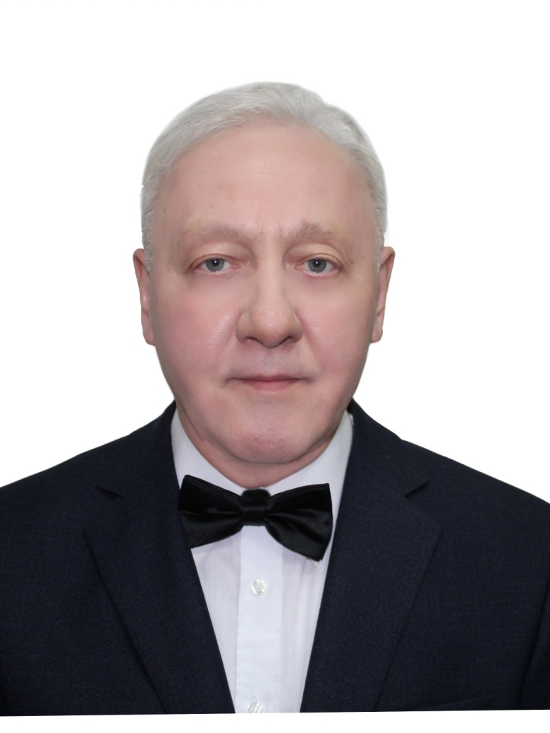

Title: Questionnaire portrait of the well-known Russian pathologist, neuromorphologist and psychiatrist Professor Pavel Evgenievich Snesarev
Author (s) Name: Alexander N. Zubritsky
Moscow, Russian Federation
This work has the aim to collect and systematize the biographical information according to the questionnaire prepared by me. Born on October 25, 1876 in village of Kamyshevskaya region of Don Army in family of regimental priest. Married. Children: George, Gleb. Graduated from the Military Medical Academy; foreign scientific trip to Munich (Germany) to anatomical laboratory led by A. Alzheimer; defense of doctoral dissertation on topic "On the nerve fibers of the anterior brain of the frog". Assistant, St. Petersburg psychiatric hospital of St. Nicholas; Head, prosectura, psychiatric hospitals in Moscow; Head, Department of Morphology, Institute of Psychiatry of Ministry of Health and at the same time Head, Pathohistological Laboratory, Institute of Brain, AMS USSR. Achievements and awards: one of founders of domestic histopathology of nervous system and pathological anatomy of mental diseases; he created the doctrine of the granularity of the brain; he also studied the changes in the argentophilic granularity of the brain and internal organs in hypertensive disease; Honored scientist of RSFSR; awarded the orders of Lenin and the Red Banner of labor. Author of over 150 scientific papers and several monographs, including: General histopathology of brain injury; Theoretical basis of pathological anatomy of mental diseases, etc. Distinctive feature: talented organizer, devoted to his work, brilliant clinician, lecturer and forecaster. Member of All-Union Communist Party (Bolsheviks). Hobbies: played the cello, had a good voice. He died on November 5, 1954 in Moscow at the age of 78 years and is buried at Vagankovskoe cemetery of Moscow.

Biography: I was born on March 14, 1949 in Severo-Kurilsk, Sakhalin Region in the family of a military therapist. At age 15, worked as a hospital attendant in a pathology department of a hospital in Sverdlovsk (Yekaterinburg) and studied at night school for working youth. In 1974 he graduated the curative and preventative faculty of the Sverdlovsk Medical Institute. In 1974-1975 was an internship in pathological anatomy at the basis of Sverdlovsk Regional Clinical Hospital. In 1977 enrolled in correspondence postgraduate study at the Institute of Human Morphology in Moscow on a specialty “pathological anatomy” under the direction of the Hero of Socialist Labor, Lenin Prize laureate, Academician of AMS USSR Prof. A.I.Strukov. In 1990, I defended my thesis “Quantitative analysis of pathomorphological changes in the right ventricle of the heart in group of patients with chronic nonspecific pulmonary disease” in the I.M.Sechenov Moscow Medical Academy. PhD, 1991. However, after the Higher Certification Commission (HCC) assertion, I have refused from the candidate diplom, because I considered and continue considering that this work, despite of shortcomings, from which a thesis cannot be insured, meets the HCC requirements to doctoral thesis. But the most important reason of my rejection was a break of my thesis from «competent» organs, which in the different ways and methods and on various pretexts sent me to Sverdlovsk to defend my thesis, because somewhere remained a document about my pranks in the youth (see: Zubritsky, A.N. The Dead Wall. Autobiographical sketch (in Russian and in English). – Moscow, 2012. – 320 p.). Nevertheless, the question of awarding me a degree of Doctor of Medical Sciences, without re-protection, because of official circumlocution, not without participation of «competent» authorities, that is regrettable, is still «hanging in the air». In 1990 I became a finalist of the Marvin I. Dunn Award for the best presentation in Cardiology at the meeting of the American College of Chest Physicians in Toronto. In 1993 in Innsbruck is awarded by the “Pathology Research and Practice” for the best reply under the heading “Expert Quiz”. I am a winner of the International Peace Prize for 2003 (UCC). In 2004 was awarded a gold medal "Scientist of 2004" (IBC). In 2005 I was awarded the World Medal of Freedom in pathological anatomy and in the same year was awarded the title "Man of Achievement" for my outstanding contributions to pathological anatomy of cor pulmonale (ABI). I am a winner of the encyclopedia “Best People of Russia” with the presentation of my commemorative medal (2006). In 2007 I was awarded the medal "Gold Medal for Russia" (ABI). Author of the 4 rationalisation proposals and more 220 published works as sole author. Publications about myself: Great Minds of the 21st Century (ABI, 2005), Who's Who in America (Marquis Who’s Who, 2005), Best People of Russia (Spets-Adres, 2006), Who's Who: World Edition (Astreya, 2011), etc. Now I am an unemployed pensioner.

Presenting author details
Full name: Alexander N. Zubritsky
Contact number: no
Email id: zubrale@yandex.ru
Category: poster presentation
Session name: track 23
Research interest: history of medicine, cor pulmonale, oncopathology, organization of pathoanatomical service, tobacco smoking, etc.

