Therapeutic approach with commercial supplements for pantothenate kinase-associated neurodegeneration with residual PANK2 expression levels
Dr José Antonio Sánchez Alcázar, Universidad Pablo de Olavide-CABD-CSIC, Sevilla, Spain

Abstract (300 word limit)

Neurodegeneration with brain iron accumulation (NBIA) is a group of rare neurogenetic disorders frequently associated with iron accumulation in the basal nuclei of the brain characterized by progressive spasticity, dystonia, muscle rigidity, neuropsychiatric symptoms, and retinal degeneration or optic nerve atrophy. Pantothenate kinase-associated neurodegeneration (PKAN) is one of the most widespread NBIA subtypes. It is caused by mutations in the gene of pantothenate kinase 2 (PANK2) that result in dysfunction in PANK2 enzyme activity, with consequent deficiency of coenzyme A (CoA) biosynthesis, as well as low levels of essential metabolic intermediates such as 4'-phosphopantetheine, a necessary cofactor for essential cytosolic and mitochondrial proteins.

In this work, we examined the therapeutic effectiveness of pantothenate, panthetine, antioxidants (vitamin E, omega 3 and α-lipoic acid) and mitochondrial function boosting supplements (L-carnitine and thiamine) in mutant PANK2 cells with residual expression levels.

Commercial supplements, pantothenate, pantethine, vitamin E, omega 3, α-lipoic acid, carnitine and thiamine were able to eliminate iron accumulation, increase PANK2, mtACP, and NFS1 expression levels and improve pathological alterations in mutant cells with residual PANK2 expression levels.

Our results suggest that several commercial compounds are indeed able to significantly correct the mutant phenotype in cellular models of PKAN. These compounds alone or in combinations are of common use in clinical practice and may be useful for the treatment of PKAN patients with residual enzyme expression levels.
Image
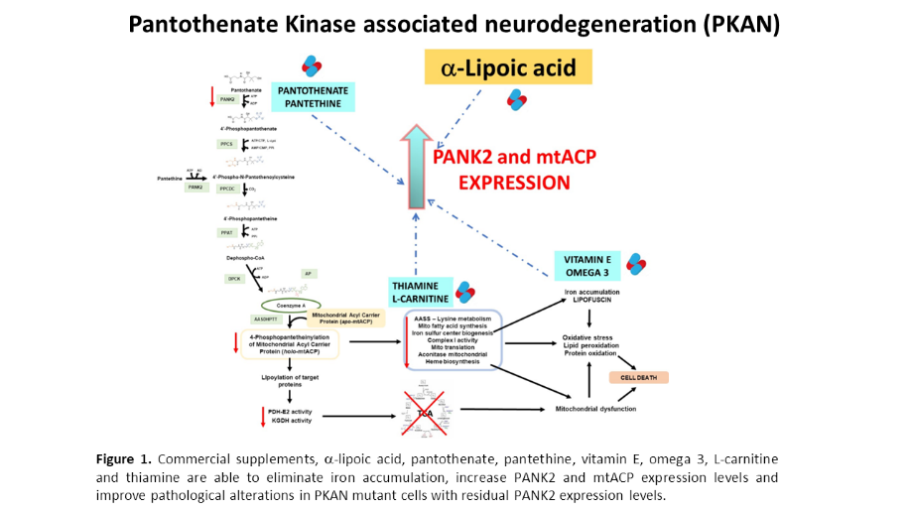
Recent Publications (minimum 5)
1. Vitamin E prevents lipid peroxidation and iron accumulation in PLA2G6-Associated Neurodegeneration. Irene Villalón-García et al. Neurobiology of Disease 2022 Apr;165:105649.

2. Therapeutic approach with commercial supplements for pantothenate kinase-associated neurodegeneration with residual PANK2 expression levels. Mónica Álvarez-Córdoba et al. Orphanet J Rare Dis.. 2022, Aug 9;17(1):311. doi: 10.1186/s13023-022-02465-9.

113. Vicious cycle of lipid peroxidation and iron accumulation in neurodegeneration. Irene Villalón-Garcíaet al.. Neural Regeneration Research 2023 Jun;18(6):1196-1202..

114. mtUPR Modulation as a Therapeutic Target for Primary and Secondary Mitochondrial Diseases. Cilleros-Holgado Pet al. Int J Mol Sci. 2023 Jan 12;24(2):1482. doi: 10.3390/ijms24021482.

116. Alpha-lipoic acid supplementation corrects pathological alterations in cellular models of pantothenate kinase-associated neurodegeneration with residual PANK2 expression levels. Talaverón-Rey Met al. Orphanet J Rare Dis. 2023 Apr 12;18(1):80.

Photograph

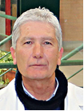Biography (150 word limit)
Jose Antonio Sanchez Alcazar is Full professor at Pablo de Olavide University (Seville, Spain). He is a Principal Investigator at Andalusian Center for Developmental Biology (CABD). His research group proposes that precision or personalized medicine approaches can be an alternative to find potential therapies in genetic rare diseases. To this end, patients’ own cells can be used to carry out personalized pharmacological screening for the identification of potential treatments. His group has developed three platforms for performing precision or personalized medicine in rare diseases: Braincure for neurodegenerative diseases; Mitocure platform for mitochondrial diseases; and Myocure for congenital myopathies
.Email: jasanalc@upo.es

Notes/Comments:

