REHABILITATIVE MANAGEMENT OF MOBILITY IMPAIRMENTS IN PATIENTS WITH PARKINSON DISAESE IN NIGERIA: INCLUSION OF AN INNOVATIVE PHYSIOTHERAPEUTIC STRATEGY.

Matthew O.B. Olaogun
University of Medical Sciences, Ondo City, Ondo State, Nigeria.

Abstract

The prevalence of Parkinson's disease (PD) is increasing in sub-Saharan Africa. This is due to the upsurge in ageing population and chronic illnesses as majority of patients that report for care and rehabilitation are above 60 years of age. About 1-2% of individual above 60 years are affected by PD worldwide. And approximately 9.1 million Nigerians are above 60 years and are therefore at the risk of developing PD. Research reports on the clinical profile of patients with PD show that it is the same with other populations elsewhere but characterized by delayed report and presentation. Mobility and balance limitations are some of the most significant consequences of PD which always lead to functional impairments and frequent falls. Consequently, they are the most significant reason for physiotherapy attention which complements pharmacotherapy and neurosurgical attentions. This presentation outlines the general profile of the disease progress, the general medical management and the guidelines of physiotherapy intervention in slowing down the progress of the disease and facilitating the rehabilitation. In addition to mobility, balance and gait training, cueing exercises, treadmill training and hydrotherapy that are advocated in most textbooks and research reports, an innovation of employing virtual reality gaming has proven to be effective rehabilitation strategies allowing clinicians and patients to make an evidence based decision in clinical and home programme management of the disease in Nigeria. [224 words]

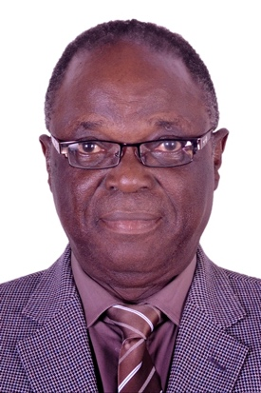 MATTHEW Olatokunbo Bamidele. OLAOGUN is
A physiotherapist of over 35 years of academic and clinical experience in neuro- and orthopaedic rehabilitation. He specialized in clinical research in Pathokinesiology, Non-Pharmacologic Pain Management and Neurologic physiotherapy and Neurorehabilitation.

Lead researcher in a number of studies and co-investigator in many research projects in the areas mentioned above and in grant aided projects.

