Myxozoan parasitic infestation of aquaculture fishes in Punjab (India)
Anu Katoch Ph.D, Punjabi University Patiala, Punjab (India)

Abstract

In Punjab, there is lot of development in aquaculture and increasing interest in fish farming, representing it as the fastest growing animal husbandry. As natural stocks have declined due to over exploitation/pollution, the aquaculture has become increasingly important as the source of fishery products. Fishes in these farmlands are prone to several diseases like trichodiniosis, haemorrhagic septicemia and various parasitic infectious diseases. Myxozoanosis is the emerging disease caused by microscopic metazoan parasites are economically important group of parasites infecting fish harvested for food. Myxozoans are widely dispersed in native and pond-reared fish populations. Since, new aquaculture practices such as intensive and polyculture systems have resulted in increased disease outbreaks therefore, research in this direction is urgently needed. The present study was conducted to record diversity, prevalence and effects of pathogenicity caused by myxozoan parasitic infections in cultured fishes in Punjab. For this native carps such as Labeo rohita, Catla catla, Cirrhinus mrigala, exotic carps such as Cyprinus carpio, Hypophthalmichthys molitrix, Ctenopharyngodon idellus and catfish Sperata seenghala were collected and examined for the presence of myxozoan parasites. In total 30 species belonging to four genera Myxobolus (19), Thelohanellus (7) and Henneguya (3) and Triangula (1) have been identified. Description of morphological and morphometric variations of myxospores, host specificity, locality, site of infection, size of the plasmodium, type of plasmodium and pathogenicity have been provided. Histopathological studies reveal the type of plasmodia, exact location of the plasmodia for each species studied and identified infecting gills, fins, scales, liver and gall bladder of cultured fishes. Intensity of infection and mixed infection was also recorded. Native fishes were more infected with prevalence of 44.2% as compared to exotic fishes 27.4%. Female fishes were more infected with prevalence of 38.25% as compared to males 26.21%. Temperature influenced the prevalence of myxozoan as with the increase in temperature, prevalence of infection also increased.

Image

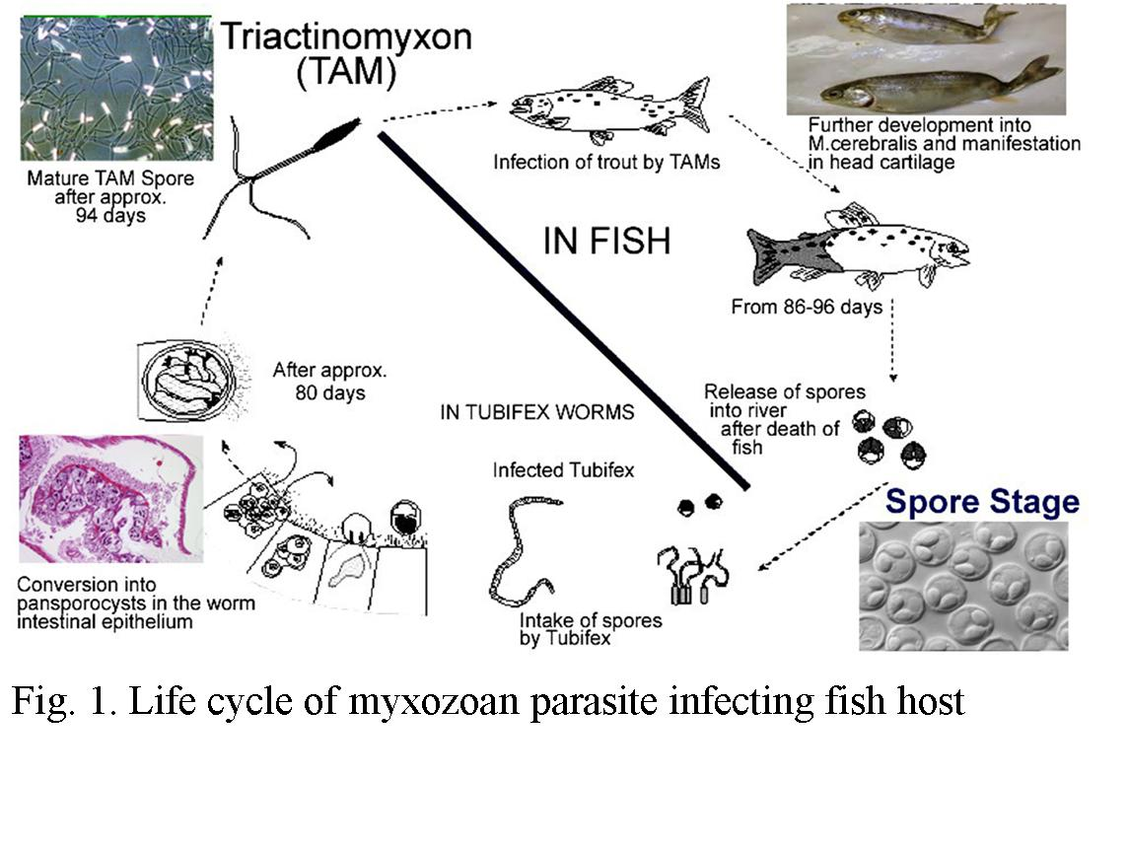

Recent Publications
- Katoch A, Kaur H (2016) Histological location of myxosporean plasmodia in fish tissue with Luna’s method. Parasitology Research, 115(10):3705-3707).
- Kaur H, Katoch A (2016) Prevalence, site and tissue preference of myxozoan parasites infecting gills of cultured fish in Punjab (India). Diseases of Aquatic Organisms, 118: 129-137.
- Kaur H, Katoch A (2014) Gill disease caused by Thelohanellus bifurcata Basu and Haldar, 1999 a pathogenic myxozoan parasite in cultured Indian carp, Labeo rohita (Hamilton, 1822) in Punjab, India. Journal of Animal Health and Production, 2 (2): 19-24.
- Kaur H, Katoch A, Gupta, M. (2014) Thelohanellus filli sp. n., a pathogenic myxosporean infecting gills of cultured carp, Labeo rohita (Hamilton 1822) in Punjab, India. Species, 10(23): 31-38.
- Kaur, H, Dar S A, Katoch A (2014) Thelohanellus dykovi sp. nov. (Myxozoa: Bivalvulidae), a pathogenic gill parasite in cultured Indian major carp, Labeo rohita (Hamilton 1822) in Punjab (India). Species, 10(23): 24-30.

Biography (150 word limit)
Anu Katoch has completed her Ph.D at the age of 33 years from Punjabi University, Patiala (Punjab, India). She is working as Assistant Professor in Mata Gujri College Fatehgarh Sahib, affiliated to Punjabi University, Patiala (Punjab) India. She has published 9 papers in reputed journals and represented her work in many National and International conferences. She has expertise in the field of taxonomy of parasites, diversity, histopathology and pathogenicity.
Email: anuraajput@gmail.com

