Primary hydatid cyst of kidney: A rare case report

Shakti Jain¹, A. J. Chitkara², Vijay Laxmi Sharma³, Bhawna S. Narula⁴

¹Senior Consultant Microbiology and Infection Control Officer (Max Super Speciality Hospital, Shalimar Bagh, Delhi, India)
²Head. Dept. of Pediatrics (Max Super Speciality Hospital, Shalimar Bagh, Delhi, India)
³Senior Consultant Pathology (Max Super Speciality Hospital, Shalimar Bagh, Delhi, India)
⁴Senior Consultant Histopathology (Max Super Speciality Hospital, Shalimar Bagh, Delhi, India)

Abstract

Introduction: Primary hydatid cyst of kidney is extremely rare (1-5%) as compared to liver and lung. Most of the patients with renal hydatid cyst present with atypical clinical manifestations. Diagnosis of primary renal hydatid cyst, in the absence of hydatiduria, is usually radiological. Immunological tests are mostly negative in renal echinococcosis. Treatment is surgery as systemic scolicidal agents are not very effective.
Case: Here we are presenting a rare case of primary hydatid cyst of right kidney. A well conscious, nontoxic, afebrile 6 years old female child presented with complaints of swelling over right side of upper abdomen last for 1 month, abdominal pain last for 6-7 days and fever last for 2 days. Abdominal examination revealed round 9.8×9.8×11.4 cm in size, mild tender, right hypochondrium lump. Rest of the systemic examination was normal. Routine blood investigations were normal with increased eosinophil count. Renal and liver function tests were normal. Hydatid serology for anti echinococcus, IgG was strongly positive. X-ray chest PA view was normal. USG and CECT scan abdomen revealed large exophytic right renal hydatid cyst; liver was normal. Symptomatic treatment was started. USG guided aspiration of cyst fluid was done under sedation by PAIR (percutaneous aspiration, injection and reaspiration) technique. Cystic cavity was instilled with 5% betadine solution followed by scolicidal hypertonic saline solution. Scoleces and hooklets of Echinococcus granulosus were found on lactophenol cotton blue mount and fluid cytology; suggestive of renal hydatid disease. Albendazole tablet was started. She responded well to the treatment and discharged in a stable condition.
Discussion: Primary renal hydatid cyst is extremely rare caused by larval stage of echinococcus tapeworm and usually remain asymptomatic for many years. Radiological investigations like USG, CT scan and MRI remain the mainstay of diagnosis. Surgery with pre and postoperative Albendazole is the treatment of choice.

Keywords— Hydatid cyst, Kidney, PAIR, Scoleces

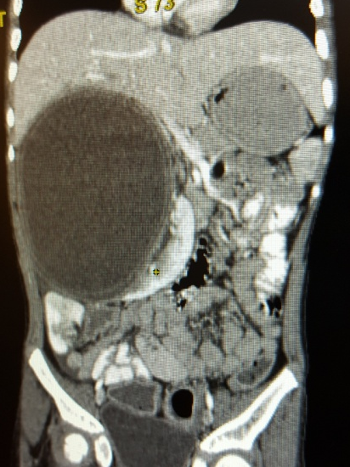 | Figure 1: CECT abdomen revealed a 9.8×9.8×11.4 cm large cystic lesion from anterior aspect of right kidney.
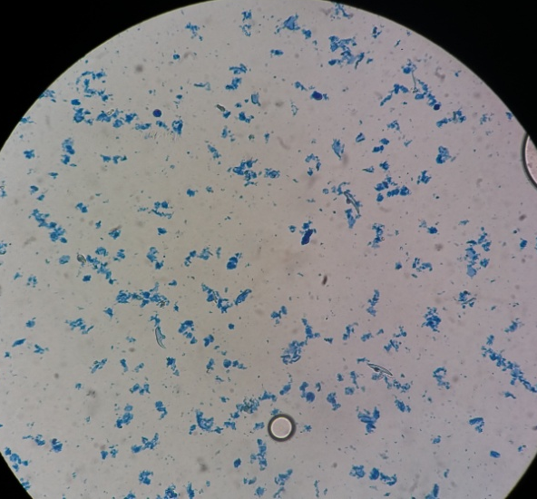 | Figure 2: Lactophenol cotton blue wet mount showing hooklets of Echinococcus spp.
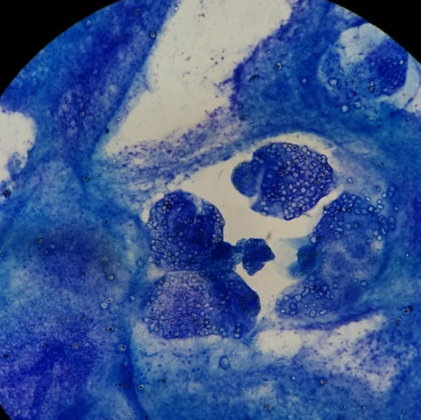 | Figure 3: MGG stain showing Scoleces and hooklets of Echinococcus spp.

Professional Biography

Dr. Shakti Jain has completed his MD (Microbiology) at the age of 31 years from Sanjay Gandhi Post Graduate Institute of Medical Sciences, Lucknow, (U.P.), India. Dr. Shakti has 10 years of experience in the field of Clinical Microbiology. He is currently working as Senior Consultant Microbiology and Infection Control Officer at Max hospital, Delhi, India. Max hospital is a 300 bedded super specialty hospital. He has published more than 14 papers in reputed journals and has been awarded with AGD Prize for excellent researches by 5th DITAN International conference on Infectious Diseases, Beijing, China; International young scientist travel grant award from DST, New Delhi, India; Young scientist travel grant award from 4th Ditan International Conference on Infectious Diseases (DICID), china; International young scientist travel grant award from DBT, New Delhi, India. He has been attended and presented papers in several national and international conferences.


Email Id: shaktijain@rediffmail.com

