Microscopic and molecular detection of Theileria annulata infection of cattle in Egypt
Khaled Mohamed El-Dakhly¹, Waleed Arafa¹, Saad Soliman Ghanem²,
Omima Ramadan Abdel-Fatah³, Ahmed Anwar Wahba⁴
¹Department of Parasitology, Faculty of Veterinary Medicine, Beni-Suef University,
Beni-Suef 62511, Egypt
²Directorate of Veterinary Medicine, Veterinary Administration, El-Dakhla, El-Wadi
El-Gadid, Egypt
³Animal Health Research Institute, El-Fayoum, Egypt
⁴Animal Health Research Institute, Dokki, Giza

Abstract

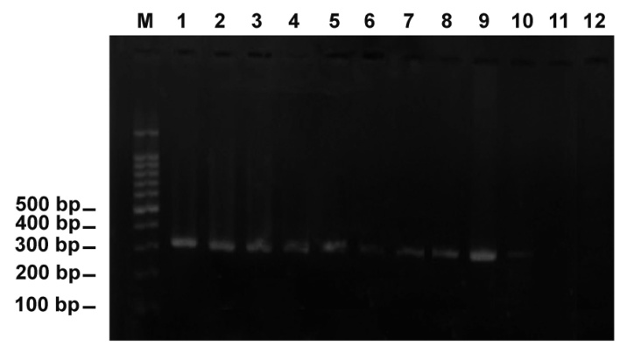
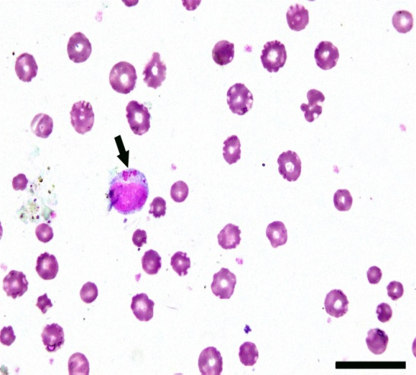
Bovine theileriosis is a global tick-borne disease and it has emerged as one of the major constraints affecting livestock production in Egypt. The disease is caused by the hemoparasite, Theileria annulata, which is transmitted by the tick vector, Hyalomma species. A total of 376 Egyptian female Balady-Friesian cross cattle were randomly selected in El-Wadi El-Gadid province, Egypt and were examined using direct microscopy of Giemsa-stained blood smears and PCR-dependant molecular identification using a Theileria annulata-specific primer, Cytob1, targeting the amplicon of 312 bp of the mitochondrial cytochrome b gene. It has been found that 102 (27.13%) animals had clinical symptoms of theileriosis, predominantly enlargement of superficial lymph nodes and a sustainable high fever (40-42°C), anorexia, loss of generalized conditions, lacrimation, corneal affections, ocuo-nasal discharge, dyspnea and diarrhea. Light microscopy of Giemsa-stained blood smears revealed that 35 (9.31%) of examined animals showed the presence of intra-lymphocytic and/or intra-erythrocytic stages of Theileria organisms. Various Theileria stages; macroschizonts, microschizonts and merozoites were demonstrated in blood smears. Application of PCR elucidated that 11.44% (43/376) animals had theileriosis indicated by the appearance of specific diagnostic bands. Most of clinically-positive animals and all those positive by the use of direct microscopy and PCR are associated with the existence of ticks vector. In conclusion, The present work revealed the prevalence of bovine theileriosis in El-Wadi El-Gadid, Egypt using direct microscopy of Giemsa-stained blood smears (9.31%) and PCR (11.44%). To reduce economic losses induced in cattle due to theileriosis, a considerable attention and veterinary care are mandatory to be done by authorities and veterinarians through elimination of the tick vectors and frequent treatment of infected animals.

Keywords Cattle, Theileria annulata, PCR, Egypt.

Professional Biography

Khaled Mohamed El-Dakhly has completed his PhD at the age of 33 years from Beni-Suef University, Beni-Suef 62511, Egypt and act as a foreign researcher in Gifu University, Japan during the period from April 2010 to September 2013. Currently, he is a Professor and Chairman of Parasitology, Faculty of Veterinary Medicine, Beni-Suef University. He has published more than 42 articles in reputed journals and has been serving as an editorial board member and/or reviewer of several journals. He attended a lot of international conferences and exhibitions. He has a great experience in presentations of several lectures about scientific writing and publication.


Email ID:
eldakley_s71@yahoo.com
eldakley_s71@bsu.vet.edu.eg

Any Comments:
This abstract is now included in a research article under consideration of publication in a certain journal.
Thank you

