Liver enzymes, fatty liver and type 2 diabetes mellitus in Jinchang Cohort
Ning Cheng^{1*}, Jianping Zhang^{1,2}, Desheng Zheng³, Tongzhang Zheng⁴, Haiyan Li³, Zhiyuan Cheng⁵,Jiao Ding³, Simin Liu⁴,Yanxu Yang², Caili He^{1,2}, Yubao Ma^{1,2} ,Xiaoyu Ren^{1,2}, Dian Shi¹, Xiping Shen², Juansheng Li², Hongquan Pu³ , Yawei Zhang⁵ and Yana Bai^{2*}
1.Key Laboratory of Preclinical Study for New Drugs of Gansu Province, Basic Medical College, Lanzhou University, Lanzhou, Gansu, P.R. China;
2.Institute of Epidemiology and Statistics, School of Public Health, Lanzhou University, Lanzhou, Gansu, P.R. China;
3.Workers’ Hospital of Jinchuan Group Co., Ltd., Jinchang, Gansu, China;
4.Department of Epidemiology, School of Public Health, Brown University, Providence, RI, USA;
5.School of Medicine, Yale Cancer Center, Department of Surgery, Yale University, New haven, Connecticut, USA

Correspondence: Prof. Ning CHENG, Key Laboratory of Preclinical Study for New Drugs of Gansu Province, Basic Medical College, Lanzhou University, Lanzhou, Gansu, 730000, P.R. China, Tel/Fax: 0086-0931-8915206, Email: chengn@lzu.edu.cn; or Prof. Yana Bai, Lanzhou University School of Public Health, Lanzhou, 730000 China. Telephone: +86 (931) 8915-526. Fax: +86 (931) 8915-526. E-mail: baiyana@lzu.edu.cn.

Abstract (300 word limit)

Background High levels of serum liver enzymes and fatty liver have been associated with increased risk of type 2 diabetes mellitus (T2DM) in some studies. It is unclear whether liver enzymes is the predictors of T2DM, which is independent for fatty liver.

Methods A total of 48,001 subjects aged 19 to 90 participated in a baseline examination from 2011 to 2013 in Jinchang cohort. Among the subjects, 33,355 underwent follow-up examination from 2014 to 2015, for average follow-up period of 2.2 years. Cox proportional hazard models were used to examine the adjusted associations of ALT, AST and GGT with T2DM.

Results The cumulative incidence of T2DM were 8.05% to 9.02% for fatty liver (FL) and 2.25% to 4.10% for non-fatty liver (NFL), both giving a statistically significant difference. Compared with the normal liver enzyme level in FL group, the adjusted incident hazard ratios of T2DM were ALT 1.23 (95% CI: 1.10–1.50) , AST 1.30 (95% CI:1.07–1.59) and GGT 1.34 (95% CI: 1.08–1.65) in FL group. In addition, the adjusted hazard ratio of T2DM in the abnormal GGT rise of NFL group was significantly higher than that of the GGT normal of NFL group (HR=1.53, 95%CI: 1.19–1.98) by adjusting confounding factors and compared with normal ALT and AST in NFL group, the adjusted hazard ratios of T2DM were 1.27 (95% CI: 1.02–1.59) and1.33(95% CI: 1.02–1.59) respectively. There are significant interaction of T2DM hazard ratios between GGT and AST, GGT and AST (Pinteraction<0.05) in addition to ALT and AST.

Conclusions The incidence of diabetes in the fatty liver group is significantly higher than that in the normal population and the serum AST,GGT and ALT levels rise are independent risk factors for fatty liver in the development of T2DM.

Key Word: Liver enzymes, Fatty liver,T2DM,Association,Cohort.

Recent Publications
1.Yana Bai*, Aimin Yang, Huangquan Pu,Min Dai, Ning Cheng,Jiao Ding, Juansheng Li, Haiyan Li, Xiaobin Hu, Xiaowei Ren,Jie He, Tongzhang Zheng. Cohort Profile: The China Metal-Exposed Workers Cohort Study (Jinchang Cohort). International Journal of Epidemiology, 2017;46(4):1095-1103.

Image

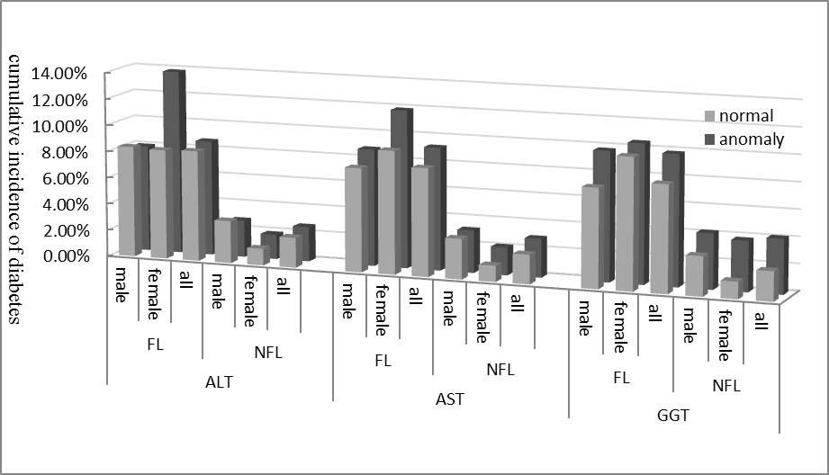

Figure 1 the cumulative incidence of T2DM in fatty liver and normal population according to the normal and abnormal levels of each liver enzyme.
2.Aimin Yang, Simin Liu, Zhiyuan Cheng , Hongquan Pu , Ning Cheng , Jiao Ding,Juansheng Li , Haiyan Li , Xiaobin Hu , Xiaowei Ren , Kehu Yang ,Tongzhang Zheng,Yana Bai*. Dose-response analysis of environmental exposure to multiple metals and their joint effects with fasting plasma glucose among occupational workers. Chemosphere 186 (2017) 314-321.
3.Aimin Yang, Simin Liu, Ning Cheng , Hongquan Pu , Min Dai , Jiao Ding, Juansheng Li , Haiyan Li, Xiaobin Hu , Xiaowei Ren ,Jie He, Tongzhang Zheng, Yana Bai*. Multiple metals exposure, elevated blood glucose and dysglycemia among Chinese occupational workers. Journal of Diabetes and Its Complications. 2017;31(1):101-107.
4.YANG Ai Min, CHENG Zhi Yuan, PU Hong Quan,CHENG Ning, LI Hai Yan,LIU Si Min,DING Jiao, LI Juan Sheng, HU Xiao Bin,REN Xiao Wei,ZHENG Tong Zhang,and Yana Bai*. Heavy Metal Assessment among Chinese Nonferrous Metal-exposed Workers from the Jinchang Cohort Study. Biomed Environ Sci, 2017; 30(7): 530-534.
5.Yang Ai Min,Cheng Ning,Pu Hong Quan,Liu Si Min, Li Juan Sheng, Bassig Bryan A, Dai Min,Li Hai Yan,Hu Xiao Bin,Ren Xiao Wei, Zheng Tong Zhang, Bai Ya Na*.Metal Exposure and Risk of Diabetes and Prediabetes among Chinese Occupational Workers. Biomed Environ Sci,2015, 28(12): 875-883.

Photograph

 Biography
Bai yana has established the Jinchang cohort in China, as the largest multi-metal exposure cohort in the world, who is mainly engaged in the research of prevention and treatment strategies and measures for diabetes and cancer. The risk factors, etiology, pathogenesis, early diagnosis and evaluation of intervention effect of diabetes and tumor were carried out through Jinchang cohort..
Email: chengn@lzu.edu.cn

