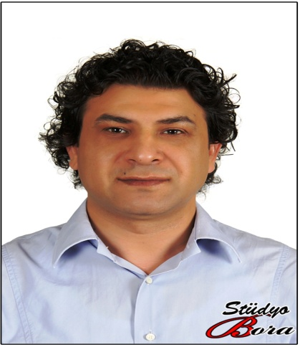
Title: Prevelance of occult HBV in chronic hepatitis C and cryptogenic hepatitis patients
Name: Cakal B.
Affiliation: Department of Microbiology, Istanbul Faculty of Medicine, Istanbul University, Istanbul, Turkey.
Occult Hepatitis B Virus (HBV) infection (OBI) is considered as the possible a phase of the HBV natural history but it remains unclear the molecular mechanisms and clinical impact and epidemiology aspect of OBİ (1,2,3). We investigated the prevalence of OBI and its clinical impact among patients with Hepatitis C virus (HCV) infection and with cryptogenic hepatitis. This study protocol was approved by the ethics committee of İstanbul University İstanbul School of Medicine (No: 2015/1519). This prospective cohort study included a total of 60 HBsAg-negative patients (27 patients with chronic HCV and 33 patients with cryptogenic hepatitis) were enrolled in department of gastroenterology, Istanbul Faculty of Medicine. Liver tissue samples had been obtained by percutaneous needle liver biopsy and immediately frozen and stored at -80°C. Total nucleic acids were extracted from frozen liver biopsies using QIAamp DNA Mini Kit (Qiagen) according to the manufacturer’s instructions. OBI was defined as HBV DNA positivity in 2 or more different viral genomic regions by nested polymerase chain reaction PCR using 4 sets of primers in preS-S (S), precore-core (C), Pol, and X viral regions of the HBV genome. Plasmid HBV DNA 4.1 kb and liver biopsy samples obtained from patients with chronic HBV infection (positive control) were used. Statistical analyses were evaluated using Mann–Whitney, Chi-square test and Kruskal Wallis tests. The baseline characteristics of patients are presented in Table 1. The prevalence of OBI was %25.9 (7/26) with %27.3 (9/33), %26.7 (16/60) in patients anti-HCV (+),cryptogenic hepatitis, and totaly respectively (Table 2). There wasn’t significant differences for prevelance of OBİ between patients with Chronic HCV infection and cryptogenic hepatitis (P=0.907). Patients with anti-HCV (+), OBİ (+) were older compared with patients anti-HCV (+), OBİ (-), (P: 0.033). As it is expected that cryptogenic hepatitis patients had higher serum alkaline phosphatase and gamma-glutamyltransferase level (P<0.05). Clinical signifance and role of OBI in patients with chronic HCV infection is controversial (4,5,6). According first results of the study to prevelance of OBİ is correlated with endemicity of Hepatitis B infection moreover OBİ can be associated with liver injury rather than chronic HCV infection. Therefore, it appears that host factors rather than viral factors are more responsible for OBI.
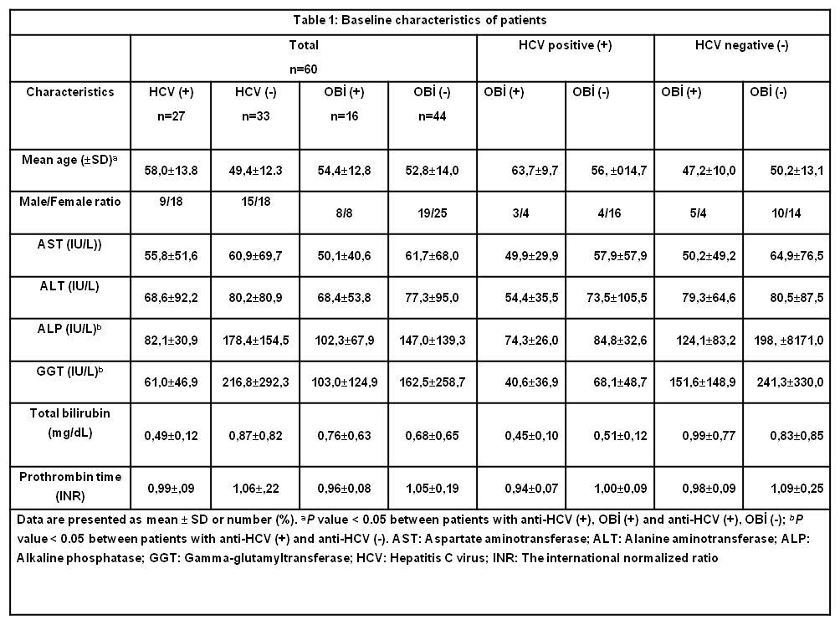

Table 2: Prevalence of Occult HBV in anti-HCV (+) and anti-HCV (-) Patients With Cryptogenic Hepatitis
 | Anti-HCV positive patients n=27 | Anti-HCV negative (Cryptogenic Hepatitis)  patients n=33 | Total  n=60 | P  value
Occult HBV  positive | 7 (%25.9) | 9 (%27.3) | 16 (%26.7) | 0.907
- EASL 2017 Clinical Practice Guidelines on the management of hepatitis B virus infection. J Hepatol 2017; 67: 370-98.
- Raimondo G, Allain JP, Brunetto MR, Buendia MA, Chen DS, Colombo M, et al. Statements from the Taormina expert meeting on occult hepatitis B virus infection. J Hepatol 2008; 49: 652-657.
- Torbenson M, Thomas DL. Occult hepatitis B. Lancet Infect Dis. 2002; 2: 479-86.
- Pollicino T, Saitta C. Occult hepatitis B virus and hepatocellular carcinoma. World J Gastroenterol 2014; 20(20): 5951-5961.
- Lok AS, Everhart JE, Di Bisceglie AM, Kim HY, Hussain M,Morgan TR. Occult and previous hepatitis B virus infection are not associated with hepatocellular carcinoma in United States patients with chronic hepatitis C. Hepatology 2011; 54: 434-442.
- Cho J, Soo L. S, Suk C. Y, Jeon Y, Wha C. J, Baeg. J ,. et al. Occult hepatitis B virus infection is not associated with disease progression of chronic hepatitis C virus infection. World J Gastroenterol 2016 14; 22: 9427-9436.
Biography
Bülent Çakal completed his PhD from istanbul University, Turkey. He worked Post-doctoral Research Fellow about molecular virology of Hepatitis B Virus (HBV) at Department of Microbiology and Immunology College of Medicine University of Illinois at Chicago / U.S.A. He has three publication over 20 times, and his publication H-index is 6.98 and he has worked depermant of medical microbiology and he has two research project about HBV.
Presenting author details
Full name: Bülent ÇAKAL
Contact number: +90 532 7266454
Twitter account: bulentcakal1
Linked In account: bülent çakalSession name/ number:
Category: (Oral presentation)
Email ID: bulentcakal@yahoo.com

