Spontaneous osteogenesis of dehiscent frontal sinus wall after endoscopic removal of mucocele
Dr. Tan Dexian Arthur, MBBCS MRCS, Changi General Hospital, Singapore
Dr. James Wei Ming Kwek, MBBS, MRCS, MMed, Changi General Hospital, Singapore
Dr. Ian Loh, MBBS, MRCS, MMed, FAMS, Changi General Hospital, Singapore
Dr. Tee Sin Lee, MBBS, MRCS, MMed, FAMS, Changi General Hospital, Singapore

Abstract (300 word limit)
Statement of the Problem: Mucoceles most commonly affect the frontal sinus, which results from chronic obstruction of the sinus ostium or cystic dilatation of mucous glands with ductal obstruction. They are known to cause bony erosion of the sinus walls, which can lead to large defects. These defects were typically managed by obliteration or cranialization of the frontal sinus. Although short term outcomes of conservative management of significant posterior table defects from fractures are promising, there have been no studies on the long-term outcomes of large dehiscences in the posterior wall of the frontal sinus. Methodology & Findings : Computed Tomography (CT) Paranasal Sinuses images were analyzed and found complete spontaneous osteogenesis of a large dehiscent frontal sinus posterior wall, secondary to a large mucocele, 9 years from functional endoscopic sinus surgery with the defect managed conservatively. Conclusion & Significance: The dura is well known for its osteogenic properties. Prior studies have showed that dura could induce osteogenesis in cutaneous tissue in the absence of other central nervous system structures. It was also demonstrated that osteogenesis and chondrogenesis were possible in zygomatic fractures by transplanting neonatal dura grafts to the bony defects in rats. Extrapolating from these studies, the authors postulate that the presence of dura beneath the bony deformity of the posterior frontal sinus wall had likely initiated the osteogenesis and restored the bony defect in the patient. In our literature review, we did not find any reports of spontaneous osteogenesis of large frontal sinus defects. While our experience is incidental, it reinforces the osteogenetic potential of an intact dura and further highlights that selected large defects of the posterior wall of the frontal sinus can be conservatively managed.

Image
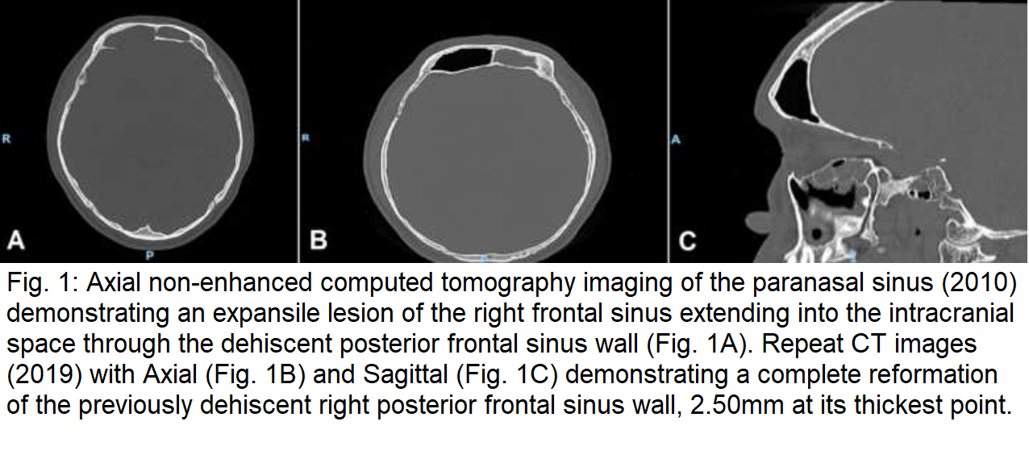
Recent Publications
- Dexian Tan A, Ng JH, Lim SA, Low DYM, Yuen HW. Classification of temporal bone pneumatization on high‐resolution computed tomography: Prevalence patterns and implications. Otolaryngology–Head and Neck Surgery. 2018;159(4):743-749. doi:10.1177/0194599818778268
- See A, Loh RH, Tan DA, et al. The long-term results of modified maxillomandibular advancement in Asian osa patients. American Journal of Otolaryngology. 2023;44(1):103677. doi:10.1016/j.amjoto.2022.103677
- Tan AD, Kwek JW, Loh I, Lee TS. Spontaneous osteogenesis of dehiscent frontal sinus wall after endoscopic removal of Mucocele. Journal of Craniofacial Surgery. 2021;33(1). doi:10.1097/scs.0000000000007823
- Tan AD, Ng JH, Low DY-M, Yuen HW. Post-operative healing and long-term stability after mastoid cavity reconstruction using the middle temporal artery and inferior musculoperiosteal flaps. European Archives of Oto-Rhino-Laryngology. 2021;279(2):639-644. doi:10.1007/s00405-021-06681-0

Photograph

Biography
Dr Tan Dexian Arthur is a practicing doctor in Singapore, under Ministry of Health Holding. He has experience in Otorhinolaryngology since 2019 and has practiced as a junior doctor in various government hospitals in Singapore including Singapore General Hospital, Changi General Hospital, Sengkang General Hospital and KK Women's and Children's Hospital. Dr. Tan has also served in the Singapore Armed Forces both as a Military Doctor and as an Otorhinolaryngology medical officer. Dr. Tan currently holds 4 publications.

Email: arthurtan1994@gmail.com

Notes/Comments:

