A review of nasal polyposis
Dr .Eyad .SH. Zein Aldean MD , MSc, UEMS-ORL

Abstract :
Nasal polyps (NP) are one of the most common inflammatory lesions of the nose, affecting up to 4% of the population. Their etiology remains unclear, but they are known to have associations with allergy, asthma, infection, cystic fibrosis, and aspirin sensitivity. However, the underlying mechanisms interlinking these pathologic conditions to NP formation remain unclear. Also strong genetic factors are implicated in the pathogenesis of NP, but genetic and molecular alterations required for its development and progression are still unclear. They present with nasal obstruction, anosmia, rhinorrhoea, post nasal drip, and less commonly facial pain.
Management of polyposis involves a combination of medical therapy and surgery. There is good evidence for the use of corticosteroids (systemic and topical) both as primary treatment and as postoperative prophylaxis against recurrence. Surgical treatment has been refined significantly over the past twenty years with the advent of endoscopic sinus surgery and, in general, is reserved for cases refractory to medical treatment. Recurrence of the polyposis is common with severe disease recurring in up to ten percent of patients.
In this talk I will present the newer treatment options available for better control and possibly cure of the disease.
Keywords: nasal polyps, disease management, surgical procedures

Image
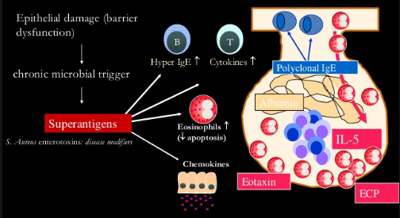

Photograph

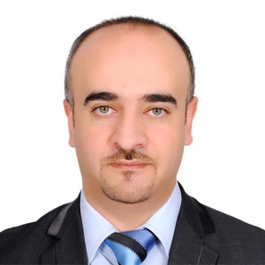Biography
Dr Eyad Zein Aldean is working as ENT specialist since 2009 ,he got his postgraduate European board membership in 2013
Currently working in UAE , highly interested in international conferences and recent updated practical guidelines.
Email: dreyadenthns@Gmail.com

Notes/Comments:

