PAEDITRIC AERODIGESTIVE FOREIGN BODIES: 10 YEAR RETROSPECTIVE STUDY IN A TERTIARY CARE HOSPITAL

INTRODUCTION: Foreign bodies in the aerodigestive tract in children pose serious challenge to an otolaryngologist. Clinical assessment, proper instruments ,early intervention , surgical skill are the key words for success.
METHODS: A retrospective study was done in the otolaryngology department, North Bengal Medical college, Darjeeling , between 1st October 2008 to 30th September 2018.
Inclusion criteria : All children below 12 years of age , with history of suspected foreign body ingestion or inhalation. Foreign bodies of posterior nares, hypopharynx oesophagus, tracheobronchial tree were included.
Exclusion critera were foreign bodies of Tonsil, oropharynx and anterior nasal space.
Results of 160 patients were analysed with reference to age, sex ,investigation ,atypical presentation, retrieval and complications.
RESULTS :In the present study Mean age was 3.8 yrs, Male : Female ratio was 5:3. Common sites of Foreign body impaction were Oesophagus 112 (70%), Tracheobronchial tree 20(12.5%) . In digestive tract COIN was the commonest foreign body 96 (78.6%). Pea nut was the commonest in tracheobronchial tree 6(30%). Virtual Bronchoscopy CT scan was helpful in 4 case of Bronchoscopy. Oesophagoscopy was done in 108(67.5%) cases. Rigid Bronchoscopy was done in 19(11.8%).
Atypical presentations included one 11 month old child with two pieces of chicken bone one in the GLOTTIS ,another in the OESOPHAGUS, was treated successfully. A case of broken tracheostomy tube in the right bronchus was removed by bronchoscopy. A metal piece in the subglottis of a 2 yr old child with stridor, was removed by bronchoscopy.Chicken bone in the glottis of a two year old child was successfully removed.
Successful retrieval was done in150 (93.7%) cases. COMPLICATIONS included TRACHEAL INJURY 1(0.62%), OESOPHAGEAL RUPTURE 1(0.62%) DEATH 2(1.25%)cases.
Conclusion:Rigid endoscopy remains the treatment of choice in children with aerodigestive foreign bodies.

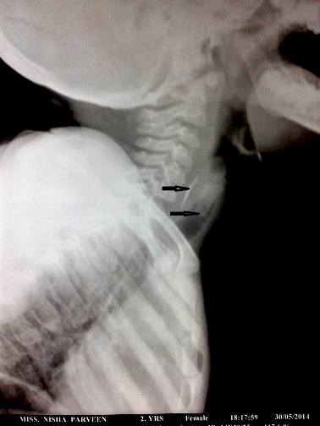
DOUBLE CHICKEN BONE in an 11 month old child
(One in oesophagus, other in subglottis)

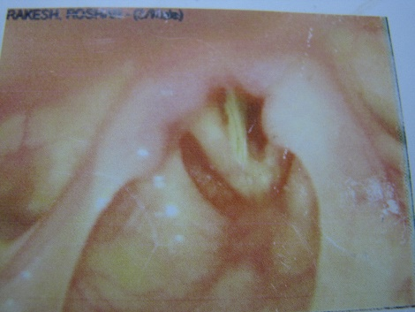
CHICKEN BONE IN THE GLOTTIS
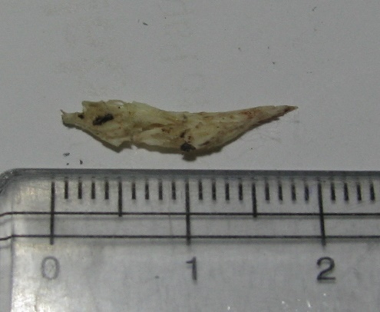
The removed chicken bone
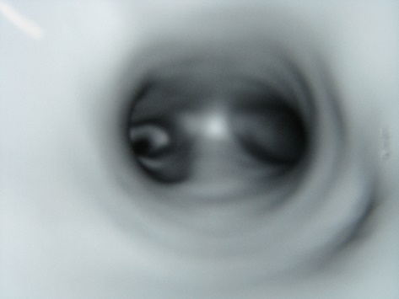 Virtual Bronchoscopy CT: Showing F.B. in the LEFT
MAIN BRONCHUS

REFERENCES:
1) RICHA GUPTA et al(2014) : “ INCIDENCE OF FOREIGN BODIES IN AERODIGESTIVE TRACT IN VINDHYA REGION” .
Indian journal of otolaryngology head and neck surgery 2014 Jun : 66(2):132-141
2) OZGUNER IF et al (2004), : “ CLINICAL EXPERIENCE OF REMOVING AERODIGESTIVE TRACT FOREIGN BODIES WITH RIGID ENDOSCOPY”
Pediatric emergency care 2004 OCT: 20(10):671-3
3)K AMATH P et al (2006) : FOREIGN BODIES IN THE AETRODIGESTIVE TRACT- A CLINICAL STUDY OF CASES IN THE COASTAL BELT OF SOUTH INDIA.
American journal of otolaryngology 2006, NOV-DEC:27(6):373-7
4) INES HARIGA et al(2014):” MANAGEMENT OF FOREIGN BODIES IN THE AERODIGESTIVE TRACT.”
Indian journal of otolaryngology head and neck surgery 2014, Jan 66(suppl1):220-224
5)SELVAM DK et al(2018) “A CLINICAL STUDY ON PAEDIATRIC AERODIGESTIVE FOREIGN BODY IN EMERGENCY DEPARTMENT”
International journal of otorhinolaryngology head and neck surgery 2018 May;4(3)682-685

BIO GRAPHY

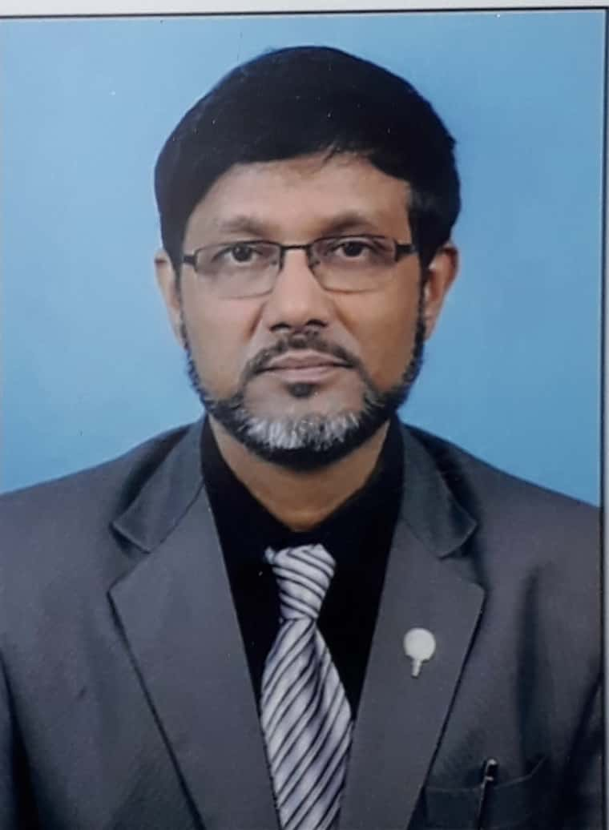
NAME: DR. SEKHAR BANDYOPADHYAY
DATE OF BIRTH: 30th DECEMBER, 1963
QUALIFICATIONS: M.B.B.S ;CALCUTTA UNIVERSITY– (1985),
D.L.O ; CALCUTTA UNIVERSITY –(1989)
M.S. (OTOLARYNGOLOGY) ; PATNA UNIVERSITY (1992)
PRESENT ATTACHMENT: SPECIALIST MEDICAL OFFICER, DEPTT.OF OTOLARYNGOLOGY, N.B.MEDICAL COLLEGE,& HOSPITAL, SUSHRUTNAGHAR , DARJEELING, 734010, INDIA
PROFESSIONAL CARREER: CONSULTANT OTOLARYNGO,LOGIST.
INTERESTED IN: OTOLOGY, THYROID SURGERY, BRONCHOSCOPY &
OESOPHAGOSCOPY.
PUBLICATIONS:
- “PARTIAL ANODONTIA IN A CASE OF WAARDENBURG’S SYNDROME”
Published in ‘THE JOURNAL OF LARYNGOLOGY AND OTOLOGY’
In July 1999, vol 113 pp 672-674.

- “PAROTID ABSCESS AN UNUSUSAL PRESENTATION WITH PALATAL
PALSY” Published in “INDIAN JOURNAL OF OTOLARYNGOLOGY”
In JULY 1993
- “ HAEMANGIOMA OF CHEEK DIFFERENT PRESENTATION AND MANAGEMENT” published as a co-author in “ INDIAN JOURNAL OF OTOLARYNGOLOGY & HEAD AND NECK SURGERY”, 2014 JUNE
66(2):162-166.

PAPER PRESENTATATIONS IN INTERNATIONAL CONFERENCES

- “ OBSERVATIONS IN ALLERGIC RHINITIS” In 2n SAARC ENT CONGRESS , KATHMANDU in May 2000
- “ PEDIATRIC AERODIGESTIVE FOREIGN BODIES: 10 YEAR RETOSPECTIVE STUDY IN A TERTIARY CARE HOSPITAL” In
14 th ASIA OCEANIA ENT CONGRESS , HYDERABAD 2019

PAPER PRESENTATIONS AT NATIONAL CONFERENCES OF
ASSOCIATION OF OTOLARYNGOLOGISTS OF INDIA:

- “ HEARING LOSS IN CHILDREN BETWEEN SIX TO TWELVE YEARS-ANALYSIS OF 200 CASES(1994)
- “ WAARDENBURG’S SYNDROME -REPORT OF TWO CASES IN AN INDIAN FAMILY”:(1998)
- “VARIANT OF PROTEUS SYNDROME” (2000)
- “ UNUSUAL FOREIGN BODIES IN THE NOSE -REPORT OF TWO CASES.” (2004)

