Outcomes of Drill Canalplasty in Exostoses and Osteoma: Analysis of 256 Cases and Literature Review

Golda Grinblat, Sampath Chandra Prasad, Gianluca Piras
Department of Otology & Skull Base Surgery, Gruppo Otologico, Piacenza, Rome, Italy;

In this retrospective study we describe the surgical technique of drill canaplasty for exostosis and osteoma and evaluate our results in 256 operated cases. As well, we propose a new grading system for external auditory canal stenosis (EACS).
Mean age was 51.5 (13.41) years. One hundred sixty nine cases were men and 48 women. Two hundred forty three (95%) cases were exostosis and 13 (5%) were osteomas. According to the proposed grading system, 81% ears had severe or complete stenosis. Seventy eight (30.5%) ears had a concurrent diagnosis of otosclerosis. Retroauricular approach was used in 245 (95.7%). Intraoperative complications included tympanic membrane (TM) perforation seen in four (2%) and mastoid cell exposure in two (1%). Postoperative stenosis/prolonged healing was seen in 11 (4%) patients and
required revision in seven cases. Audiologic analysis available for 153 ears-showed the mean change in air-bone gaps (ABG) of 2.18 dB, pure tone averages (PTA) bone conduction BC (0.5–4 kHz) of 0.3 dB. Mean healing rate was available for 246 (96.1%) patients and was found to be 6.35 (4–16) weeks.
A systematically performed drill canalplasty via retroauricular approach, as described in this article, yields excellent postoperative outcomes as seen in our series. Notably, one-third of exostoses patients in this series, also suffered from otosclerosis. The proposed grading system for EACS enables the surgeon to objectively stage the disease.
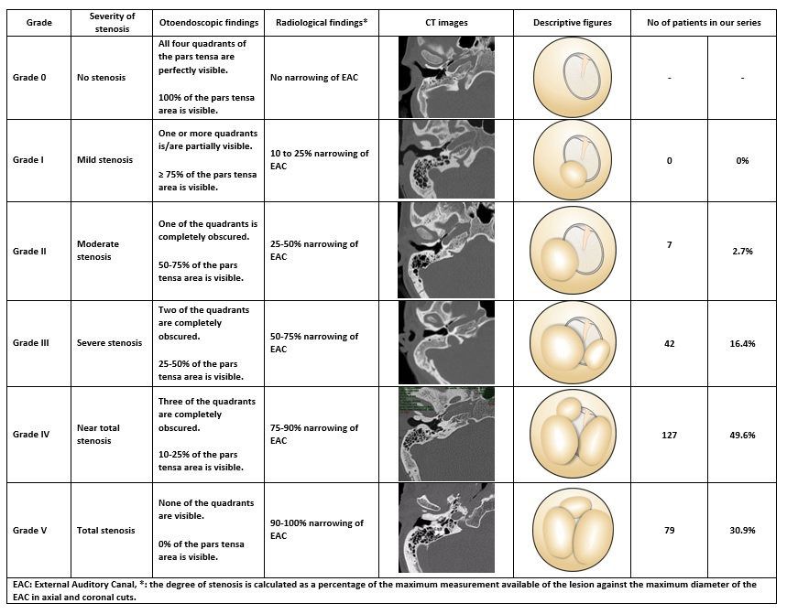
Recent Literature
- Ghavami Y, Bhatt J, Ziai K, Maducdoc MM, Djalilian HR. Transcanal micro-osteotome only technique for excision of exostoses. Otol Neurotol 2016;37:185–9.
- Barrett G, Ronan N, Cowan E, Flanagan P. To drill or to chisel? A long-term follow-up study of 92 exostectomy procedures in the UK. Laryngoscope 2015;125:453–6.
- Moss WJ, Lin HW, Cueva RA. Canalplasty for exostoses with maximal skin preservation with temporoparietal fascia grafting and use of bone wax for skin flap protection: a retrospective case series. Ann Otol Rhinol Laryngol 2015;124:978–86.
- Mudry A, Hetzler D. Birth and evolution of chiselling and drilling techniques for removing ear canal exostoses. Otol Neurotol 2016;37:109–14.
- Hempel JM, Forell S, Krause E, Mu¨ ller J, Braun T. Surgery for outer ear canal exostoses and osteomata: focusing on patient benefit and health-related quality of life. Otol Neurotol 2012;33:83–6.

