Temporal bone Meningo-encephalic-Herniation: Etiological Categorization and Surgical Strategy

Abstract

This retrospective study deals with the clinical presentation, intraoperative findings and surgical management of 262 operated cases of Meningo-encephalic-herniation (MEH) based on the etiology. The data were extracted regarding demographics, laterality, clinical presentation, past surgeries, contralateral-ear condition, intraoperative findings, complications, recurrences, revision-surgeries, audiometric-data and follow-up. Lesions were categorized according the etiology as chronic-otitis-media with/without cholesteatoma-MEH (COM/CHOL-MEH)-47.7%; iatrogenic-MEHs -20.9%; traumatic-MEHs -8% and spontaneous-MEHs-23.3%. At presentation, hearing loss (100% and 98.2%) and otorrhea (65.6% and 49.1%) were predominant in COM/CHOL-MEHs and iatrogenic-MEHs respectively. On the other hand, meningitis (23.9% and 14.3%) and cerebrospinal fluid-leak (52.4% and 42.8%) were more pronounced in spontaneous and traumatic MEHs, respectively.
Surgical approaches included- 1) Transmastoid, 2) Middle-cranial-fossa-approach (MCFA), 3)

Combined and 4) Middle-ear- obliteration(MEO) techniques. A total of 52.8% of
COM/CHOL-MEHs and 49.1% of iatrogenic-MEHs underwent MEO. MCFA was
predominantly used in spontaneous-MEHs (52.5%) and traumatic-MEHs (38.1%). The defect
was mostly single (75.2%). Smaller, multiple, bilateral lesions were more common in
spontaneous-MEHs with tegmen-tympani involvement (57.4%).
Incorporating etiology into MEHs is a key-step which can be used as a guidance
in choosing the right surgery. MEO is a part of armamentarium, and should be used whenever
needed, if the objective is performing a definitive surgery.
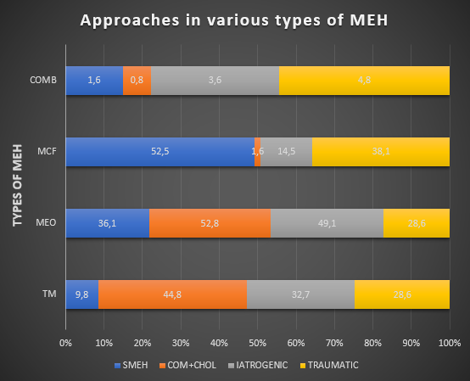

Figure 1: Surgical approaches followed in MEH

Recent Publications
- Semaan MT, Gilpin DA, Hsu DP, Wasman JK, Megerian CA. Transmastoid extradural-
intracranial approach for repair of transtemporal meningoencephalocele: a review of 31
consecutive cases. The Laryngoscope. 2011;121(8):1765-1772.
- Stucken EZ, Selesnick SH, Brown KD. The role of obesity in spontaneous temporal bone
encephaloceles and CSF leak. Otol Neurotol. 2012;33(8):1412-1417.
- Kari E, Mattox DE. Transtemporal management of temporal bone encephaloceles and CSF
leaks: review of 56 consecutive patients. Acta Otolaryngol. 2011;131(4):391-394.
- O'Connell BP, Hunter JB, Sweeney AD, et al. Outcomes of the Suture "Pull-Through" Technique

for Repair of Lateral Skull Base CSF Fistula and Encephaloceles. Otol Neurotol. 2017;38(3):416-422.
5. Jeevan DS, Ormond DR, Kim AH, et al. Cerebrospinal fluid leaks and encephaloceles of
temporal bone origin: nuances to diagnosis and management. World Neurosurg.2015;83(4):560-566.

