Surgical outcomes in facial nerve palsy of various aetiologies
Dr A A KHABEER,MS ENT,INDIA

Abstract (300 word limit)
Statement of the Problem: Facial nerve is the seventh cranial nerve innervating mainly muscles of face. It is involved by various etiological factors. Various components of facial nerve are
Of all the functions of facial nerve most important is the motor function as it leads exposure keratitis (due to incomplete closure of eye) and loss of self-confidence / self-esteem of an individual (deviation of face)
Facial nerve is affected by various etiological factors like Cholesteotoma, malignant otitis externa, trauma etc. Most of the times, facial nerve palsy cases are treated by conservative means such as systemic steroids and physiotherapy. Few cases do respond but others end up having residual weakness. Therefore Facial nerve cases should be treated by conservative means till an optimal time and if the improvement is not satisfactory need to be intervened surgically. Surgical intervention by decompression or grafting gives better and quicker recovery than conservative treatment alone. This paper is to emphasize the same.
Methodology & Theoretical Orientation: It’s a prospective study. All the patients with facial nerve palsy attending ENT OPD and those with traumatic facial nerve referred from neurosurgery departments who have not shown satisfactory improvement in spite of optimal conservative treatment have been taken up for surgical intervention. This paper is to discuss the importance of surgical intervention in cases which do not respond to conservative means.
Findings: 26 cases of facial nerve palsy were taken for the study. All the cases were given trial of conservative treatment and were considered for surgical intervention. House-Brackmann grading system of facial nerve is taken to study improvement. 90% of cases recovered to grade 2 to3 and 10% cases recovered upto grade 5.
Conclusion & Significance: Facial nerve palsy cases were once treated by conservative means only. Surgical intervention was not considered as a treatment option. This paper is to study role of surgical intervention in cases which received conservative treatment for optimal time but did not recover satisfactorily. Such cases were operated and studied to show that such cases with incomplete recovery also showed good improvement. Therefore surgical intervention should be considered after considered after optimal conservative management a definitive treatment option.

Image
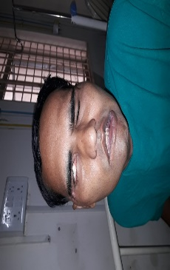
Post-op
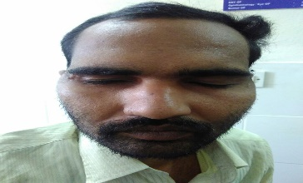
Pre-op
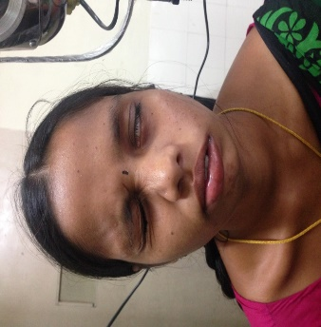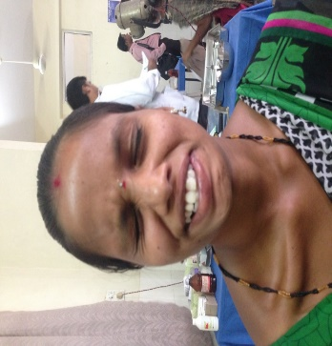
Pre-op Post-op
Recent Publications (minimum 5)

Dr Ahmed Abdul Khabeer,2018, A COMPARATIVE STUDY BETWEEN DIFFERENT SURGICAL TECHNIQUES FOR PREAURICULAR SINUS AT TERTIARY CARE CENTRE,Journal of Evolution of Medical and Dental Sciences,Volume 7,Issue 4,Page 474 to 478
- Dr A A KHABEER,2018, A Study on The Role of Septoplasty in Tubotympanic Diseases And Its Outcomes,IOSR Journal of Dental and Medical Sciences,Volume 17,Issue 01,Page 23-27.
- Dr A A KHABEER,2018, A study on newer technique for reconstruction of pre auricular soft tissue defect with temporo-parietal fascia flap(Khabeer’s flap),International Journal of Otolaryngology and Head and Neck Surgery, Volume 4,Issue 6,page 1485-1488.
- Dr A A KHABEER,2018, A Study of Correlation between CT Findings and MMA Findings in Cases of Maxillary Sinusitis,Journal of Medical Science and Clinical Research,Volume 6,Issue 10,page 690-695.
- Dr A A KHABEER,2018, A Clinical Study of Cases Undergoing Functional Endoscopic Sinus Surgery and Its Outcome, Journal of Medical Science and Clinical Research,Volume 6,Issue 10,page 696-701

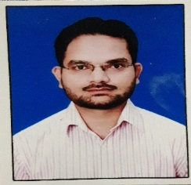Biography (150 word limit)
Dr Ahmed Abdul Khabeer completed Master’s degree qualification in otorhinolaryngology and acquired additional qualification of Fellowship in Advanced Micro Ear Surgery, Global Online and also Fellowship Head & Neck Surgery and Oncology (MSKCC group, USA), fellowship Diploma Skull Base Surgery. He is Currently working as Asst Professor of ENT Head&Neck Surgery,Gandhi Medical College, Hyderabad. He actively Participates in all the academic activitiesand also Published in both national and international journals. He is a Member of professional bodies like Indian Society of otology, Indian Medical Association, Cochlear Implant Group of India etc. He has Designed a flap to reconstruct the defect formed after resection of pre auricular sinus which is named as “KHABEER’s Flap”
Email: aakhabeer@gmail.com

