Excision of lingual thyroid by tongue splitting approach

Dr. Hafiz Sajjad Hyder, FCPS (ENT), FMU ,Faisalabad,Pakistan

Abstract (300 word limit)
Introduction: Lingual thyroid is the ectopic thyroid tissue at the base of the tongue in the midline .It presents as progressive dysphagia, excessive snoring, a visible mass in oral cavity and dyspnoea. Various surgical approaches have been used for its removal including Transoral route ,The suprahyoid and transhyoid approach , Transmandibular route, Lateral Pharyngotomy and Tongue splitting procedure.
Patients and methods: Nine patients with lingual thyroid tissue were admitted in our department in last five years. All were having normal thyroid function tests with some patients having slightly increased TSH. The normal thyroid tissue was present in its anatomical position in neck in all patients. They were operated by using tongue splitting approach, observed for any intra-operative complication and followed post operatively to look for healing of tongue, any recurrence of disease and preservation of proper tongue movements.
Results: Procedure was successful in all our patients with minimal blood loss. Complete healing was observed in one month. There was no recurrence and all patients maintained proper tongue movements.
Conclusion: Tongue splitting approach is a safe and feasible treatment for lingual thyroid and in experienced hands, should be offered as a valid treatment for this pathology.

Images

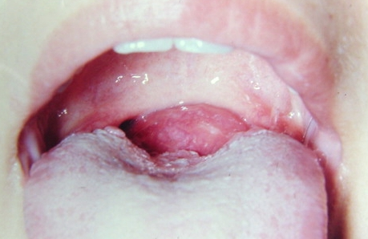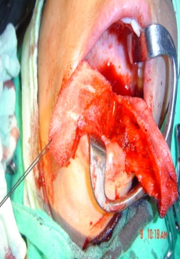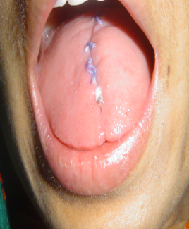

Recent Publications (minimum 5)

Akbay E, Simsek G, Kilic R.(2017) Transposition of lingual thyroid gland to the submandibular region by transoral approach.Auris Nasus Larynx. 2017 Jun;44(3):345-350.

Terris DJ, Seybt MW, Vaughters RB 3rd(2010). A new minimally invasive lingual thyroidectomy technique.Thyroid. 2010 Dec;20(12):1367-9

Rabiei S, Rahimi M, Ebrahimi A.(2010) .Coblation assisted excision of lingual thyroid.Indian J Otolaryngol Head Neck Surg. 2010 Jun;62(2):108-10
- Wu ZX, Zheng LW, Dong YJ, Li ZB, Zhang WF, Zhao YF.(2008) Modified approach for lingual thyroid transposition: report of two cases. Thyroid. 2008 Apr;18(4):465-8.
- Ramzisham AR, Somasundaram S, Nasir ZM. Lingual thyroid--a lesson to learn. Med J Malaysia. 2004 Oct;59(4):533-4.

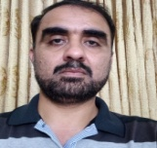 Biography (150 word limit)
Dr. Hafiz Sajjad Hyder has completed his fellowship in ENT from college of physicians and surgeons of Pakistan. He is working as ENT consultant at Faisalabad Medical University, Faisalabad ,Punjab ,Pakistan .He has done his study on patients presenting with lingual thyroid at ENT Department of Allied Hospital Faisalabad. He has used tongue splitting approach to excise the lingual thyroid tissue and found it an effective and safe technique. He also welcomes positive suggestions and further studies from other surgeons performing similar type of procedures
Email: sajjadhyder120@yahoo.com

Notes/Comments:

