Post-operative outcomes in Navigation guided Endoscopic transnasal transphenoidal hypophysectomy in a tertiary care hospital
Dr. Sandipta Mitra
Aim: To assess post-operative outcomes in Navigation guided endoscopic TNTS hypophysectomy
Methodology:
- Patient Selection: 38 diagnosed cases of pituitary macroadenoma selected based on clinical, hormonal and radiological parameters.
- Study design: Prospective observational.
- Outcome parameters: -Symptomatic improvement
-Hormonal profile alteration
-Visual alteration
-Post-operative morbidity
-Residual mass

- Technique: Complete hormonal profile, radiological investigations done along with automated perimetry in selected cases. Preoperative CT Nose+PNS (according to Navigation protocol) fed into Medtronic Fusion ENT Navigation system. Pre-operative tracer contour registration and tracking done. Endoscopic TNTS resection of macroadenoma done. Followed up at 2weeks, 4weeks, 3months and 6 months. Hormonal profile checked at 3months; MRI at 3rd and 6th month.

Results: Out of the 30 patients having secretory macroadenoma, 28 patients showed improvement in hormonal profile. All patients with pre-operative visual abnormality experienced improvement in vision. Residual mass was found in 13%. Single case each of hypopituitarism, DI, CSF rhinorrhoea and meningitis occurred. Mortality rate was zero.

Conclusion: With low incidence of complications and early ambulation, navigation guided endoscopic TNTS hypophysectomy appears promising.

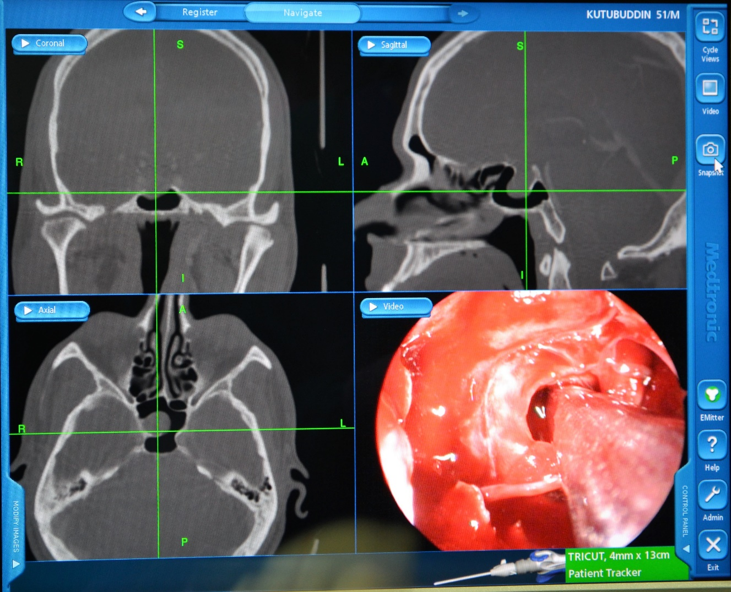

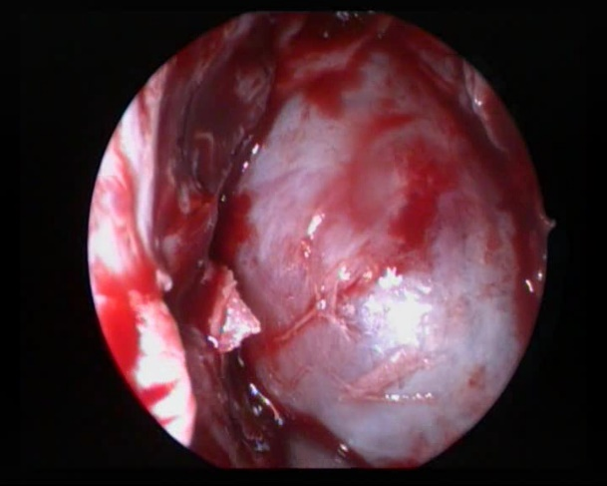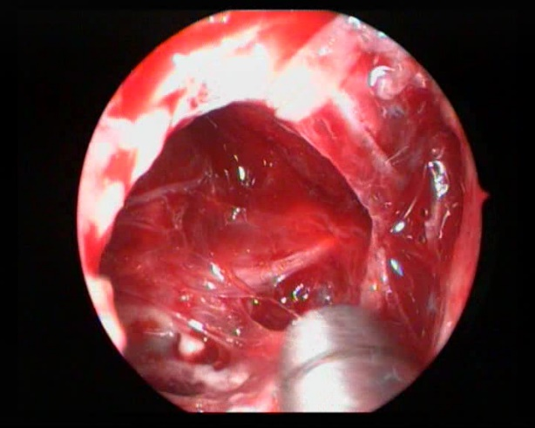

Tumor Mass: Before and after removal

References:

- Hughes-Hallett, A., Pratt, P., Dilley, J. et al. Cancer Imaging (2015) 15(Suppl 1): O8. doi:10.1186/1470-7330-15-S1-O8
- http://www.medtronic.com/us-en/healthcare-professionals/products/ear-nose-throat/image-guided-surgery/fusion-ent-navigation-system/related-navigation-products.html
- Shlomo Melmed, Kenneth S. Polonsky, P. Reed Larsen, Henry M. Kronenberg, Williams Textbook of Endocrinology, P241
- https://pituitary.mgh.harvard.edu/E-F-933.HTM
- https://neurosurgery.mgh.harvard.edu/IGSimages.htm
- Zhang Hongwei, Wang Guangzhi, Ding Hui, 6th World Congress of Biomechanics (WCB 2010). August 1-6, 2010 Singapore, Volume 31 of the series IFMBE Proceedings pp 1538-1541
- Dalgorf DM, Sacks R, Wormald PJ, Naidoo Y, Panizza B, Uren B, Brown C, Curotta J, Snidvongs K, Harvey RJ. Image-guided surgery influences perioperative morbidity from endoscopic sinus surgery: a systematic review and meta-analysis. Otolaryngol Head Neck Surg. 2013 Jul;149(1):17-29

Bibliography:

Sandipta Mitra is pursuing her residency in the Department of Otorhinolaryngology and Head Neck Surgery at Institute of Post Graduate Medical Education and Research, Kolkata, India. Her areas of interest include anterior skull base surgery and paediatric otorhinolaryngology.

Email: onlysandipta@gmail.com

