Bi-nostril transseptal endoscopic approach to the sphenoidal gate. A new technique

Author: Ihsan Abbas Al-Baldawi Fellow of the European Board of Otorhinolaryngology, Head and Neck Surgery
Department of otorhinolaryngology-skull base surgery Neuroscience hospital, Baghdad, Iraq

Abstract

Background
There are multiple approaches to reach the sellar region using microscope or endoscope, which are the old sublabial, with its post-operative morbidities, or the uni-nostril transseptal, which has a limited working field. Another technique is the direct transnasal, which is associated with tissue sacrifice, and lastly the bi-nostril (one side transseptal-other side transnasal), aiming to preserve one of the septal flaps.

Method
We have 27 case studies using a new technique in which we access the sphenoid endoscopicaly through the nasal septum from both nostrils under the mucoperichondrial-periosteal flap.

Conclusion

This new technique provides easy way of wide exposure to the sphenoidal gate, with easier closure of the operative field.

Image 1: Diagram for comparing mean total anesthesia time in relation to the pre op. tumor size for the three different transsphenoidal approaches.

Biography
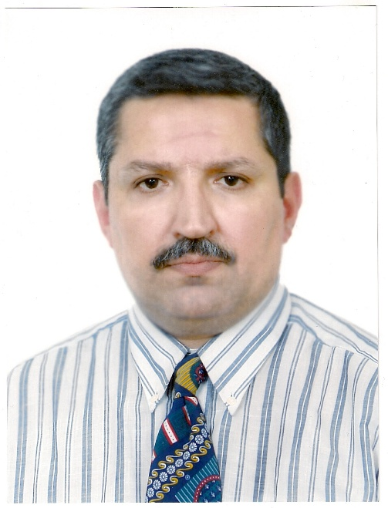
Dr. Ihsan Abbas Al-Baldawi born in Baghdad \ Iraq in 1963. A graduate of collage of medicine/ University of Mosul/ Iraq M.B.Ch.B. in 1987.
He worked as obligatory military services doctor 1988-1992, then became resident in otolaryngology from 1997 till 2004.
-Diploma in Otorhinolaryngology from Baghdad medical collage in 2006. -Fellow of the European Board of Otorhinolaryngology-Head and Neck surgery in Vienna 2014.
-ENT surgeon in AL-Kindy teaching hospital \Baghdad from 2006 till now. ENT-Skullbase surgeon in Neurosciences hospital \Baghdad from 2009 till now.
-Member of the Arab Association of otorhinological surgeons’ society since 2011.
Publications :
1- Al-Baldawi IA (2017). Bi-nostril transseptal endoscopic approach to the sphenoidal gate. A new technique. Acta Neurochirurgica (Wien) Jul; 159(7): 1247-1252.

Adress:
Neuroscience Hospital/ Sader al-qanaat\ Alresafa district
Baghdad-IRAQ
Mobile: 009647801348002
E.Mail: drihsanabbas@yahoo.com

