Reorganization of auditory cortex in tinnitus with a normal audiogram
Department of Otolaryngology head and neck surgery, Shanghai Jiao Tong University Affiliated Sixth People’s Hospital, Shanghai, China, 200233

Abstract (300 word limit)
High-density electroencephalogram (EEG) source analysis was used to determine
whether there is reorganization of auditory cortex in tinnitus with a normal audiogram. Brain responses from 45 healthy right-handed tinnitus patients and 20 matched controls with normal audiometry (pure tone threshold below 25 dB HL at all frequencies from 0.125 to 8 kHz) were recorded with a 256-channel high-density electroencephalogram (HD-EEG) and auditory brainstem responses. We reported that in human subjects with tinnitus and a normal audiogram, auditory brainstem responses show a significantly reduced amplitude of the wave I potential but normal amplitudes of wave V. A marked shift of the cortical representation of the tinnitus frequency into an area adjacent to the expected tonotopic location was observed after source analysis. This provides evidence of “hidden hearing loss” that manifests as reduced neural output from the cochlea in the absence of elevated hearing thresholds, and consequent cortical reorganization.

Image
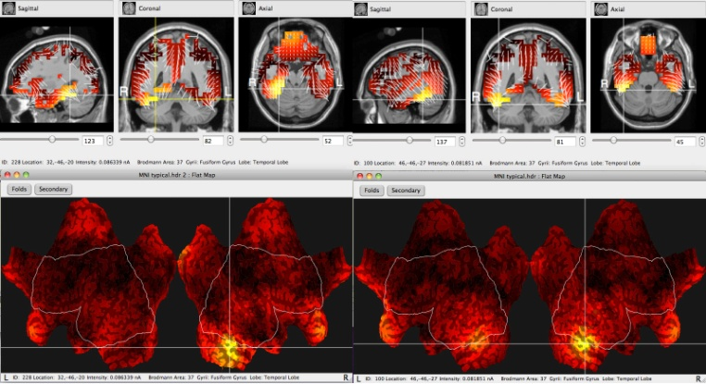
Recent Publications (minimum 5)
1. Hui Wang, Bei Li, Yanmei Feng, Biao Cui, Hongmin Wu*, Haibo Shi*, Shankai Yin,A Pilot Study of EEG Source Analysis Based Repetitive Transcranial Magnetic Stimulation for the Treatment of Tinnitus, PLoS ONE, 10(10): e0139622. doi:10.1371/journal.pone.0139622
2. Hui Wang, B. Li, et al. (2016). "Factor Analysis of Low-Frequency Repetitive Transcranial Magnetic Stimulation to the Temporoparietal Junction for Tinnitus." Neural Plast 2016: 2814056.
3. Hui Wang, Bei Li, Hongmin Wu*, Haibo Shi *, Shankai Yin, Combination of gaps in noise detection and visual analog scale for measuring tinnitus components in patients treated with repetitive transcranial magnetic stimulation, Auris Nasus Larynx, Larynx,2015, 43(3): 254-258.
4. Li, B., H. Wang, et al. (2016). "The Importance of Acoustic Temporal Fine Structure Cues in Different Spectral Regions for Mandarin Sentence Recognition." Ear Hear 37(1): e52-56.
5. Hui Li, GangFeng, HuiWang*, YanmeiFeng*, Intratympanic Steroid Therapy as a Salvage Treatment for Sudden Sensorineural Hearing Loss After Failure of Conventional Therapy: A Meta-analysis of Randomized, Controlled Trials, Clinical Therapeutics, 2015,37(1):178-187

Biography (150 word limit)
Dr. Hui Wang has her expertise in evaluation and passion in researching about otology. She served as the secretary of Otorhinolaryngology institute in Chinese Medical Association Shanghai tinnitus Branch. She has taken charge of 2 project of National Nature Science Foundation of China and Postdoctoral Science Foundation of China.
Email: wangh2014@163.com

Notes/Comments:

