Chebulinic acid attenuates LPS induced bone loss in mice by ameliorating ROS & inflammation via blockage of NFkB pathway
Kriti Sharma, Shiv Kumar, Ravi Prakash, Sonu Khanka, Tripti Mishra, Rajat Rathur, T. Narendra*, Divya Singh*
CSIR-Central Drug Research Institute, India

Abstract
Statement of the Problem: Bone regeneration is reported to negatively affect by inflammation, a common phase during bone healing. Inflammatory bone loss conditions like periodontitis and inflammatory arthritis, all driven by Lipopolysaccharide (LPS), which has been identified as a key pathogenic agent. Till date, there are limited therapeutic approaches for inflammation triggered osteoblast differentiation inhibition. Chebulinic acid (CA), an ellagitannin derived from Triphala, exhibits anti-inflammatory & anti-oxidant activity. We hypothesized that CA may prevent the inflammatory bone loss induced by LPS. Methodology & Theoretical Orientation: LPS induced bone loss model was established using 10wk old male & female C57BL/6J mice which were divided into Control(PBS), LPS(5mg/kg; IP injection), LPS+CA(5mg/kg; orally) and LPS+CA(10mg/kg) groups. After 7 & 21days, micro-CT analysis and histomorphometric evaluation were conducted. In vitro, murine osteoblasts were treated with vehicle, LPS and LPS+CA. Cell viability & proliferation, inflammatory behavior, oxidative stress, and NFkB signalling were determined. Findings: Our results show that in 7day study, CA ameliorates LPS induced inhibited bone remodelling in both female & male mice with more pronounced results in male mice. In 21day study, CA administration alleviates LPS-induced bone destruction & biochemical changes with marked protective effect by enhancing bone formation invivo. In osteoblast cells, LPS treatment causes osteoblast & mitochondrial dysfunction by increasing ROS levels with enhanced expression of inflammatory cytokines. Chebulinic acid (CA) improves the inhibitory effect of LPS on osteoblast functions by enhancing cell differentiation and proliferation. Moreover, CA inhibited the oxidative stress & mitochondrial dysfunction stimulated by LPS treatment by blocking increased secretion of inflammatory cytokines. Mechanistically, CA presented remarkable protective effects against LPS treatment by blocking NFkB signalling. Conclusion & Significance: Taken together, protective role of CA against LPS-induced bone loss & inhibitory effect on total ROS levels hold as a potential novel therapeutic strategy for inflammatory diseases in bones.

Image
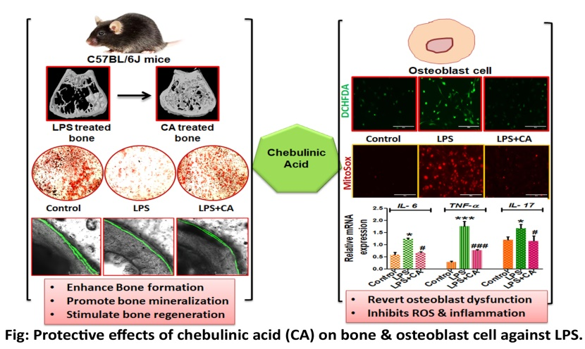
Recent Publications (minimum 5)
- Kim HJ, Song HK, Park SH, Jang S, Park KS, Song KH, Lee SK, Kim T. Terminalia chebula Retz. extract ameliorates the symptoms of atopic dermatitis by regulating anti-inflammatory factors in vivo and suppressing STAT1/3 and NF-ĸB signaling in vitro. Phytomedicine. 2022 Sep 1;104:154318.; https://doi.org/10.1016/j.phymed.2022.154318
- Zhao Y, Gao J, Zhang Y, Gan X, Yu H. Cyclosporine a promotes bone remodeling in lps-related inflammation via inhibiting ros/erk signaling: studies in vivo and in vitro. Oxidative Medicine and Cellular Longevity. 2021 Jan 7;2021.; https://doi.org/10.1155/2021/8836599
- Sapkota M, Gao M, Li L, Yang M, Shrestha SK, Choi H, Soh Y. Macrolactin A protects against LPS-induced bone loss by regulation of bone remodeling. European journal of pharmacology. 2020 Sep 15;883:173305.; https://doi.org/10.1016/j.ejphar.2020.173305

- Park HJ, Gholam Zadeh M, Suh JH, Choi HS. Dauricine protects from LPS-induced bone loss via the ROS/PP2A/NF-κB axis in osteoclasts. Antioxidants. 2020 Jul 6;9(7):588.; https://doi.org/10.3390/antiox9070588
- He YQ, Yang H, Shen Y, Zhang JH, Zhang ZG, Liu LL, Song HT, Lin B, Hsu HY, Qin LP, Han T. Monotropein attenuates ovariectomy and LPS-induced bone loss in mice and decreases inflammatory impairment on osteoblast through blocking activation of NF-κB pathway. Chemico-biological interactions. 2018 Aug 1;291:128-36; https://doi.org/10.1016/j.cbi.2018.06.015

Photograph


Biography
Ms. Kriti pursuing her research as Senior research fellow in Endocrinology Division of CSIR- Central Drug research Institute, Lucknow. She is double Gold-medalist in her Bachelors & Masters. She has her expertise in identifying novel agents using monotherapy and combination therapy approaches for estrogen deficiency induced bone loss & LPS- induced bone loss. She is being recipient of many fellowships and awards including DST-Inspire Fellowship program since 2018 for pursuing her research under Govt. funded labs, Young Investigator Award at IOF Regional Asia Pacific Osteoporosis Conference 2021 (IOF-2021),Thailand, Best Poster Award’ in International 8th annual Conference of International chemical Biology Society (ICBS-2019), India. She has got several publications in peer-reviewed journals from her work pertaining to bone health. She has established various invivo models for ovariectomy induced bone loss, LPS induced bone loss, Dexamethasone induced bone loss in mice & rats; critical size defect surgery in Rabbit during her research tenure.
Email: kriti41@gmail.com

Notes/Comments:

