Significant contribution to bone homeostasis restoring through modeling mechanisms induced by a marine bioactive complex
Dr. Laura Olariu, SC Biotehnos SA, associate member of the Academy of Romanian Scientists
Dr. Emilia Buse, SC Biotehnos SA – corresponding author: emilia.buse@biotehnos.com
Dr. Brindusa Georgiana Dumitriu, SC Biotehnos SA
Dr. Mihai Bojinca, Dr. I. Cantacuzino Hospital Bucharest, Internal Medicine and Rheumatology Clinic

Abstract (300 word limit)
Statement of the Problem: Bone remodeling occurs as a multifactorial event coordinated by bone-resorbing osteoclasts and bone-forming osteoblasts and is a key process in many osteoarticular diseases: osteoarthritis, osteoporosis, osteodystrophy, osteogenesis imperfecta, etc. The ageing time is associated with a low osteoblasts synthesis and an accelerated osteoclasts-driven bone resorption. The bone homeostasis could dramatically be destroyed by extrinsic factors as hormones or growth factors or by intrinsic mechanisms caused by osteoblasts cellular senescence. As a consequence, the progressive bone loss is installed. The main therapies for these wide spreading phenomena concern the anti-catabolic drugs, including estrogens, SERMS(selective estrogen receptor modulators), amino-biphosphonates and RANKL-inhibitors. These drugs reduce bone resorption during the remodeling process. Even they are efficient in bone mass stabilization, anabolic drugs targeting osteoblastic cells are needed to increase bone formation and resistance. Methodology & Theoretical Orientation: Our research is focused on main remodeling cycle mechanisms: “in vitro” differentiation of osteoclasts and their activation, as well as osteoarthritic osteoblasts synthesis and mineralization. The experimental framework designed in order to define the role of a marine bioactive complex obtained through original biotechnologies consists in standardized cell lines (OCP – Lonza and HOB-OA - Promocell) and reliable methodologies of investigation: fluorescence microscopy, flow cytometry. Findings: The marine bioactive complex stimulates the osteoblasts mineralization and alkaline phosphatase externalization, suggesting their regeneration, and inhibits osteoclasts differentiation expressed by morphological changes of their multinucleate status, together with the bone resorption process driven by extracellular RANKL. Conclusion & Significance: Acting on both mechanisms essentials for bone homeostasis, the marine bioactive complex gain a particular interest for therapy, as a promising natural solution for “in situ” restoring of metabolic processes.

Image
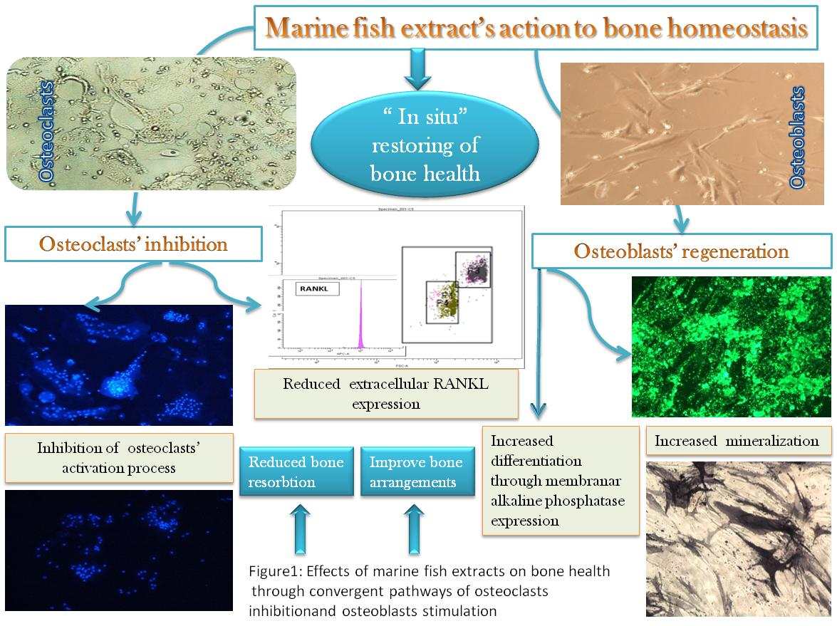
Recent Publications (minimum 5)
- C.D. Hoemann et al., Pathologie Biologie 57 (2009) 318–323
- LJ Raggatt, The Journal of Biological Chemistry vol. 285, No. 33, pp. 25103–25108, August 13, 2010
- Marie P.J., Kassem M., Eur J Endocrinol., 165(1):1-10, 2011
- Ann N.Y., Hadjidakis D.J.., Androulakis I.I., Acad Sci., 1092:385-96, 2006
- Cavalli L., Brandi M. L., Therapeutics and clinical risk management vol. 8 (2012): 253-66.
- Lewiecki EM, Ther Adv Musculoskelet Dis. 2018 Oct 22; 10(11):209-223.
Biography:
Laura Olariu, director of the R&D department of Biotehnos SA, PhD in biology - biochemistry, associate member of the Academy of Scientists has as fields of expertise: cell and molecular biology, biochemistry, border biotechnologies with medicine science, biopharmaceuticals, immunology, cancer biology, applications in dermatocosmetics and food safety. Her competence results from the quality of project director for 12 complex research and technological transfer projects and partner coordinator for 27 projects including 4 international ones. She has experience in complex research projects - innovation development of technologies for obtaining biologically active substances from indigenous raw materials associated with the development of specific models of cellular dynamics and prediction and preclinical pharmacological investigation. She has14 international awards (7 gold medals, 5 silver, 1 bronze, 1 “Woman in research” award 2018), is co-author of 10 patents and 3 patent applications, as well as over 140 relevant research communication and published papers.

