Mechanical stimulation of PIEZO1 induces Runx-2 gene expression through the Akt/GSK-3β/β-catenin pathway in MC3T3-E1 cells
Dr Jidong Song, MD, Xi’an Jiaotong University, China
Dr Xiaoqian Dang, MD, Xi’an Jiaotong University, China

Abstract (300 word limit)
Mechanically-induced biological responses in bone cells involve a complex biophysical process. Although various mechanosensors have been identified, the precise mechanotransduction pathway remains poorly understood. PIEZO1 functions as a new mechanically activated ion channel in bone cells. This study aimed to explore the involvement of PIEZO1 in mechanical loading (fluid shear stress)-induced signaling cascades that control osteogenesis. We applied a physiological range of fluid shear stress to the osteoblasts using a horizontal shaking apparatus. The results showed that fluid shear stress increased PIEZO1 expression in MC3T3-E1 cells. The fluid shear stress promoted osteoblastic proliferation and elicited the key osteoblastic gene Runx-2 overexpression; however, PIEZO1 silencing using small interference RNA blocked these effects. The AKT/GSK-3β/β-catenin pathway was activated in this process. PIEZO1 silencing impaired mechanically-induced activation of the AKT/GSK-3β/β-catenin pathway. Therefore, the results demonstrated that MC3T3-E1 osteoblasts required PIEZO1 to adapt to the external mechanical fluid shear stress, thereby inducing osteoblastic Runx-2 gene overexpression, partly through the AKT/GSK-3β/β-catenin pathway.

Image
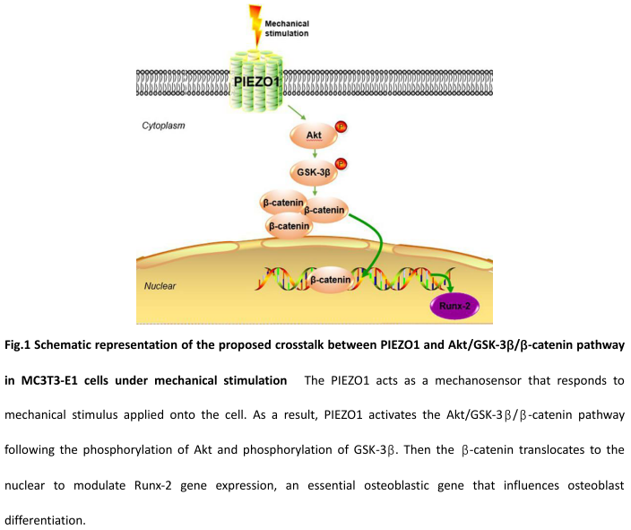
Recent Publications (minimum 5)
- Wu, J., Du, Y., Song, J., Dang, X., . Liu, R. (2019). Genome-wide DNA methylation profiling of hip articular cartilage identifies differentially methylated loci associated with osteonecrosis of the femoral head. Bone, 127, 296-304.
- Song, D., Song, J., Yang, K., ..Wang, W. (2018). Correlation analysis between pre-anesthesia/post-anesthesia range of motion and knee flexion function after total knee arthroplasty. Journal of Chinese Physician, 20, 324-326.
- Ren, S., Lv, L., Ma, J., Li, X., . . . Dang, X. (2019). Slow-release lubrication effect of graphene oxide/poly(ethylene glycol) wrapped in chitosan/sodium glycerophosphate hydrogel applied on artificial joints. Mater Sci Eng C Mater Biol Appl, 98, 452-460.
- Jiang, W., Yu, Y., Liu, J., Zhang, J., & Dang, X. (2019). Downregulation of Cdc6 inhibits tumorigenesis of osteosarcoma in vivo and in vitro. Biomed Pharmacother, 115, 108949.
- Ni, J., Li, D., Mao, M., Dang, X., ..Shi, Z. (2018). A Method of Accurate Bone Tunnel Placement for Anterior Cruciate Ligament Reconstruction Based on 3-Dimensional Printing Technology: A Cadaveric Study. Arthroscopy, 34(2), 546-556.

Photograph

Biography (150 word limit)
Dr Jidong Song, MD, the department of orthopaedics in the second affiliated hospital of Xi’an Jiaotong University. The department made an in-depth study in the pathogenesis of femoral head necrosis and creatively carried out the reconstruction of the joint function of Kashin-Beck disease. In China, we first performed the anastomotic vascular fibular grafting for the treatment of femoral head necrosis and femoral neck fracture. We are interested in the pathogenesis of femoral head necrosis and metabolic bone disease.
.
Email: sjidong12@stu.xjtu.edu.cn
Notes/Comment

