Non surgical regenerative treatment in arthritis using a natural solution (Prolotherapy)
Dr Stephen CAVALLINO, ITALY
Director of the European School of Prolotherapy

Abstract
Prolotherapy is a non surgical injection therapy in regeneration medicine. Arthritis is a degenerative disease and with Prolotherapy we can stop the degeneration and start the regenerative fase of healing. The objective in this presentation is to show how important it is to understand why joints become degenerative as a normal aging process and how we can correct this degenerative process by treating the connective tissues to strengthen the ligaments. The Ligaments are the structure that are forgotten and are so important in joint stability. Once the ligaments are treated with prolotherapy injection therapy using dextrose, the bio-tensegrity of the joint will function better and we can avoid surgery like in knee arthritis where grade 3-4 would need to be surgically treated with a knee replacement. In conclusion, prolotherapy is a very safe, effective and easy treatment to improve the joint function, reduce pain, avoid surgery and to give the patient a better quality of life.

Image

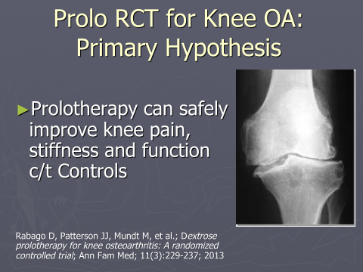

Recent Publications (minimum 5)
- Rabago D, Patterson JJ, Mundt M, et al.; Dextrose prolotherapy for knee osteoarthritis: A randomized controlled trial; Ann Fam Med; 11(3):229-237; 2013
- Rabago D, Mundt M, Zgierska A, et al.; Hypertonic dextrose injection (Prolotherapy) for knee osteoarthritis: Long term outcomes; Comp Ther in Med; 23: 388–395;2015
- Rabago D, van Leuven L, Benes L, et al.; Qualitative assessment of patients receiving prolotherapy for knee osteoarthritis in a multi-method study; J Alt and Comp Med; 2016
- Sit RWS, Chung VCH, Reeves KD, et al. Hypertonic dextrose injections (prolotherapy) in the treatment of symptomatic knee osteoarthritis: A systematic review and meta-analysis. Scientific Reports. 2016;6(epub).
- Chondrogenic Effect of Intra-articular Hypertonic-Dextrose (Prolotherapy) in Severe Knee Osteoarthritis.
Topol GA¹, Podesta LA², Reeves KD³, Giraldo MM⁴, Johnson LL⁵, Grasso R⁶, Jamín A⁷, Clark T⁸, Rabago D⁹.

Photograph

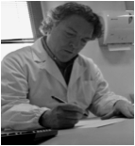Biography
Dr. Stephen Cavallino – Board Certified in Emergency Medicine in Italy - I have been involved in regenerative medicine for more than 20 years. I am now the Director of the European School of Prolotherapy in italy. I participate in many different voluntary Prolotherapy Missions worldwide. My time is focused on helping people that have MSK problems and their pain by understand the cause of pain and treating the structure in orthopedic medicine to improve their quality of life.
I am a member of the Hackett Hemwall Patterson Foundation (HHPF) in Wisconsin, USA and I am the Vice-President of the Italian Association of Prolotherapy (SIPRO) since 2003. Prolotherapy has grown now throughout Europe because I dedicated many years of teaching prolotherapy with the help of many clinical instructors from the SIPRO and HHPF. Currently I am a Clinical Instructor for Prolotherapy and Neuroprolotherapy (Perineural Injection Treatment) www.proloterapia.it , www.proloterapia.eu and email s.cavallino@gmail.com

Notes/Comments:
I really hope to be able to participate in this educational event. Thanks, Dr. Stephen Cavallino

