Clinical Outcomes after Platelet Rich Plasma (PRP) Treatment for Knee Osteoarthritis.
Emad Gaber Kamel Mohamed Elbanna

Beni-Suef University,Egypy
Abstract
Background: Platelet –rich plasma (PRP) is a natural concentrate of autologous blood growth factors experimented in different fields of medicine in order to test its potential to enhance tissue regeneration.Patients and method: Thirty patients (12males- 18 females) with mild to moderate knee OA were treated with PRP intra articular injections and evaluated by Visual Analogue Score of pain (VAS) and Western Ontarioand Mc Masters Universities Arthritis Index(WOMAC index).
Results: A statistically significant improvement of all clinical scores was gained from start of procedure to six months after injection (P >0.001).Conclusion: The results indicate that the treatment with PRP injection is effective in pain reduction and improvement of knee function and quality of life in younger patients with low degree of arthritis, safe and low cost compared to other treatment modalities.
Keywords: Intra articular injection , Osteoarthritis, Platelet rich plasma.
Professional Biogrphy :
Emad Gaber Kamel Mohamed Elbanna graduated from faculty of medicine ,Cairo University in December 1995 then obtained Master degree in orthopaedic surgery in November 1999 from Cairo University, Kasr El Ainy School of Medicine and obtained Doctorate degree in orthopaedic surgery in November 2005 from Cairo University ,Kasr El Ainy School of Medicine.
And now he is Professor of Orthopaedic surgery in Beni-Suef University School of Medicine.s
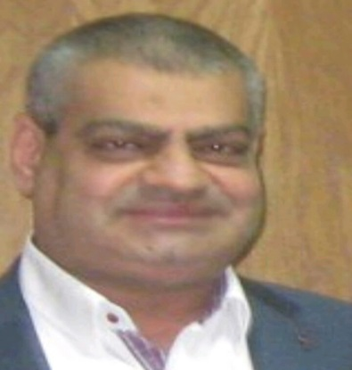
Email : elbanaemad@yahoo.com

