What influences the results in MACI?: A 2-5 year follow-up study.

S.Gursoy¹, M.Akkaya¹, M.Bulut², M.Dogan³, M.Bozkurt³
¹ Yıldırım Beyazıt University Yenimahalle Training and Research Hospital, Dept. of Orthopaedics
² Izmir Katip Celebi University, Ataturk Training and Research Hospital, Department of Radiology
³ Yıldırım Beyazıt University Ataturk Training and Research Hospital, Dept. of Orthopaedics

Abstract
Purpose: This study aimed to investigate the outcomes of Matrix-associated Autologous Chondrocyte Implantation(MACI) on the treatment of osteochondral lesions in the knee joint and to determine the factors affecting the functional results.
Methods: The study included 34 patients with a cartilage defect in the knee joint who were applied MACI®(GenzymeBiosurgery,Cambridge,Massachusetts,USA) with the two-staged surgical technique between the years 2010-2015. The defect localizations and sizes, past surgeries and accompanying surgeries were recorded. The clinical results were measured with Modified Cincinnati, Tegner Lysholm scores.
Results: As a result of the repeated measures at postoperatively, it was found that the patients had increased Lysholm and Cincinnati functional scores after 6 months (p=0.0001). The established increase was seen as significant on review of the scale scores of the male patients. When the mean value of Lysholm and Cincinnati functional scores were assessed according to BMI group, no statistically significant difference was determined (p=0.941 and p=0.779). The measurements at 6 and 12 months of the follow up indicated that the mean scores of the group with no concomitant pathologies were significantly higher than those of the group with concomitant pathologies.
Conclusion: The MACI application provides good and stable outcomes for focal cartilage damage in young patients. In order to obtain significant results after autologous chondrocyte implantation, the selection of appropriate patients without concomitant pathologies is required.
Key terms: Knee, articular cartilage, Tissue engineering, Clinical assessment
Professional Biography
Safa Gursoy has completed his orthopaedics and traumatology residency at the age of 30 years from Ankara Yildirim Beyazit University and studying his PhD at the same university in the dept. of musculoskeletal system and regenerative medicine . He is the past president of Turkish Resident and young attendings council. He is currently working in orthopaedic department as assistant professor. He has published more than 14 papers in reputed journals.

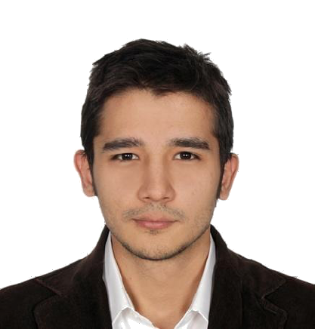
Asst. Prof. Safa Gursoy, MD

