Traumatic cervical spine intradural hematoma: A case report and review of literature
Abdulaziz Sobhi, Amer Hashim Al Ani
Ajman University college of medicine

Abstract (300 word limit)
Introduction: Intradural spinal hematoma, which refers to subdural and/or subarachnoid hematomas, represent a small percentage of spinal hematoma cases, with both hematomas together being only 19.8% of all spinal hematomas. Taken individually, a traumatic cervical spine subdural hematoma is a rare presentation by itself with only 11 cases reported in literature so far.
Presentation of case: A 31 years old male presented to the ER with trauma to his neck after fall from height. ASIA (American Spinal Injury Association) impairment scale showed a grade A injury with no sensory or motor function preserved in the sacral segment S4-S5, upper paraparesis and lower paraplegia. Computed Tomography scan showed fracture of C6 vertebrae. Cervical spine T1 and T2 MRI showed intradural hematoma extending from C6 to craniocervical junction. Cervical traction and corpectomy were done.
Discussion: Traumatic Cervical spine intradural hematoma is a rare entity. Unlike spinal subarachnoid hematoma, spinal subdural hematoma’s pathophysiology is still unclear. Spinal MRI is the best imaging modality to reach the diagnosis. First line management is surgical evacuation of hematoma, but conservative management is a valid option in certain cases.
Conclusion: Knowing the risk factors that increase the chance of intradural extramedullary spinal hematomas and clinically distinguishing those who need to be managed surgically or conservatively is an important step in managing intradural extramedullary spinal hematoma cases.


Image
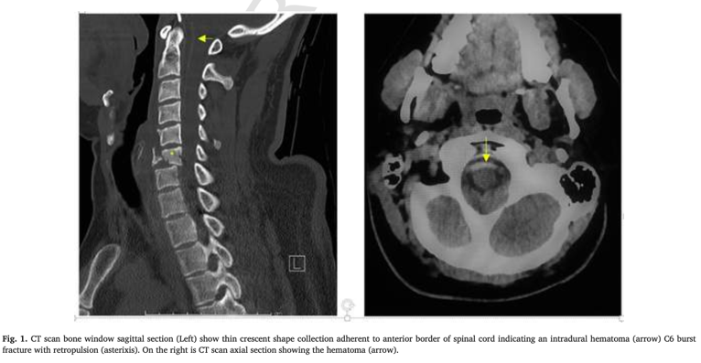
Recent Publications (minimum 5)
- DKreppel,GAntoniadis,WSeeling,Spinalhematoma:aliteraturesurveywith meta-analysis of 613 patients, Neurosurg.Rev.26 (1) (2003)1–49,doi:10.1007/ s10143-002-0224-y

- R A Bruce Brand, G C Colleran, J M Broderick, D F Lui, E M Smith, E C Kavanagh, A R Poynton, Acute nontraumatic spinal intradural hematoma in a patient on Warfarin,J.Emerg.Med.45(5)(2013)695–697,doi:10.1016/ j.jemermed.2013.04.048

- P. Varela Rois, J. González García, M. Regueira Portas, P. Martínez Cueto, E. Azevedo González. Spinal haematomas: The spinal apoplexy. Neurología (English Edition) 25(2) (2010): 96–103. doi:10.1016/s2173-5808(10)70019-5.

- Motor Disorders. In: Simon R.P., Aminoff M.J., Greenberg D.A. (eds). Clinical Neurology, 10e. New York, NY: McGraw-Hill. Available at: http://accessmedicine.mhmedical.com/content.aspx?bookid=2274&sectionid=176233445. Accessed February 25, 2019.

- P. Braun, K. Kazmi, P. Nogués-Meléndez, F. Mas-Estellés, F. Aparici-Robles. MRI findings in spinal subdural and epidural hematomas. European Journal of Radiology 64(1) (2007): 119–125. doi:10.1016/j.ejrad.2007.02.014.

Photograph

Biography (150 word limit)

Abdulaziz Sobhi is a final-year medical student from Egypt with a strong passion for surgery and trauma. He currently serves as President of the Surgery Club, where he leads initiatives to foster surgical interest and skills among medical students. Abdulaziz has four publications, with two additional works in progress, reflecting his dedication to research and academic growth. With a deep commitment to advancing his surgical knowledge, he actively engages in conferences, case discussions, and collaborative projects. His career goals are centered on becoming a skilled surgeon who contributes to both patient care and the academic surgical community.
Notes/Comments:

