Templating in Total Hip Replacement: Does the KingMarkTM Make a Difference?
Mohammad Mirza - Maidstone and Tunbridge Wells Hospitals, United Kingdom
Annis Maatough - East Kent Hospitals, United Kingdom
Hany Albardesy - Ashford and St Peters Hospital, United Kingdom
Nimesh Patel - East Kent Hospitals, United Kingdom
Tofunmi Oni - East Kent Hospitals, Canterbury, United Kingdom

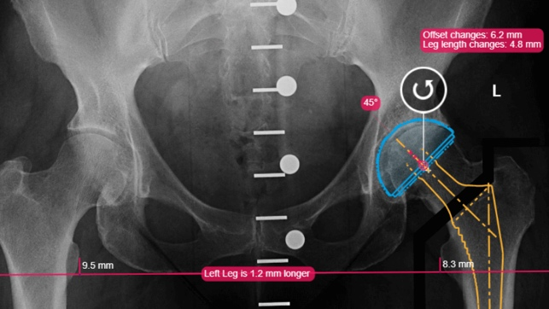
Aim: Total hip replacements (THRs) are common and effective surgical procedures. Templating plays an important role in preoperative planning. Calibrating the magnification factor of radiographs allows for accurate determination of the prospective implant sizes. The Kingmark (Brainlab) purports to increase the accuracy of determining magnification factor. In this study, we compare the conventional single-marker to the newer KingMarkTM dual-templating system at predicting the size of the actual implants used.
Method: This retrospective study compares two cohorts of 50 consecutively selected patients who underwent primary THR under the care of two surgeons. All patients had pre-operative AP pelvis radiographs to facilitate templating by one of the two methods. For both groups the templated size of the acetabular and femoral implants were compared to the definitive acetabular and femoral implants respectively.
Alnahhal A, Aslam-Pervez N, Sheikh HQ (2019) Templating Hip Arthroplasty. Open Access Maced J Med Sci 7:672–685. https://doi.org/10.3889/oamjms.2019.088
Crooijmans HJA, Laumen AMRP, van Pul C, van Mourik JBA (2009) A New Digital Preoperative Planning Method for Total Hip Arthroplasties. Clin Orthop Relat Res 467:909– 916. https://doi.org/10.1007/s11999-008-0486-y
Boese CK, Wilhelm S, Haneder S, et al (2019) Influence of calibration on digital templating of hip arthroplasty. Int Orthop 43:1799–1805. https://doi.org/10.1007/s00264-018-4120- 7
Baxter JA, Barlow T, Karthikeyan S, et al (2012) The Accuracy of Automatic Calibration of Digital Pelvic Radiographs using two Different Scale Markers: A Comparative Study. HIP Int 22:82–89. https://doi.org/10.5301/HIP.2012.9044
Warschawski Y, Shichman I, Morgan S, et al (2020) The accuracy of external calibration markers in digital templating using the double marker and single marker method: a comparative study. Arch Orthop Trauma Surg 140:1559–1565. https://doi.org/10.1007/s00402-020-03569-2
Results: Single-marker templating correctly predicted the size of the femoral implant in 32% of cases, the KingMarkTM correctly predicted the same in 54% of cases which was a statistically significant improvement (P=0.03). In contrast the single-marker system correctly predicted the implanted acetabular component in 32% whilst the KingMarkTM system did the same in 30% of cases with no statistically significant difference.
Conclusions: Our study shows a statistically significant improvement in predicting femoral stem sizes, but not the acetabular cup for the KingMarkTM. Our findings suggest that in the clinical setting the KingMarkTM does not provide a particular advantage over more the conventional single marker systems.


Mohammad Mirza is a dedicated Trauma and Orthopaedic trainee currently working in Maidstone and Tunbridge Wells Hospitals NHS Trust (United Kingdom). He has a keen interest in Hip and knee Arthroplasty along with medical education. He holds a PGCert in medical education. Mohammad is committed to advancing their expertise and contributing to the field of orthopaedic surgery.
mohammad.mirza@nhs.net

