A – Aegis Mark II S – Study on P – Powered Air P – Purifying I – Innovation R – Respirator E – Efficiency: ASPIRE

Hansel Gould B. Cocjin, MD, FPOA
Jair Kimri P. Jingco, M.D., FPOA
Pierre Napoleon P. Niere, MD.

Abstract (300 word limit)

Introduction: The COVID-19 pandemic has caused approximately 7 million mortalities worldwide and evidence suggests that it is transmitted through respiratory droplets resulting to shortages of Personal Protective Equipment (PPEs) needed for prompt patient care. This study was done to assess the locally developed Aegis Mark II Powered Air Purifying Respirator (PAPR).

Methodology: This laboratory controlled non-interventional testing included: battery and usable power; mechanical construct of hood and blower unit; user acceptance through a clinical simulation that included the training and education, clinical performance, communication, comfort and PAPR care; and filtration efficacy using NaCl particulate.

Results: The Aegis Mark II PAPR has a 20,000mAh rechargeable Lithium battery pack with a mean usable time of 11:34, (Std. dev.: 0:16 (H/M)), and 8:34, (Std. dev.: 0:38 (H/M)), for low and high flow blower settings, respectively. The mean charging time of 2:20, (Std. dev.: 0:19 (H/M)), using a Fast Cellphone Charger (2.4 Amps). It had significantly better survey responses compared to the commercial PAPR. The mean particle counts inside the hood of the Aegis Mark II PAPR and Commercial PAPR showed that PM2.5 (5.7 and 6.2), and PM10 (6.2 and 6.6) values were within acceptable Ambient Air Quality Standards.

Conclusion: The Aegis Mark II PAPR battery power supply is adequate and showed significantly better survey scores compared with the commercial PAPR and the filtration efficacy was comparable with the commercial PAPR. It can provide a high degree of protection and will alleviate the logistical strain during pandemics and public health emergency.
Image
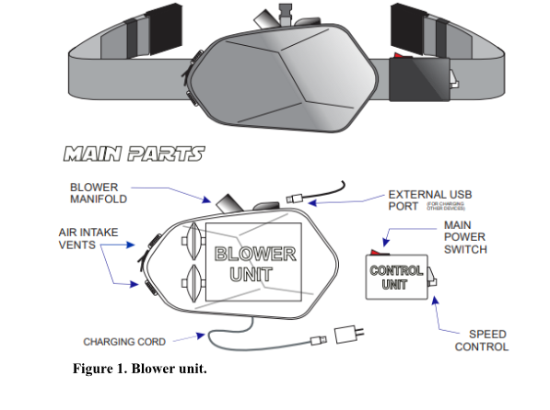
Recent Publications
- Cocjin, HGB., Jingco, JKP., Coruña, JMR. Efficacy and Cost of Negative Pressure Wound Therapy (NPWT) Dressing versus Tie-Over Bolster Dressing on Integrating Split-Thickness Skin Grafts. PJSS Vol. 73, No. 1, January-June, 2018. 19-27.

- Cocjin, HGB., Jingko, JK., Villaber, ALL. Closed Treatment of Humeral Shaft Fractures by Functional Bracing using Polyvinyl Chloride versus Plaster-of-Paris Cast: A Randomized Controlled Trial. PJSS Vol. 74. January-June 2019. 15-23.

- Cocjin, HGB., Jingco, JKP., Tumaneng, FDC., Coruña, JMR. Wound-Healing Following Negative-Pressure Wound Therapy with Use of a Locally Developed AquaVac System as Compared with the Vacuum-Assisted Closure (VAC) System. The Journal of Bone and Joint Surgery. November 20, 2019; 101 (22): 1990. 10.2106/JBJS.19.00125

Photograph


Name: Hansel Gould B. Cocjin, MD, DPBO
Address: Bacolod City, Negros Occidental, 6100
Date of Birth: March 27, 1986
Citizenship: Filipino
Sex: Male
Doctor of Medicine West Visayas State University - Jaro, Iloilo City 2007-2011
Post Graduate Internship Bacolod Adventist Medical Center-Bacolod City 2011-2012
Residency Training C.L. Montelibano Memorial Regional Hospital 2012-2016
Trauma Fellowship C.L. Montelibano Memorial Regional Hospital 2017-2018
Email: hanselgouldcocjin@gmail.com

