Revision Of Unicompartmental To Total Knee Arthroplasty Using Robotic Technology.
Dr. Charles Wallace, MRCS, University College Hospital London
Dr. Peter Moriarty, MRCS, University College Hospital London

Abstract (300 word limit)
Purpose:
The aim of this study was to describe a novel technique using robotic assisted technology to perform a revision of a unicompartmental knee arthroplasty (UKA) to a total knee arthroplasty (TKA). This technique hasn’t been reported on in literature to date.
Method:
The robotic arm computer application allows the surgeon to preoperatively plan intra-operative cuts, implant positioning, and implant sizes based on the CT scan which was done pre-operatively. A standard medial parapatellar approach is performed. Two 4.0 mm pins for the computer arrays are placed in the tibia and two into the femur. Intra-operative bone registration is performed for both the femur and tibia. The previous UKA components are carefully removed, followed by the tibial and femoral bone cuts which are performed using the robotic-assisted arm. The components are then trialled, followed-by the definitive components cemented in a standard fashion and final measurements are recorded.
Results:
Surgical data from the first six patients undergoing revision UKA to TKA using robotic-arm assisted technology has been recorded. All patients were corrected to within 3 degrees of neutral mechanical alignment. Medial and lateral gaps were recorded in both flexion and extension to demonstrate a well-balanced knee. The amount of bone resection was also recorded to highlight the advantage of bone preservation using robotic technology.
Conclusion:
The study shows how robotic technology allows surgeons to confidently perform accurate and reproducible revision knee surgery. There is optimism that the use of robotic technology will subsequently result in improved functional outcomes and improved overall survivorship for patients undergoing revision UKA to TKA.

Image

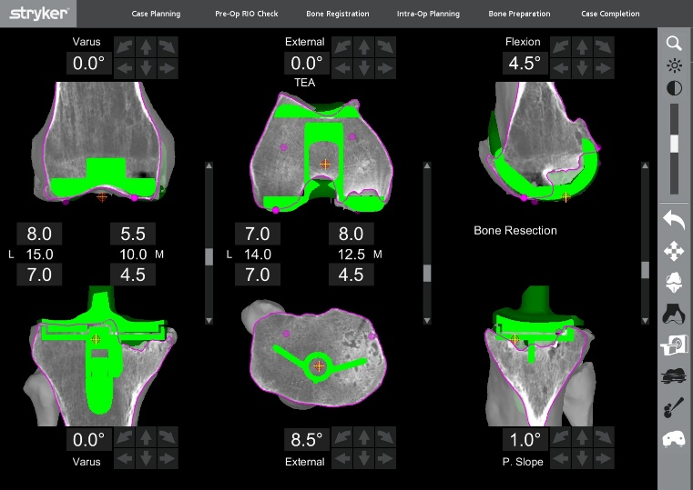

Recent Publications (minimum 5)
- Babar Kayani et. al (2019), Posterior cruciate ligament resection in total knee arthroplasty: the effect on flexion-extension gaps, mediolateral laxity, and fixed flexion deformity, The Bone & Joint Journal
- S. Konan et. al (2018), Robotic-arm assisted total knee arthroplasty is associated with improved early functional recovery and reduced time to hospital discharge compared with conventional jig-based total knee arthroplasty: a prospective cohort study, The Bone & Joint Journal
- F.S. Haddad (2018), The learning curve associated with robotic-arm assisted unicompartmental knee arthroplasty: a prospective cohort study, The Bone & Joint Journal

- Malkani AL, et. al (2019), New Technology for Total Knee Arthroplasty Provides Excellent Patient-Reported Outcomes: A Minimum Two-Year Analysis. Surg Technol Int
- Sires JD, Craik JD, Wilson CJ (2019) Accuracy of Bone Resection in MAKO Total Knee Robotic-Assisted Surgery. J Knee Surg

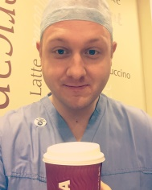Biography (150 word limit)
Dr. Charles Wallace received his MD from Leiden University, The Netherlands. He is currently working in a dual clinical and research role as an Orthopaedic registrar at University College London Hospital. He is committed to Orthopaedic research and further advancement in the Orthopaedic field. He has a special interest in Robotics in Orthopaedics.
Email: charlesnwallace@gmail.com

Notes/Comments:

