
Audit of Consent in Hip Fracture
Dr V Beynon, MBChB, BSc, Frimley Health Foundation
Trust, United Kingdom

Miss R Richardson, BMBS, MRCS (2014), Frimley Health
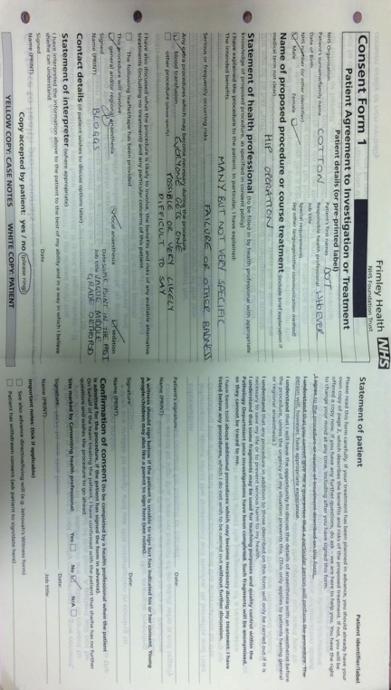
Foundation Trust, United Kingdom

Abstract (300 word limit)
Background/Aim: Following Montgomery v Lanarkshire (2015) issues surrounding consent are increasingly subject to litigation. The GMC is currently updating its guidance, emphasising a patient-centred approach, particularly in relation to peri-operative risk.
Consent in hip fracture is frequently undertaken by SHO grade doctors who may be unfamiliar with the procedure, potentially compromising quality of consent.
This audit-cycle’s aim was to assess standard of consent in hip fracture and implement interventions to improve practice.
Study Design: The audit examined Consent Form 1 for NOF patients admitted over two months. Standards were taken from the BOA guideline ‘OrthoConsent’. Data included; accurate completion of consent form, grade of health-professional and legibility.
The number of documented peri-operative risks were totalled, categorised into three ranges (0-4), (5-9), (10-16) and allotted a score (1, 2 or 3 respectively).
Following initial audit, intervention included education from medical and medico-legal professionals and provision of electronic guidelines. Re-audit followed intervention.
Results: Baseline assessment comprised 40 consent forms, 22 (55%) completed by SHOs & 18 (45%) by SpRs, with 100% legibility.
Patient demographics, indication, procedure & anaesthesia were documented in 95% of cases. Consultants confirmed consent in 7 (17.5%) cases. 2 (5%) provided patient copies. For risk documentation, 3 forms scored 1 (7.5%), 34 scored 2 (85%) & 3 scored 3 (7.5%).
Re-audit was conducted for 45 consent forms; 41 (91.1%) by SHOs & 4 (8.9%) by SpRs. Results were similar for all parameters bar risk documentation. No forms scored 1, 18 scored 2 (40%), 27 scored 3 (60%). The standard of SHO consent was similar to SpR.
Conclusions: Results showed overall improvement in documented peri-operative risk, with those scoring 3 increasing to 60%. The education intervention also had the unintended effect of improving SHO’s confidence in consenting such that, at re-audit, only 9% of patients were consented by a registrar.

Image
Recent Publications (minimum 5)
1. OrthoConsent Forms [Internet]. Orthoconsent.com. 2019 [cited 28 October 2019]. Available from: http://www.orthoconsent.com/body2.asp?BodyPartID=4
2. Thiruchandran G, McKean A, Rudran B, Imam M, Yeong K, Hassan A. Improving consent in patients undergoing surgery for fractured neck of femur. British Journal of Hospital Medicine. 2018;79(5):284-287.
3. Bajada S, Dwamena S, Abdul Z, Williams R, Ennis O. Improving consent form documentation and introduction of procedure-specific labels in a district general hospital. BMJ Quality Improvement Reports. 2017;6(1):u211571.w4730.
4. Rahman L, Clamp J, Hutchinson J. Is consent for hip fracture surgery for older people adequate? The case for pre-printed consent forms. Journal of Medical Ethics. 2010;37(3):187-189.
5. Knight S, Pearson R, Kiely C, Lee G, MacDonald A, Macdonald A et al. Patient consent in the post-Montgomery era: A national multi-speciality prospective study. The Surgeon. 2019;17(5):277-283.

Photograph

Biography (150 word limit)
Email: Victoria.Beynon1@nhs.net

Notes/Comments:

