Improving the management of shoulder dislocation by use of the BESS/BOA Patient Care Pathway for the Management of Traumatic Anterior Shoulder Instability
M A R Awadallah, MRCS, MSc T&O, NWAFT, UK
J Wheble, AJ White, PM Robinson.

Abstract (300 word limit)
Background: Shoulder dislocation and associated neurovascular injuries can have poor outcomes if missed. In 2015 the British Elbow and Shoulder Society and British Orthopaedic Association (BESS/BOA) published a Patient Care Pathway for the Management of Traumatic Anterior Shoulder Instability. We audited our management of shoulder dislocations against these guidelines and implemented changes to improve patient care.
Methods: We conducted an initial audit of the management of shoulder dislocation in the Emergency Department (ED). We noted areas of poor performance for the documentation of neurovascular examination and for obtaining adequate X-ray views. We concentrated on improving these prior to audit 2. We produced a simple chart and pro forma to guide correct management conducted teaching sessions for ED staff. We also met with ED consultants, radiographers and radiology consultants to encourage the use of Axillary / modified Axillary view X-rays.
Results: Audit 1, n=22. Pre-reduction; the Axillary nerve was documented in 6 patients (27%). Median, Ulnar and Radial nerves 2(9%). AP X-ray was performed in 22(100%) and Axillary X-ray 4(19%). Post-reduction; the Axillary nerve was documented in 6(27%). Median, Ulnar and Radial nerves 1(4.5%). AP X-ray 22(100%), Axillary X-ray 3(15%).
Audit 2, n=20. There was a large improvement in all parameters.
Pre-reduction; the Axillary nerve was documented in 16(80%). Median, Ulnar and Radial nerves 15(75%). AP X-ray was performed in 19(95%), Axillary X-ray 16(80%). Post-reduction; the Axillary nerve was documented in 11(55%). Median, Ulnar and Radial nerves 11(55%). AP X-ray 22(100%), Axillary X-ray 17(85%).
Conclusion: We have greatly improved the documentation of neurovascular status after shoulder dislocation and the use of pre- and post-reduction X-rays, including a large increase in the use of Axillary / modified Axillary views.
Implications: By implementing the BESS/BOA guidelines we have improved the care of patients with shoulder dislocations..

Image
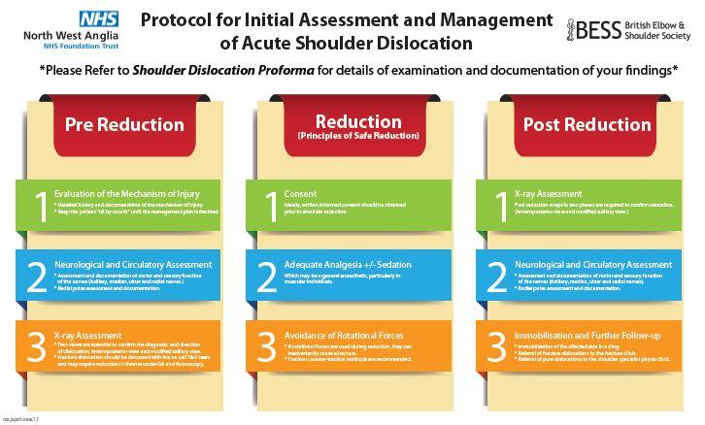
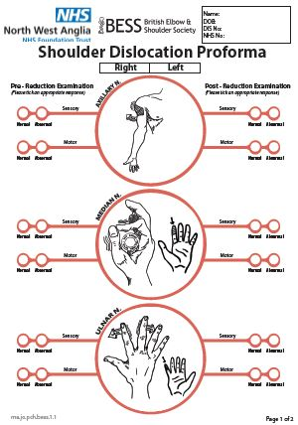
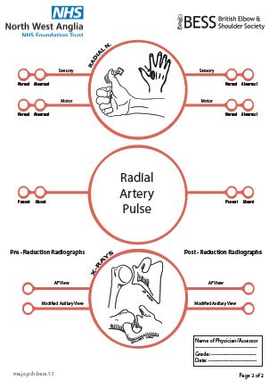

Photograph

Biography (150 word limit)
MR Awadallah has his passion in improving the quality of care and service provided to patients in the NHS. He designed a creative solution in the form of an illustrative "Proforma", created and implemented a "Protocol'' to guide the clinician/assessor through the steps of assessment and management of patients with acute shoulder dislocation. The locally implemented work has resulted in significant improvement of practice and patients' care, better compliance with the guidelines, noticeable clarity of detailed documentation of examination findings, as well as improvement of service provision.
Email: mahmoud.awadallah@nhs.net

Notes/Comment

