Nailing Intertrochanteric-subtrochanteric fractures: Thoughts, Techniques, tips, and tricks cases based approach.
Dr. Mohammed Q Htiaf, M.D, Sana’a, Yemen
Dr. Basim S. AL-Magtri, M.D, Sana’a, Yemen

Abstract

Cephalomedullary-nailing system is becoming a key implant for treating proximal Femur fracture, especially for some types of unstable fractures like AO-OTA type 31 A3 fractures. Recent awareness of the correlation between the intraoperative lateral wall fracture and the failure through cutout after DHS fixation draws surgeons’ attention more to nailing as an alternative to DHS.

The Incidence of High energy and more complex proximal femur fractures are more common in young Yemeni patient.

Between 08/01/2015, and 30/8/2018, 56 consecutive fractures were treated surgically, using long intramedullary nails. ) Clinical follow-up was accomplished using the Functional Recovery Score (FRS) as described by Zuckerman and Koval, With a mean duration of radiographic follow – up of 6 months (range, 3 to 18 months) With an average clinical follow – up of 11 months (range, 6– 22 months)

One patient had a deep infection, and subsequent screw cut out. that involved revision of an intertrochanteric nonunion to a Total Hip Arthroplasty. The patient required multiple operative debridement’s and long – term intravenous antibiotic therapy. One patient with subtrochanteric fracture Long Proximal femoral Nail Fixation (LPFN) went to nonunion. Immediate postoperative x ray revealed significant malreduction, Varus, the nail insertion point in the greater trochanter situated more lateral than is typically indicated. In conclusion, intramedullary nail is a good device that provides effective treatment for fixation complex proximal femur fractures.
Image
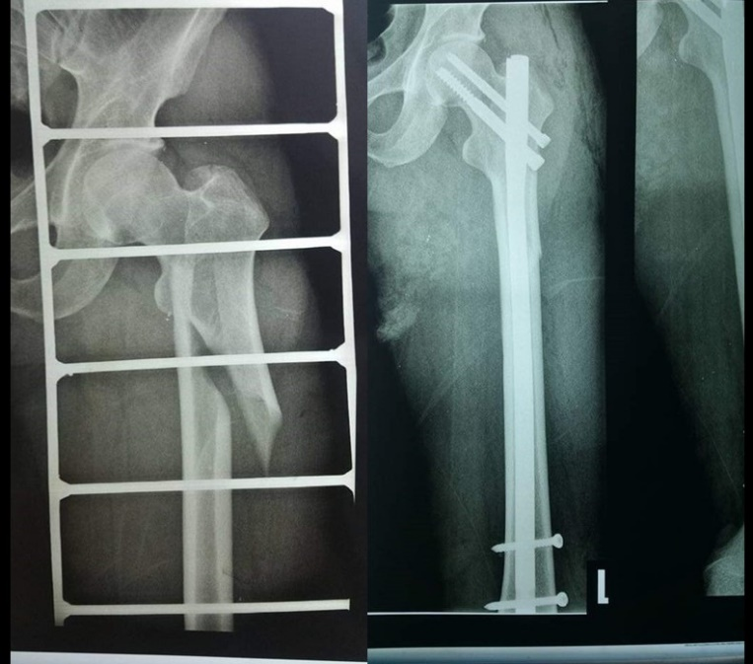
Recent Publications (minimum 5)
- Nherera L1, Trueman P2, Horner A2, Watson T3, Johnstone AJ4. (2018) Comparison of a twin interlocking derotation and compression screw cephalomedullary nail (InterTAN) with a single screw derotation cephalomedullary nail (proximal femoral nail antirotation): a systematic review and meta-analysis for intertrochanteric fractures. J Orthop Surg . doi: 10.1186/s13018-018-0749-6..
- Boris A. Zelle,corresponding author1 Antonio J. Webb,1 (2018) Safety and efficacy of a two-screw cephalomedullary nail for intertrochanteric femur fracture fixation: a retrospective case series in 264 patients doi: 10.1186/s13037-018-0177
- Keong-Hwan Kim, MD, Kye Young Han, MD, Ph.D., (2018) Local Postoperative Complications after Surgery for Intertrochanteric Fractures Using Cephalomedullary Nails.
doi: 10.5371/hp.2018.30.3.168.
- Eui Yub Jung, MD, In Taek Oh, MD,* Sang Yeup Shim, MD, (2019) The Effect of Valgus Reduction on the Position of the Blade of the Proximal Femoral Nail Antirotation in Intertrochanteric Hip Fractures. 10.4055/cios.2019.11.1.36
5. Yasir S Siddiqui, Abdul Qayyum Khan, Naiyer Asif, (2019) Modes of failure of the proximal femoral nail (PFN) in unstable trochanteric fractures. Moj orthopedic

Photograph

 Biography
Dr. Mohammad Q, Hutaif
Assistant Professor At Sana’a University
Orthopedic Consultant Kuwait University Hospital, Sana’a, Yemen
SGH Saudi German, Hospital, Sana’a, Yemen
General Secretary Yemeni Orthopedic Association Y.O.A
Email: hutaif9@gmail.com

