Bone regeneration using rhFGF-2-impregnated gelatin hydrogel for early-stage osteonecrosis of the femoral head

Yutaka Kuroda, BEc, MD, PhD, Kyoto University, Japan

Abstract (300 word limit)
Osteonecrosis of the femoral head (ONFH) is a multifactorial disease that can cause femoral head collapse, pain, gait disorders. ONFH is common among young people in their 30s and 40s. In the clinic, although patients are diagnosed, 70%–80% of untreated patients experience femoral head collapse and have to undergo total hip arthroplasty. In the past decades, minimally invasive regenerative therapy has been desired for the early stages of ONFH. The purpose of this study was to evaluate the safety and clinical outcomes of rhFGF-2 gelatin hydrogel. Ten ONFH patients up to precollapse stage 2 underwent a single local administration of 800-μg rhFGF-2 gelatin hydrogel and were followed up for one year. Primary outcomes included adverse events and complications. Secondary outcomes included changes in Harris Hip Scores, VAS pain scores, UCLA scores, radiological changes as determined via X-ray, CT, and MRI images. There were 14 adverse events (five patients). Patients completely recovered from all adverse events without problem. The surgery was performed with a minimally invasive technique (1 cm of skin incision), and walking was allowed from the day after surgery. Mean clinical scores improved significantly after four years compared with before surgery. There was only one case of femoral head collapse, and it had the greatest necrosis volume fraction and was considered to be in the early collapse stage at the time of operation. The other nine cases did not involve ONFH stage progression, and collapse was prevented. CT and MRI images confirmed bone regeneration in the ONFH. Clinical application of rhFGF-2 gelatin hydrogel for precollapse stage of ONFH was feasible and safe. Our research is ongoing, further phase II multiple center study has been started in January 2016.

Image
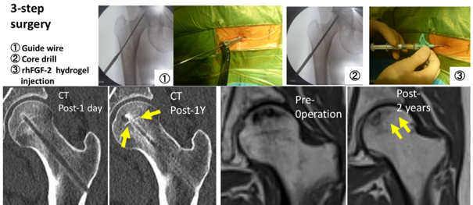
Recent Publications (minimum 5)
- Kuroda Y et al (2016) A pilot study of regenerative therapy using controlled release of rhFGF-2 for patients with precollapse osteonecrosis of the femoral head. Int Orthop. 40(8):1747-54.
- Kuroda Y et al (2016) Joint-preserving regenerative therapy for patients with early-stage osteonecrosis of the femoral head. Inflamm. Regener. 36:4.
- Kuroda Y et al (2016) Extremely early stage osteonecrosis of the femoral head in a patient with hip pain secondary systemic steroid pulse therapy for Vogt-Koyanagi-Harada syndrome. Int J Surg Case Rep. 25:97-101.
- Kuroda Y et al (2015) A Report on Three Consecutive Cases using Computer Tomography 3D Preoperative Planning for Conversion of Arthrodesed Hips to Total Hip Replacements. HSS Journal. 11(1):76-83.
- Kuroda Y et al (2015) Modified Mostardi's approach with ultra-high molecular weight polyethylene tapes for total hip arthroplasty provides a good union rate of the osteotomized fragment. J Orthop Sci. 20(4):633-41.

Biography (150 word limit)
Dr. Yutaka Kuroda, Medicine Doctor (Ph.D.-medicine), now is an Assistant professor of Department of Orthopaedic surgery, Kyoto university. In 1994, was received the B.E. degree in Economics from Keio university, got medical doctor license at St. Marianna university school of medicine in 1999, and Medicine Doctor's degree (Ph.D.) at Graduate School of Medicine, Kyoto University in 2011. Dr. Yutaka Kuroda’s researches focus on the bone regeneration using growth factor and osteonecrosis of the femoral head. A Research Award from “The Japanese Society of Inflammation and Regeneration 2014 and 2016 meeting”. Member of the Japanese Investigation Committee of Health and Welfare on the establishment of guidelines for Osteonecrosis of the femoral head.
Email: ykuromd@gmail.com

Notes/Comments:

