Risk Determinants for Lateral Ankle Sprains among Division 1 Collegiate Athletes
Bryan Soth, MS-II, Ohio University Heritage College of Osteopathic Medicine, USA
Dr. Carrie Docherty, PhD ATC, Indiana University School of Public Health, USA
Dr. Janet Simon, PhD ATC, Ohio University, USA
Dr. Emily Hall, PhD ATC, Ohio University, USA
Ahmet Yildirim, ODTU, Middle Each Technical University, Turkey

Abstract
Purpose: The study aimed to pinpoint risk factors for lateral ankle sprains (LAS) to inform preventative and rehabilitative program development for Division I collegiate athletes, with the goal of reducing sprain occurrence and long-term impact. Methods: A cohort of 746 athletes across varied sports disciplines received comprehensive pre-participation examinations, providing data on demographic variables, LAS history, Chronic Ankle Instability (CAI), and sprain severity. The Sport Injury Monitoring System (SIMS)™ tracked LAS occurrences, excluding injuries not related to sports. We utilized survival analysis, including Kaplan-Meier curves and Cox proportional hazards modeling, to evaluate the association between LAS incidence and risk factors such as CAI severity, sprain history, and frequency of ankle instability, categorized via the IdFAI questionnaire and meta-analysis data. SAS system version 9.4 facilitated statistical evaluations. Results: LAS was sustained by 10.3% of participants, with CAI severity, sprain frequency, history, and prior sprain severity being significant risk predictors. Sport type also proved influential, while gender showed no significant effect. Relative risk calculations, derived from regression analyses, underscored the predictive strength of these factors, aligning with the model’s proportionality criteria. Discussion: LAS substantially affects collegiate athletes, with particular factors significantly heightening injury risk. History of sprains, CAI, and frequent ankle instability notably increase susceptibility, especially in field and indoor/court sports. The study advocates for specialized ankle training within athletic programs and indicates a higher re-injury risk for athletes with severe prior sprains, suggesting benefits of tailored rehabilitation and support measures. Despite gender not emerging as a significant predictor, its potential relevance to ankle sprain risks warrants further exploration.

Image
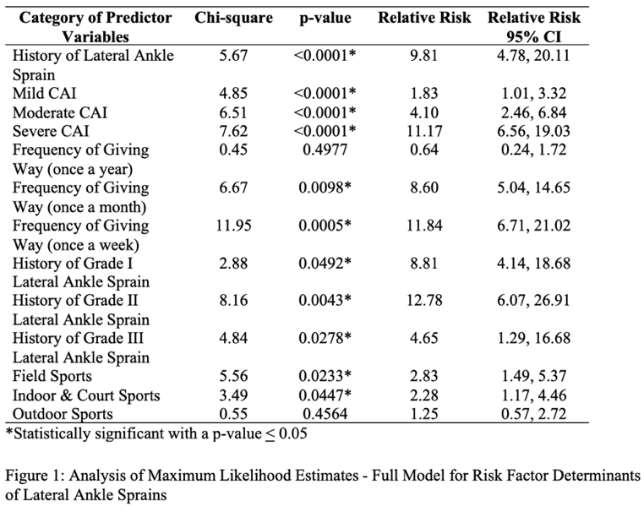
Recent Publications
1. Soth, B., Wissner, R. J., Simon, J. E., Onate, J. A., & Grooms, D. R. Post-ACLR Individuals Self-Report Higher Physical Activity Levels Than Healthy Controls. 2024. Pediatric Sports Medicine and Orthopedics. Forthcoming.
2. Soth, B., Higginbotham, H., Grooms, D. R., Farraye, B., & Simon, J. E. Adding Cognitive-Motor Assessments to the Knee Sanity Athletic Return to Sport Test Battery May Increase Fatigue. 2024. Neuroscience and Orthopedics. Forthcoming.
3. Soth, B., Higginbotham, H., Grooms, D. R., Farraye, B., & Simon, J. E. Heart Rate Increases with Simultaneous Increase in Rating of Perceived Exertion during The Neuro Knee Sanity Athletic Return To Sport Testing. 2024. Neuroscience and Orthopedics. Forthcoming.
4. Soth, B., Higginbotham, H., Grooms, D. R., Farraye, B., & Simon, J. E. Quantifying Physical Performance during Typical Clinical Return to Activity Testing. 2023. Neuroscience and Orthopedics. Forthcoming.
5. Soth, B., Agrawal, M., Bailey, S., & Welshhans, K. RACK1 is Altered in Down Syndrome Fibroblasts. 2020. Kent State University Open Journal.


Bryan Soth, MS-II, is an aspiring physician, currently pursuing his D.O. at the Heritage College of Osteopathic Medicine, Ohio University. He holds a Bachelor of Science in Biochemistry from Kent State University, where he was also recognized as a Baseball Scholarship Athlete and part of the Biological Sciences Scholars Program. His profound commitment to medical research is reflected in his multiple positions as a Clinical Research Fellow in Orthopedic Surgery and a Research Fellow in Neuromuscular Biomechanics and Orthopedics. His academic excellence has been acknowledged through several scholarships and awards, including the prestigious Marie A. Keener Endowment Scholarship. Bryan’s athletic background as a former collegiate baseball player is complemented by his scholarly pursuits, with multiple publications and oral presentations to his name. His commitment to healthcare extends to various student organizations where he serves in leadership roles, demonstrating a deep understanding of medicine’s multifaceted nature.
Email: bs877522@ohio.edu

