Bio Metamaterial for Orthopedics

N’Dea Irvin-Choy, Rowan University, Glassboro, NJ, USA
Hamid Seyyedhoissenzadeh, MD, Glassboro, NJ, USA
Hamed Seyyedhoissenzadeh, PhD, Glassboro, NJ, USA

Abstract

In orthopedics, stainless steel, cobalt chromium and titanium are the three main metals used for prostheses. While each metal presents specific advantages and disadvantages including wear resistance, ultimate tensile strength, and cost, none of the materials accurately replicate cortical bone. Metamaterials, commonly known as artificially engineered materials, are physically structured to produce specific mechanical properties. While these materials have been used in various mechanical engineering applications, the development of Bio Metamaterials incorporates biocompatibility, existing architectures, and mechanical properties to enhance biomedical applications, such as hip and knee prostheses. Combining the mechanical properties of the structure with physical biological properties required for invasive biomedical devices, it is believed the development of bio metamaterials is incremental to the use of prosthetics. By comparing the mathematical models of the gyroid, triangular pyramid, and antiwrapping structures, we have standardized each architecture to a simple cubic figure. After printing a 3D model of each, the structures endured several mechanical testing techniques to assess the various properties of yield strength and tensile strength. To solidify these results, computer simulations were also conducted in SolidWorks using basic force applications. While research is still underway, the development of this material is essential to the use of both knee and hip prosthetics in simulating cortical bone.

Image
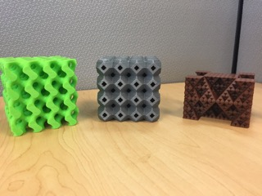
Figure 1: Image of gyroid, antiwrapping and triangular pyramid (from left to right) 3D printed structures

Pending Publications

- Irvin-Choy N. (2017) 3D Printing in Medicine

- Irvin-Choy N, Kindler M, Pursell M (2017) Reverse Hip Prosthetics

 Biography
N’Dea Irvin-Choy, age 21, studies Biomedical Engineering at Rowan University School of Engineering. As a rising senior, she is an undergraduate student researcher at Rowan University’s Orthopedic Lab located in the South Jersey Technology Park. She has written two journal articles pending publication and is developing another this fall. In between conducting research, N’Dea also plays field hockey for the NCAA Division III Varsity team and has been awarded NFCHA All American Academic, NJAC All-Academic honorable mention and NJAC All Conference honorable mention. After completing her undergraduate degree, N’Dea seeks to study drug delivery engineering in a full-time master’s program.

