Patient-related outcomes of patellofemoral
arthroplasty: experience of a single center

Dr Walimuni Yohan Mendis Abeysekera, UK
Mr Willem Schenk, UK

Abstract (300 word limit)
Purpose: The purpose of this prospective study was to present the experience of a single center on patellofemoral
arthroplasty, in terms of patient-related outcomes.
Method: From January 2005 to January 2016, 42 patients with isolated patellofemoral osteoarthritis were treated.
The patients were assessed using the Oxford Knee Score preoperatively, and one, five, and eight year(s) after
surgery. The data of the patients were analyzed using linear mixed effects models. A P value of 0.05 was considered
statistically significant.
Results: Among 42 patients who underwent patellofemoral arthroplasty, only 25 patients (31 limbs involved) had
records up to 5 years. There was a significant clinical improvement of Oxford Knee Score postoperatively (P < 0.05),
lowering the score on average by 10.4 ± 1.5 one year after surgery and 8.9 ± 1.9 five years after surgery. This
improvement was independent of the types of implants (P > 0.05), gender (P > 0.05), age (P < 0.05), and body mass
index (BMI) (P < 0.05).
Conclusion: Patellofemoral arthroplasty can significantly improve the knee function, and this improvement is
independent of the type of implant, gender, age, and BMI. However, further studies will need to assess the longterm
outcomes of PFA.

Image
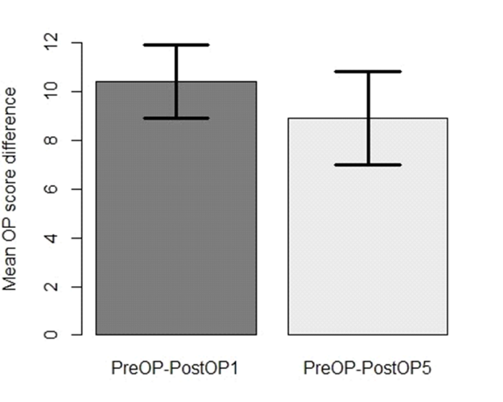
Fig. 1 Mean OKS difference 1 and 5 year(s) after operation
Recent Publications (minimum 5)
1. Davies AP, Vince AS, Shepstone L, Donell ST, Glasgow MM. The radiologic
prevalence of patellofemoral osteoarthritis. Clin Orthop Relat Res. 2002;402:
206–12.
2. Strickland SM, Bird ML, Christ AB. Advances in Patellofemoral Arthroplasty.
Curr Rev Musculoskelet Med. 2018;11(2):221–30. https://doi.org/10.1007/s121
78-018-9477-0.
3. Arciero RA, Toomey HE. Patellofemoral arthroplasty. 3-year to 9-year followup
study. Clin Orthop Relat Res. 1988;236:60–71.
4. Ackroyd CE. Development and early results of a new patellofemoral
arthroplasty. Clin Orthop Relat Res. 2005;436:7–13.
5. Odgaard A, Madsen F, Kristensen PW, Kappel A, Fabrin J. The mark Coventry
award: Patellofemoral Arthroplasty results in better range of movement and early patient-reported outcomes than TKA. Clin Orthop Relat Res. 2018;
476(1):87–100.https://doi.org/10.1007/s11999.0000000000000017.

6. Leadbetter WB, Ragland PS, Mont MA. The appropriate use of
patellofemoral arthroplasty - an analysis of reported indications,
contraindications, and failures. Clin Orthop Relat Res. 2005;436:91–9.
7. Odumenya M, Costa ML, Parsons N, Achten J, Dhillon M, Krikler SJ. The
Avonpatellofemoral joint replacement: five-year results from an
independent cen-tre. J Bone Joint Surg Br. 2010;92(1):56–60.
8. Nicol SG, Loveridge JM, Weale AE, Ackroyd CE, Newman JH. Arthritis
progres-Sion after patellofemoral joint replacement. Knee. 2006;13(4):290–5.
9. Ackroyd CE, Newman JH, Evans R, Eldridge JD, Joslin C. The Avon
patellofemoralarthroplasty: five-year survivorship and functional results. J
Bone Joint Surg Br. 2007;89(3):310–5.
10. Mont MA, Johnson AJ, Naziri Q, Kolisek FR, Leadbetter WB.
Patellofemoralarthroplasty: 7-year mean follow-up. J Arthroplasty. 2012;27(3):
358–61.
11. Akhbari P, Malak T, Dawson-Bowling S, East D, Miles K, Butler Manuel PA.
The Avon patellofemoral joint replacement: mid-term prospective results
from an independent Centre. Clin Orthop Surg. 2015;7(2):171–6. https://doi.
org/10.4055/cios.2015.7.2.171.
12. Farr J, Arendt E, Dahm D, Daynes J. Patellofemoral arthroplasty in the
athlete. Clin Sports Med. 2014;33(3):547–52. https://doi.org/10.1016/j.csm.2
014.03.003.
13. Kazarian GS, Tarity TD, Hansen EN, Cai J, Lonner JH. Significant functional
improvement at 2 years after isolated patellofemoral arthroplasty with an
onlay trochlear implant, but low mental health scores predispose to
dissatisfaction. J Arthroplasty. 2016;31(2):389–94. https://doi.org/10.1016/j.a
rth.2015.08.033.
14. Kellgren JH, Lawrence JS. Radiological assessment of osteoarthritis. Ann
Rheum Dis. 1957;16:494–501.
15. Dawson J, Fitzpatrick R, Murray D, Carr A. Questionnaire on the
perceptions of patients about total knee replacement. J Bone Joint
Surg Br. 1998;80(1):63–9.
16. Hendrix M, Ackroyd CE, Lonner JH. Revision patellofemoral arthro-plasty:
three-to seven-year follow-up. J Arthroplasty. 2008;23(7):977–83.
17. van Jonbergen H, Werkman DM, Barnaart AF. Dissociation of mobilebearingpatellar
component in low contact stress patellofemoral
arthroplasty, its mech-anism and management: two case reports. Cases J.
2009;2:7502.
18. Lustig S, Magnussen RA, Dahm DL, Parker D. Patellofemoral arthroplasty,
whereare we today? Knee Surg Sports Traumatol Arthrosc. 2012;20(7):
1216–26.
19. Dy CJ, Franco N, Ma Y, Mazumdar M, McCarthy MM. Gonzalez Della Valle a.
complications after patello-femoral versus total knee replacement in the
treatment of isolated patello-femoral osteoarthritis. A meta-analysis. Knee
Surg Sports Traumatol Arthrosc. 2012;20(11):2174–90. https://doi.org/10.1
007/s00167-011-1677-8.
20. Cartier P, Sanouiller JL, Khefacha A. Long-term results with the first
patellotemoral prosthesis. Clin Orthop Relat Res. 2005;436:47–54.
21. Starks I, Roberts S, White SH. The Avon patellofemoral joint replacement
independent assessment of early functional outcomes. J Bone Joint Surg Br.
2009;91(12):1579–82.
22. van der List JP, Chawla H, Zuiderbaan HA, Pearle AD. Survivorship and
functional outcomes of patellofemoral arthroplasty: a systematic review.
Knee Surg Sports Traumatol Arthrosc. 2015;25:2622–31. https://doi.org/10.1
007/s00167-015-3878-z.
23. Willekens P, Victor J, Verbruggen D, Vande Kerckhove M, Van Der Straeten
C. Outcome of patellofemoral arthroplasty, determinants for success. Acta
Orthop Belg. 2015;81(4):759–67.
24. Lustig S, Magnussen RA, Dahm DL, Parker D. Patellofemoral arthroplasty, where
are we today? Knee Surg Sports Traumatol Arthrosc. 2012;20(7):1216–26.
25. van Jonbergen HP, Werkman DM, Barnaart LF, van Kampen A. Long-term
outcomes of patellofemoral arthroplasty. J Arthroplasty. 2010;25(7):1066–71.
26. Berend KR, Lombardi AV Jr, Mallory TH, Adams JB, Groseth KL. Early failure
of minimally invasive unicompartmental knee arthroplasty is associated with
obesity. Clin Orthop Relat Res. 2005;440:60–6.
27. Hawker G, Wright J, Coyte P, Paul J, Dittus R, Croxford R, et al. Healthrelated
quality of life after knee replacement. J Bone Joint Surg Am.
1998;80(2):163–73.
28. Tarassoli P, Punwar S, Khan W, Johnstone D. Patellofemoral arthroplasty: a
systematic review of the literature. Open Orthop J. 2012;6:340–7.
29. Liow MH, Goh GS, Tay DK, Chia SL, Lo NN, Yeo SJ. Obesity and the
absence of trochlear dysplasia increase the risk of revision in
patellofemoral arthroplasty. Knee. 2016;23(2):331–7. https://doi.org/10.101
6/j.knee.2015.05.009.
Photograph

Biography
Dr Walimuni Yohan Mendis Abeysekera is an Orthopaedic Surgeon with MBBS MRCS MD (Orth) FRCS (Tr & Orth) and FEBOT who currently work in regional Australia.
E Mail: Yohan.abeysekera@yahoo.com

Notes/Comments:

