First Carpometacarpal Joint Pressure Reaction during Distraction with a Newly Developed Magnetic Internal Distractor Implant: A Cadaveric Study

Mahla Daliri, MD: Orthopedics Research Center, Mashhad University of Medical Sciences, Mashhad, Iran
Ali Moradi MD, PhD: Orthopedics Research Center, Mashhad University of Medical Sciences, Mashhad, Iran
Amin Rezaeian, MD: Orthopedics Research Center, Mashhad University of Medical Sciences, Mashhad, Iran
Hamed Hafiz, BS: Mechanical Engineering Department, Ferdowsi University of Mashhad, Mashhad, Iran
Arya Hedjazi, MD, PhD: Legal Medicine Research Center, Tehran, Iran, Legal Medicine Organization, Tehran, Iran
Alireza Akbarzade, PhD: Mechanical Engineering Department, Ferdowsi University of Mashhad, Mashhad, Iran

Abstract (300 word limit)

Objective: Distraction is a new treatment for first carpometacarpal (CMC1) osteoarthritis (OA) that unloads the joint and thus provides a favorable condition for cartilage repair. The purpose of this study is to test the efficiency of magnetic distraction with our newly created internal distractor. The distractor is made up of two magnets embedded inside capsules that are implanted at two sides of CMC1 constructed bones in such a way that the created repulsive force distracts the joint.

Design: Study was undertaken on the CMC1 joint of ten cadaveric hands. Using a Force Sensing Resistor (FSR), primary pre-implantation intra-articular forces were recorded. Two magnetic capsules were subsequently embedded at two sides of the CMC1 joint (one in the first metacarpal and one in trapezium bones). CMC1 intra-articular force was measured using FSR, once immediately after surgery and again 10 minutes later. Finally, we looked at the forces changes before and after the procedure in different thumb range of motions.

Results: Immediately after the procedure, intra-articular force was reduced in thumb neutral and flexion positions (P value = 0.040 and 0.023, respectively). After 10 minutes of magnetic distractor implantation, intra-articular force was reduced in thumb neutral, flexion and adduction positions. (P value = 0.032, 0.031 and 0.010, respectively).

Conclusion: Our findings show that the CMC1 joint could be offloaded by using the developed magnetic distractor in the thumb's neutral position, as well as flexion and adduction movement.
Image
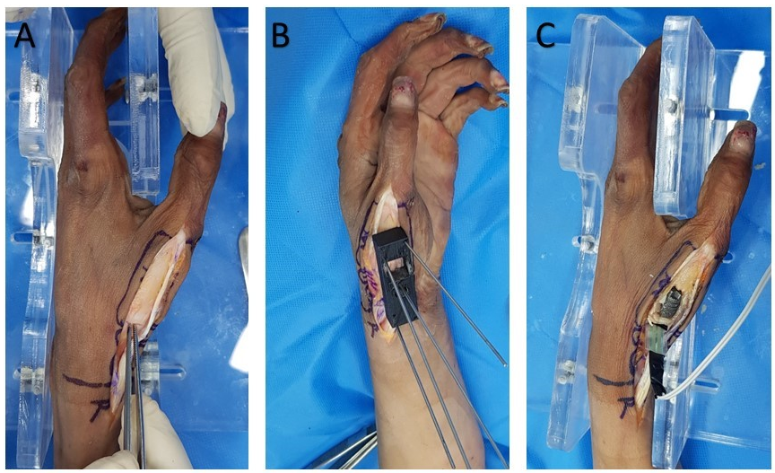
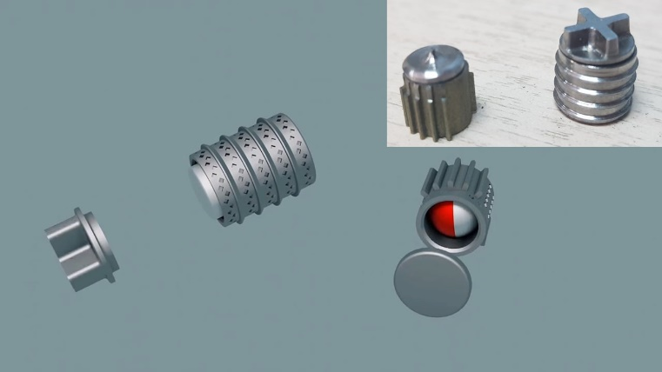
Recent Publications (minimum 5)

- Ottenhoff JS, Spaans AJ, Braakenburg A, Teunis T, van Minnen LP, van der Molen ABM. Joint distraction for thumb carpometacarpal osteoarthritis: 2-year follow-up results of 20 patients. Journal of Wrist Surgery. 2021.
- Spaans AJ, Minnen LPv, Braakenburg A, Mink van der Molen AB. Joint distraction for thumb carpometacarpal osteoarthritis: A feasibility study with 1-year follow-up. Journal of plastic surgery and hand surgery. 2017, 51: 254-8.
- Jansen MP, Mastbergen SC. Joint distraction for osteoarthritis: clinical evidence and molecular mechanisms. Nature Reviews Rheumatology. 2021:1-12
- Ottenhoff JS, Teunis T, Braakenburg A, van der Molen ABM. Can we decrease the duration of basal thumb joint distraction for early osteoarthritis from 8 to 6 weeks? Study protocol for a non-inferiority randomized controlled trial. Trials. 2021;22:1-10
- Raj S, Clay R, Ramji S, Shaunak R, Dadrewalla A, Sinha V, Shaunak S. Trapeziectomy versus joint replacement for first carpometacarpal (CMC 1) joint osteoarthritis: a systematic review and meta-analysis. European Journal of Orthopaedic Surgery & Traumatology. 2021:1-21.

Photograph

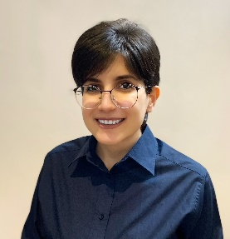Biography (150 word limit)
Dr. Mahla Daliri received his MD from Mashhad University of Medical Sciences (MUMS) in 2022, where she is currently a research fellow in Orthopedics Research Center (ORC) http://www.orthopresearch.com/. She studied medicine at MUMS from 2015 to 2022 and also worked as an orthopedics research assistant from 2018 to 2022. She has published more than ten proposals, published six Q1 journal articles, co-authored one published book, and registered six national and two international patents. Her research interests are in interdisciplinary areas of orthopedics, bionic hands, biomechanics, rehabilitation robotics, and external fixators. This is a special reference to innovation in these fields. While doing research in this field, she became acquainted and collaborated with an excellent interdisciplinary medical-engineering research group: The Center of Advanced Rehabilitation and Robotics Research (FUM CARE) (https://www.fum-care.com/). This collaboration taught her how to do research in an interdisciplinary setting, where she became acquainted with engineering tools, and saw how the practical output of such research affects patients’ lives. She has experience as research fellowship, manager, and students’ leadership at FUM CARE

Email: mahladalirib96@gmail.com

Notes/Comments:

