

New Bioactive Molecules through C-H Bond Functionalization of N-Heterocyclic Compounds
Author Name: Rakesh Kumar, Inder Kumar, Ritika sharma, Ankit Kumar Dhiman and Upendra Sharma
Affiliation: Natural Product Chemistry and Process Development Division, CSIR-Institute of Himalayan Bioresource Technology Palampur, Himachal Pradesh
University: Academy of Scientific and Innovative Research
Country: India

Abstract:
Heterocyclic compounds are widely distributed in natural products and found broad application as pharmaceuticals and agrochemicals. In particular, quinoline containing biaryls and fused N-heterocyclic compounds have shown substantial bioactivities.¹ Initial reports include the transition metal catalyzed, direct C-H functionalization of quinolines.² In our endeavour, a one pot green method for the synthesis of quinoline substituted α-hydroxy carboxylic derivatives by reacting quinoline N-oxides with acrylates has been developed.³ The main features of this method includes solvent and catalyst free conditions and high atom economy. Mechanistic study was performed to elucidate the reaction mechanism and 1,3-dipolar cycloaddition pathway was confirmed. The product obtained was converted to C-2 olefinated quinoline simply by heating under neat condition.³ In another study, a metal-free, base-promoted direct C(2)-H arylation of quinoline N-oxides with aryldiazonium salts under ambient conditions to provide a series of C-2 arylated quinoline N-oxides through highly regioselective C-H bond functionalization.⁴ Amply available anilines and heterocyclic anilines can also be employed as arylating reagents through in situ diazotization affording 2-arylquinoline N-oxides in moderate to good yields. Further, to demonstrate the applicability of this methodology, the C-8 substituted quinolines were synthesized from 2-arylated quinoline N-oxides. Mechanistic study revealed the radical pathway for C-2 arylation.⁴ Further, we have done the diastereoselective synthesis of fused N,N´-heterocycles through 1,3-DC reaction of aryl azomethine imines with activated olefins, maleimides and arynes.⁶ In continuation of this study, we have also developed the Co(III)-catalyzed alkylation of 8-methylquinolines with maleimides through C(sp³)-H activation.⁷

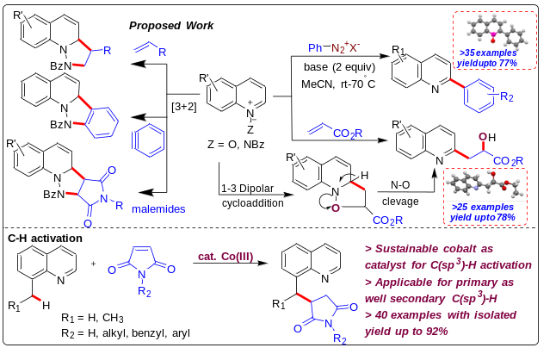

References
1) Michael, J. P. Nat. Prod. Rep., 2008, 25, 166–187.
2) Sharma, R.; Thakur, K.; Kumar, R.; Kumar, I.; Sharma, U., Catal. Rev., 2015,
57, 345-405.
3) Sharma, R.; Sharma, U., Catal. Rev., 2018, 60, 497-565
4) Kumar, R.; Kumar, I.; Sharma, R.; Sharma, U. Org. Biomol. Chem., 2016, 14, 2613.
5) Kumar, R.; Kumar, R.; Dhiman, A. K.; Sharma, U. Asian J. Org. Chem., 2017, 6,
1043-1053.
6) Kumar, R.; Chaudhary, S.; Kumar, R.; Upadhyaya, P.; Sahal, D.; Sharma, U. J. Org.
Chem., 2018, 83, 11552-11570.
7) Kumar, R.; Kumar, R.; Chandra D.; Sharma, U. J. Org. Chem., 2019, 84, 1542-1552.

Biography:

Mr. Rakesh Kumar is working as a Doctoral student in the area of Synthetic Chemistry in CSIR-IHBT, India and Graduated in Science from Himachal Pradesh University, Shimla, in 2011, M.Sc. in organic chemistry at HPU, Shimla, in 2013.

Research Interests: Asymmetric Synthesis

References: Dr. Upendra Sharma

Mail Id: rakesh66170@gmail.com

Contact Number: +919805766170

