Photograph
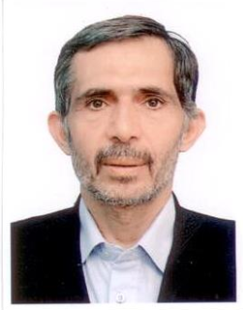

Novel asymmetric synthesis of (S)-Ketamine anesthetic drug using the chiral
tert-butanesulfinamide
Author Name:Abdollah Javidan
Affiliation:Department of Chemistry
University: University of Eyvaneky
Country: Iran

Abstract
2-(2-chlorophenyl)-2-(methylamino)-cyclohexanone (Ketamine), has been widely used as an anesthetic and analgesic drug. In this research work, At fist the 2- (N-piperidino methyl)-1- phenyl cyclohexyl amine stating material(1), was prepared from cyclohexanone piperidine by Manich reaction. Then, the sulfinylimin (2) was synthesised by condensation of tert-butanesulfinamide (tBS ) with aminoketone (1) in presence of Ti(OEt)₄ in 85% yield. The new chiral center was indused in (3) using Grignard reagent as nucleophile at -78 ◦C and 75% yield. after multi step reaction including methylation of (3) and Hoffman elimination of (4) and deprotection of (5) ,finally, the (S)-ketamine was synthesized under ozonolize reaction of alken (6) in good yield and enantioselectivity (95% yield and %85 ee).

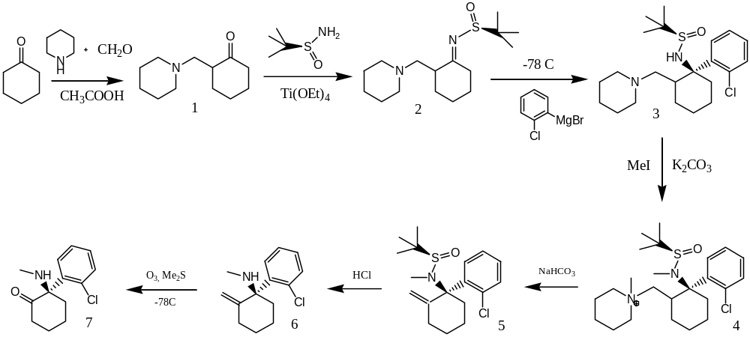

Biography:

Graduated from Department of Chemistry, Wollongong University in 1996 with a Ph.D. under supervising Prof. Steve Pyne. My Ph.D. work was on asymmetric synthesis of proline as novel angiotensin converting enzyme (ACE) inhibitors.
I worked initially as a teaching assistant with the Department of chemistry University of IHU (Tehran-Iran), followed by nano research center as a research assistant and deputy of Nano center. More than 20 Postgrduate students were under my supervising.In Feb.2016, I have retired from my university as Assoc. Professor after near 20 years work. And starting cooperation with Pharmaceutical Sciences Branch, Islamic Azad University Tehran and University of Eyvaneky.

Research Interests: pharmaceuticals, molecular Docking, Medicinal chemistry and naocatalysts nanocomposites and also on Asymmetric synthesis of amino acids and chiral drugs.

Mail Id:abdollah.javidan@gmail.comI

Contact Number:+989903875595

