New Age Diagnostic for Silent Cancer: The Future is here!
Dr. Anoop Shaji, Kerala University of Health Sciences, India

Abstract

As with communicable diseases, the broad range of chronic diseases such as cancer adds up the burden on the economy and the health status of the citizens due to the lack of timely detection measures and the post-disease treatment cost. So we definitely need new fresh innovations to tackle the above problems. As with the developing countries there are many hurdles in front of health development goals and with limitations of lack of resource persons and pricey resources being allocated to the development of the under privileged at the same pace of the urbans, widens the healthcare distrubution gap. The oral presentation will dwell deep into how a simple non-invasive device fabricated on a paper could help spot out a dreadful disease like cancer from just a drop of blood or saliva which is surely a boon for the future advancement of health statuses of our village and rural illiterate communities. The so-proposed; Hue coded Ligand-based Micro-fluidic-electro-magnetotaxis system, sorts out tumor cells based on its specific properties like Size, Polarity and Paramagnetism, and the provisional diagnosis is based on a simple charted colour- coded reaction output from the sorted cells, which requires very less skill or knowledge of medical science.

Image

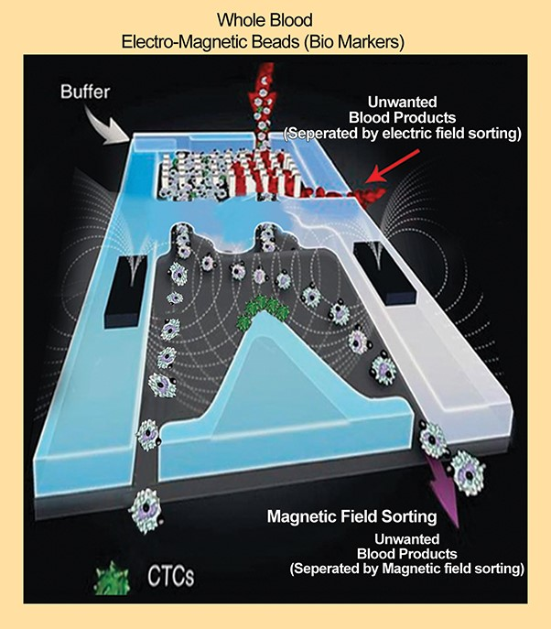

Recent Publications

1) Nicole Pamme. Magnetism and microfluidics , Lab Chip, 2006,6, 24-38

2) Jennifer Zhuo Zhang and Sunitha Nagrath*. Microfluidics and Cancer: Are we there yet?,Biomed Microdevices. 2013 Aug; 15(4): 595–609.

3) Wlodkowic D, Darzynkiewicz Z. Microfluidics: Emerging prospects for anti-cancer drug screening. World J Clin Oncol. 2010;1(1):18–23.

 Biography

Dr. Anoop Shaji is currently working as a Dental House Surgeon at Century International Institute of dental science & research centre, Kasargode, Kerala, India. His area of interest lies in Oncology-based translational research. Till date, he has delieverd dozens of award-winning scientific presentations at various international, national scientific meets on his original novel, indigenously developed, promising concept models. For an overall well-rounded achievements throughout 2017 & 2018 earned him many honours including the prestigious national awards of FAMDENT BEST UNDERGRADUATE STUDENT 2017 & 2018, International Exemplary Research and Performance Award for BEST UNDERGRADUATE STUDENT 2017, International Dental Excellence Award 2018 for BEST UNDERGRADUATE RESEARCHER, 2019 PANKOSMIA Talents in healthcare Award for RISING STAR IN DENTISTRY, Indian Dental Association's PROFILE OF THE MONTH (February 2018) & Indian Health Professional award for YOUNG DENTAL ACHIEVER OF THE YEAR of 2017. He was honored with a cover feature in a national publication along with an interview by the prestigious IDA for his achievements and contributions to the scientific fraternity in December 2018. He’s currently serving as Honorary board member of Acta Scientific-Medical Sciences & Acta Scientific- Microbiology, an international peer-reviewed journal. He is the youngest and the first Undergraduate student in the country with invitations to multiple TEDx events in 2019 as a Speaker. He is the founder of a start-up venture named Dr+ Online for practicitioners focused on hassle-free networking, flexible with adaptability for case referral and discussions, locality wise expertise search and live-on patient consultation

Email: anoopshajibdstd@gmail.com

Notes/Comments:

