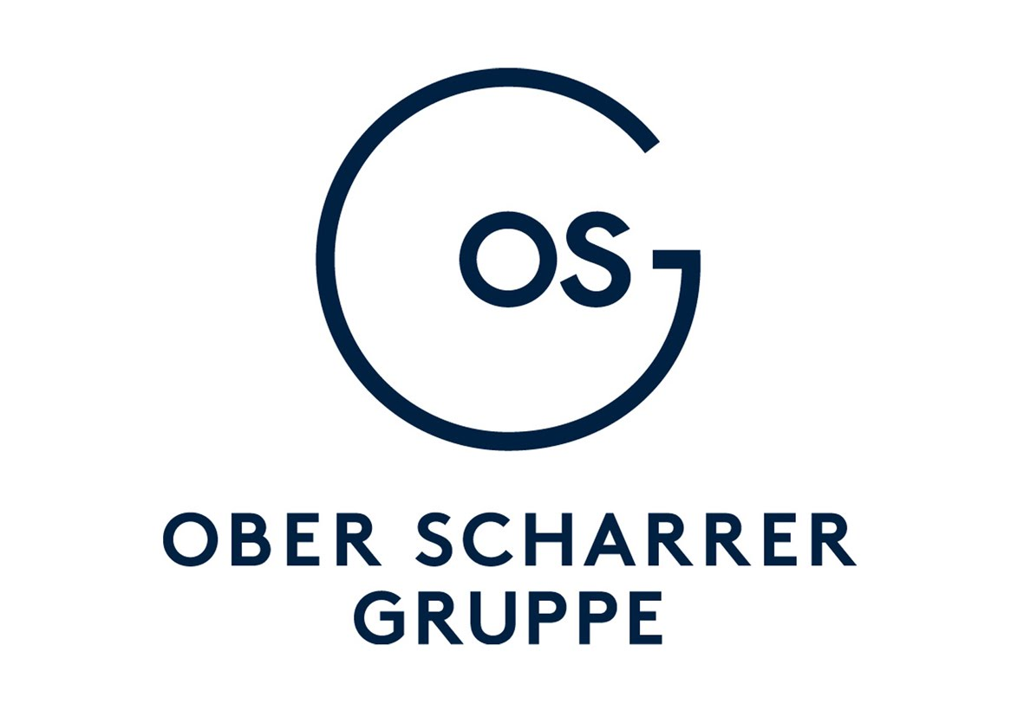
Paste your Photograph Here

Photograph
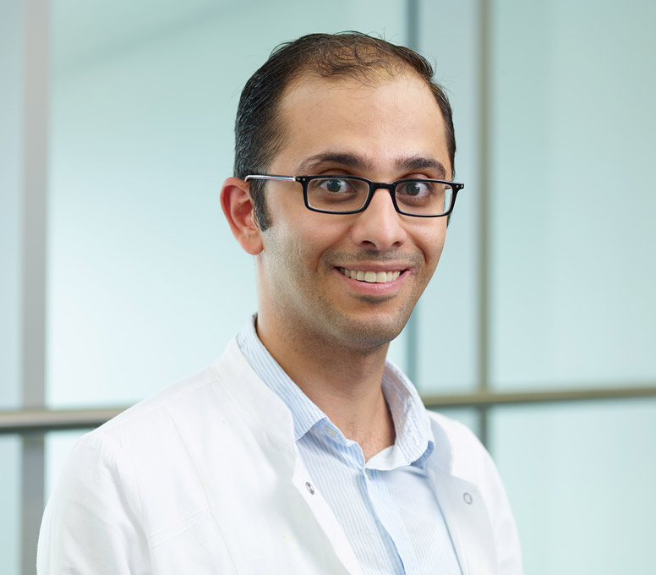

Title: Ophthalmologic Manifestations of Neurofibromatosis
Name: Dr.Kusai Almozawak

Ober Scharrer Group- ARIS Clinic Nürnberg-Germany
Abstract :
Neurofibromatosis 1 (NF1) and neurofibromatosis 2 (NF2) are characterized by an autosomal do- minant pattern of inheritance with irregular penetrance and a broad spectrum of different clinical phenotypes. ere are large variations in the age of onset, progression and prognosis. Symptoms are o en manifested early in childhood. Characteristics which the two main forms NF1 and NF2 have in common are a positive family history, characteristic skin alterations, such as café au lait macules, axillary or inguinal freckling and neural tumors such as neurofibroma and optic glio- ma (NF1) as well as (bilateral) vestibular schwannomas (NF2). An interdisciplinary cooperation is necessary for the diagnostics and therapy.
Biography :

Dr. Kusai Almozawak FEBO did his Residency at Rudolf Foundation Hospital in Vienna (under supervision of Professor Susanne Binder) and Ober Scharrer Group in Nürnberg-Germany (under supervision of Dr.Scharrer ). His Speciality exam was in Munich at 28.10.2015 und his FEBO exam was in Paris Mai 2016.
He works at ARIS Clinik-Ober Scharrer Group in Nürnberg-Germany. He specialist in Anterior Segment Surgery and Lid Surgery .
Presenting author details
Full name: Dr.Kusai Almozawak
Session : Ocular Inflammation
Category: Oral
Email id: k.almozawak@osg.de
Contact number: 0049-162-3201238 .

