Abstract Title: Topical anesthesia in children intraoperative adjustable strabismus surgery

Bolletta E¹, Mancioppi S², Franco E², Fabbri F², Migliorelli A³, Franco F².

¹Ocular Immunology Department (Reggio Emilia, Italy)
²Ophthalmology Division (University Hospital of Ferrara, Ferrara, Italy)
³Department of Anesthesiology and Intensive Care (University Hospital of Ferrara, Italy)

Abstract (not more than 300 words)

Purpose: To evaluate strabismus surgery with intraoperative adjustment of sutures under topical anesthesia in children.
Methods: Nineteen children with a mean age of 12.68 ± 2.50 years (range 8-16) and horizontal deviation, underwent a one-stage surgical technique performed under topical anesthesia. The mean preoperative angle of deviation was 24.21 ± 11.20 prism diopters (Δ) (range -50^{Δ} to +30^{Δ}) at distance. Surgery consisted in unilateral or bilateral recession and/or resection of horizontal muscles, medial or lateral rectus, with intraoperative adjustment of sutures based on alternate prism cover test. Follow-up was carried out one day, one month, three months and six months postoperatively.
Results: 17 of 19 patients (89%) remained comfortable during surgery, while two needed intravenous injection of propofol.
Mean postoperative angle of deviation at six months was 4.11^{Δ} ± 2.87^{Δ} (range -10^{Δ} to +10^{Δ}) at distance. In esotropic patients the average preoperative angle of deviation reduced from +23.80^{Δ} ± 5.89^{Δ} preoperatively to +4.80^{Δ} ± 3.35^{Δ} at six months; whereas in exotropic patients it decreased from -24.36^{Δ} ± 12.76^{Δ} to -3.86^{Δ} ± 2.77^{Δ}. The success rate, defined by postoperative residual angle of deviation ≤ ±8 ^{Δ}, was 89% at six months.
Conclusions: Strabismus surgery with intraoperative sutures adjustment under topical anesthesia in children is a tolerable procedure with encouraging outcomes, representing an alternative to general anesthesia in well selected children. Clinical evaluation of both child and parents are fundamental to predict a likely poor collaboration of the child during surgery, which, if present, would require surgery under general anesthesia.

Keywords - strabismus surgery, topical anesthesia, children, adjustable suture

Professional Biography (100-150 words)

Elena Bolletta completed her residency in Ophthalmology at the University of Ferrara.
She has been following strabismus surgery and lately uveitis at the tertiary referral center of Reggio Emilia in Italy. She has published some papers in reputed journals and followed several clinical studies.

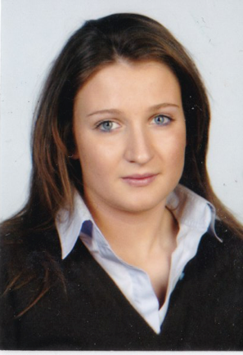

Email Id: elena.bolletta@unife.it

