A CASE REPORT- CANALICULAR INJURY REPAIR WITH 24G VENFLON LOWER MONOCANALICULAR STENTING.
AUTHORS: DR.DEEPA R¹ DR.PRAVEEN GANESH² DR.SURYA RAO³
POSTGRADUATE DEPARTMENT OF OPHTHALMOLOGY¹, DEPARTMENT OF PLASTIC AND AESTHETIC SURGERY^{2,3} SAVEETHA MEDICAL COLLEGE AND HOSPITAL
INTRODUCTION: Canalicular injury to the eye is one of the commonly encountered injury occurring following eyelid trauma. In this case report we are presenting a patient with stick injury to eye presented to our hospital diagnosed to be having canalicular injury. Canalicular repair was done for the patient, primary skin suturing with lower cancalicular stenting was done.
CASE PRESENTATION:
50 year old male presented to our hospital with stick injury to the right eyelid following which he had difficulty in closure of the right eye completely and pain. Upon further investigating canalicular injury was suspected following which patient was planned for surgery. Patient had underwent exploration and debridment with primary skin suturing with lower canalicular stenting with 24 gauge venflon. Patient’s outcome was better with no complications.
DISCUSSION : Literature quotes bicanaclicular stents- Crawford, pigtail stents. Monocanalicular- monaka,jones stent. But we are quoting a new statement, 24 gauge venflon can be a suitable cost effective alternative for canalicular repair surgery in an acute setting where immediate intervention is required or if the access to stents are delayed.
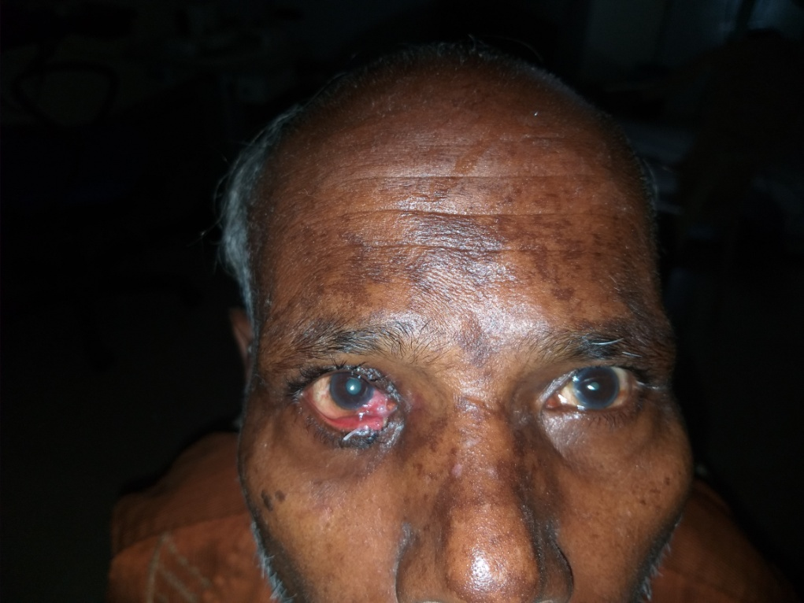
RECENT PUBLICATIONS REFERENCES:
1. A study of modified and economical approach to canalicular tear using intravenous cannula in tertiary care centre Anuradha A1,* , Vinuta Mohan Kulkarni2 , Vidya Devi M 3 , Ranjitha C S4
2. Old canalicular laceration repair: a retrospective study of the curative effects and prognostic factors Fang Bai1,2, Hai Tao2 , Yan Zhang2 , Peng Wang2 , Cui Han2 , Yi-Fei Huang1 , Ye Tao1

3. Anatomical and functional outcomes of canalicular laceration repair with self retaining mini-MONOKA stent ShahidAlamªNeha ShriraoMehta^{b}BipashaMukherjeeª

4.Is the distance from punctum a factor in the anatomical and functional success of canalicular laceration repairs?
Manpreet Singh¹, Natasha Gautam¹, Nitasha Ahir², Manpreet Kaur

BIOGRAPHY: DR.DEEPA R is an ophthalmology postgraduate resident at saveetha medical college and hospital. Aspiring to be the save the sight for future generations.

